Need to have a short paragraph summarizing why Be and BJ/psi can not be done with HFT.

B-decay J/psis
As shown in the left panel of fig.1, B-decay J/psi is kinematically closely correlated with the parent B meson due to its large mass. It is thus a good tool to study b quark interaction with the medium. Until now CMS experiment at LHC has measured B-decay J/psi production in 2.76 TeV PbPb collisions for pT(J/psi) > 6.5 GeV/c at mid-rapidity. Complementary measurements at lower pT and different collisions energy may shed new light in understanding b quark and medium interactions. With the HFT+ upgrade, STAR is capable of doing such measurement in both di-muon and di-electron channels.

Simulation procedure
PYTHIA8 with STAR heavy flavor tune is used to produce inclusive and B-decay J/psi samples in 200 GeV p+p collisions. These PYTHIA samples are then used as inputs for STAR GEANT and detector response simulations. We produced about 13K prompt J/psi and 8K B-decay J/psi for both di-muon and di-electron decay channels. To study the performance of HFT+, we cut on the pseudo-ctau (ctau’) of J/psi to distinguish B-decay J/psi from prompt J/psi. The pseudo-ctau serves as a proxy of the true B meson ctau. As shown in the right panel of fig.1, it is defined as ${cτ}^{'}={\vec{L}}_{xy}∙\frac{m_{J/ψ}}{\left|{\vec{p}}_{T}\right|}$, where ${\vec{L}}_{xy}=\vec{L}∙\frac{{\vec{p}}_{T}}{\left|{\vec{p}}_{T}\right|}$, $\vec{L}$ represents the path from collision vertex to B meson decay point, $m_{J/ψ}$ and ${\vec{p}}_{T}$ are the mass and transverse momentum of J/psi, respectively. The B meson decay point is reconstructed as the middle of the distance-of-closest-approach between the electron and positron tracks.
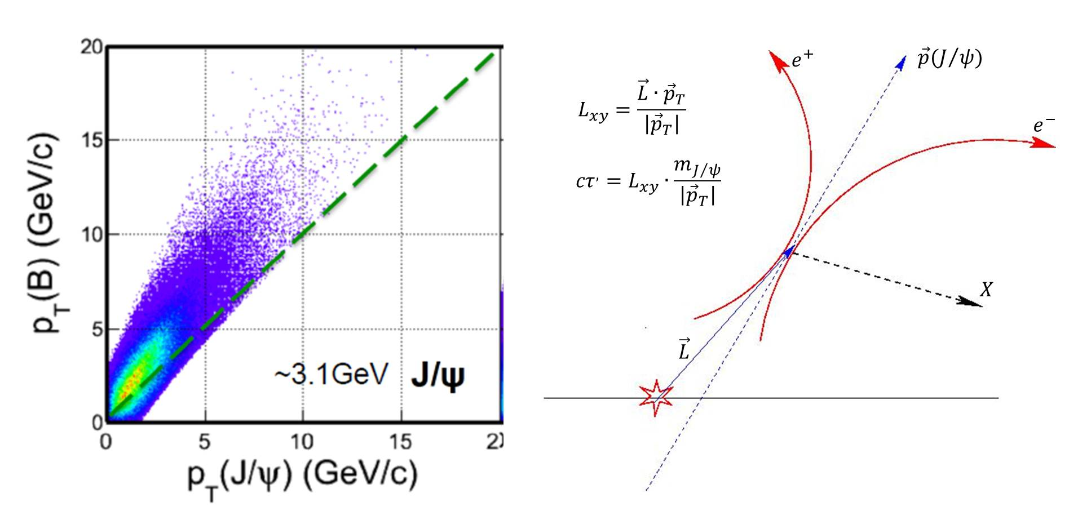
Figure 1: (left) Correlation of B meson pT and the decay J/psi pT in BJ/psi+X channel. (right) schematics of pseudo-ctau definition.

The ctau’ distribution of inclusive J/psi and B-decay J/psi in dimuon channel for pT(J/psi) > 2 GeV/c and 4 GeV/c are shown in fig.2. The B-decay J/psi and inclusive J/psi are normalized according to prediction of color evaporation model which successfully describe measurements from Tevatron and LHC. The tail of the ctau’ distribution may be an effect from tracking resolution as well as the mis-association of TPC tracks with HFT hits leading to poorly reconstructed B meson decay points. We rely on these distributions to optimize the cuts on ctau’.
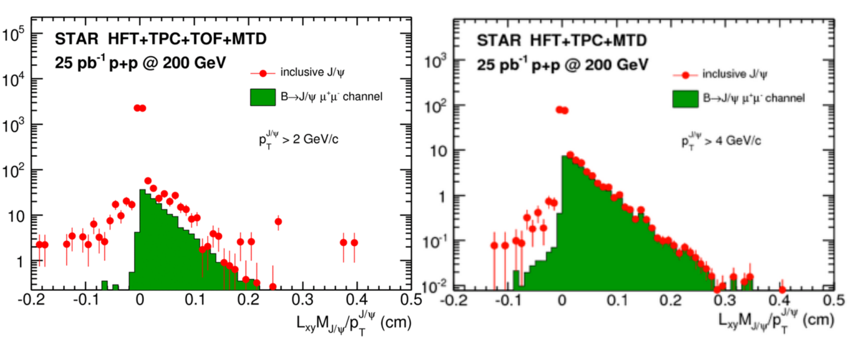
Figure 2: pseudo-ctau distribution from inclusive J/psi (red data point) and B-decay J/psi (green shaded area) in dimuon decay channels for pT(J/psi) > 2 GeV/c (left) and 4 GeV/c (right).

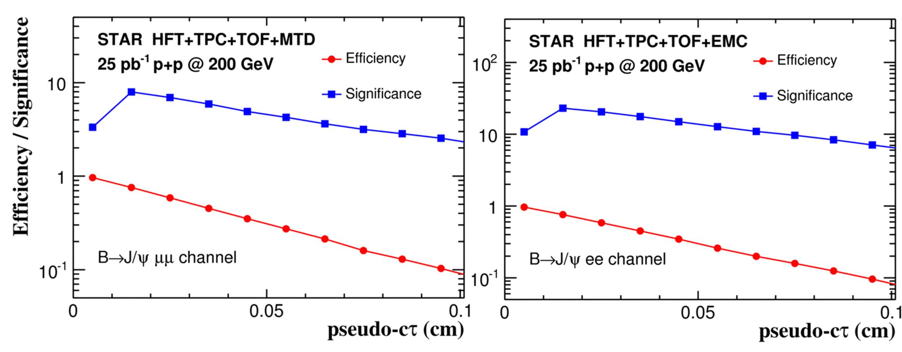
Figure 3: The efficiency and significance of BJ/psi measurement as a function of pseudo-ctau cut.

Fig.3 shows the efficiency (red closed circles) and significance of the raw B-decay J/psi signals as a function of ctau’ cut. The left and right panels of the figure are dimuon and dielectron channels, respectively. With the same ctau’ cut, the dimuon channel has a slightly higher efficiency possibly become muon suffer less multiple scattering. The significance of dielectron channel is much higher (Note: not sure about the reason. Is it because the spectra of dielectron channel is triggered, i.e. harder). The significance goes up for ctau’ < 150 um and decrease with larger ctau’ cut. (Note: can be different for different pT. Need to have that figure). We thus require ctau’ > 150 um (to be changed) for the projects of the measurements.

1.2 Measurement Projections:
Measuring B-decay J/psi production in dielectron channel at low pT is not possible in STAR for lack of effective triggers. However, STAR can trigger on J/psi->uu with dimuon triggers from the Muon Telescope Detector (MTD). The BEMC high tower trigger (HT) will allow us to measure high pT BJ/psiee channels. For p+p collisions, we expect RHIC to deliver 9.3 pb^-1 to 33 pb^-1 every week. Assuming we have a 12 week p+p run and a 30 cm diamond size, we expect an average of ~30 pb^-1 (Need to be consistent with the plot) in |Vz| < 5cm which is constraint by HFT+ detector acceptance. Figure 4 shows the expected raw yield with 30 pb^-1 200 GeV p+p collisions (NOTE: to be updated with the new level1 triggers). The blue closed squares represent projected raw signal counts from MTD dimuon trigger and the red closed circles represents those from HT trigger where the current trigger efficiency on J/psiee is taken into account. We expect to obtain a reasonable (?? To be updated when new L1 trigger is defined) measurement in 200 GeV p+p collisions up to 10 GeV/c.
Figure 4: BJ/psi raw counts as a function of J/psi pT with 20 pb^-1 p+p collision in |Vz| < 5cm from dimuon trigger (blue) and high tower electron triggers (red).

For Au+Au collisions, we expected RHIC to deliver 2.2 nb^-1 to ~5 nb^-1 every week. Assuming we have a 12 week Au+Au run and a 30 cm diamond size, we expect an average of ~5 nb^-1(Need to be consistent with others) in |Vz| < 5cm which is equivalent to ~200 pb^-1 of p+p collision with Nbinary collision scaling. The raw Au+Au yield is estimated through scaling the p+p simulation to 200 pb^-1 and used for RAA calculation (NOTE: is the suppression factor taken into account when calculating statistical error bars?). Figure 5 shows the expected precision of BJ/psi measurements as a function of J/psi pT and Npart with 5 nb^-1 of Au+Au collision and 30 pb^-1 of p+p collisions in |Vz| < 5 cm. We assume the RAA is independent of pT to estimate RAA vs. pT and use the CMS measurements as the template for RAA vs. Npart. As shown in the plot, we can get good measurement……… (NOTE: need to use some model predictions as template so that we know if the precision is good enough to distinguish different models).
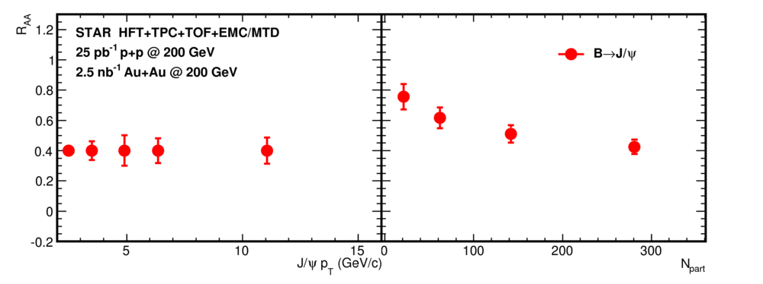
Figure 5: Projection of BJ/psi RAA as a function of J/psi pT (left) and Npart (right) with 25 pb^-1 of p+p collisions and 2.5 nb^-1 of Au+Au collision in |Vz| < 5 cm.

Figure 6 shows the projected precision of BJ/psi v2 measurement assuming v2 = 0……… (NOTE: uncertainty is large and may not need to be included in the plot. Let’s see the discussion).

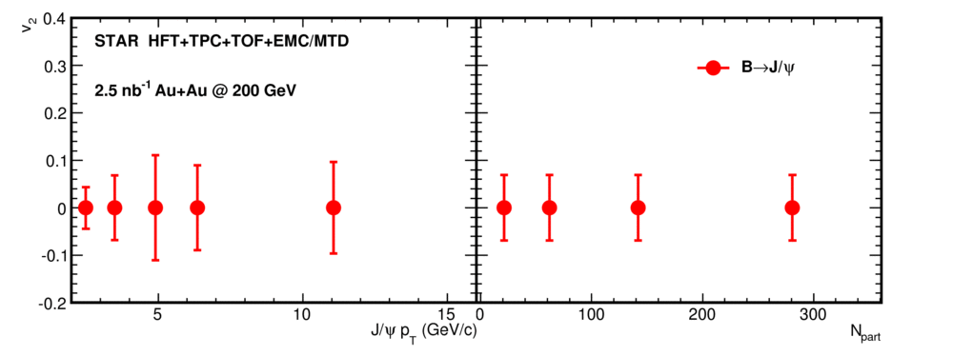
Figure 6: Projection of BJ/psi elliptic flow (v2) uncertainty as a function of J/psi pT (left) and Npart (right) assuming zero v2 with 2.5 nb^-1 Au+Au collisions in |Vz| < 5 cm.

Bottom Decay Electrons
Another way to study B-mesons is to measure their decay electrons via displaced vertices. Although the kinematics of decay electron and its parent B meson is not very well correlated as shown in the left panel of fig.7, high pT electron can be easily triggered experimentally allowing us to study the interaction between the medium and high pT B quark. The techniques of measuring heavy flavor decay electrons have been well established at RHIC. However, the fact that these measurements are a convolution of De and Be makes it difficult to interpret the data. Although various methods have been developed to disentangle the two contributions in p+p collisions, none could be applied to Au+Au collisions due to complicated medium effects and large background. With the HFT+, one can study different impact parameters of Be and De electrons to disentangle the two components. Alternatively one can calculate De spectrum from the reconstructed D-mesons, assuming the same decay kinematics as in p+p collisions, and obtain Be via subtraction.

Simulation procedure
Inclusive B-decay and D-decay electron sample in Au+Au collisions are simulated by embedding these signals into HIJING events. These embedded HIJING samples are then used as inputs for STAR GEANT and detector response simulations. We embed in every event 100 decay electrons from each of the D0, D+, B0 and B+ with flat pT distribution. The pT spectra are weighted by the STAR measurement for D mesons and FONLL prediction for B mesons. We produced about 10K D-decay electron and 10K B-decay electron in minimum-bias Au+Au collisions (is that correct Yifei? ).
To study the performance of HFT+, we cut on the impact parameter of B-decay electrons. The impact parameter is defined as the distance-of-closest-approach (DCA) between an electron track and collision vertex as show in fig 7 right panel. By requiring a minimum DCA, a large fraction of the electrons from photon conversion, vector meson decay and misidentified hadrons can be rejected. The remaining background is dominated by the electrons from D meson decay. Since the B meson has a much longer life time (~ 450 – 500 um) than that of D mesons ( ~100 – 300 um), we expected B-decay electron has on average a larger DCA which can be utilized to reject the D-decay electrons.

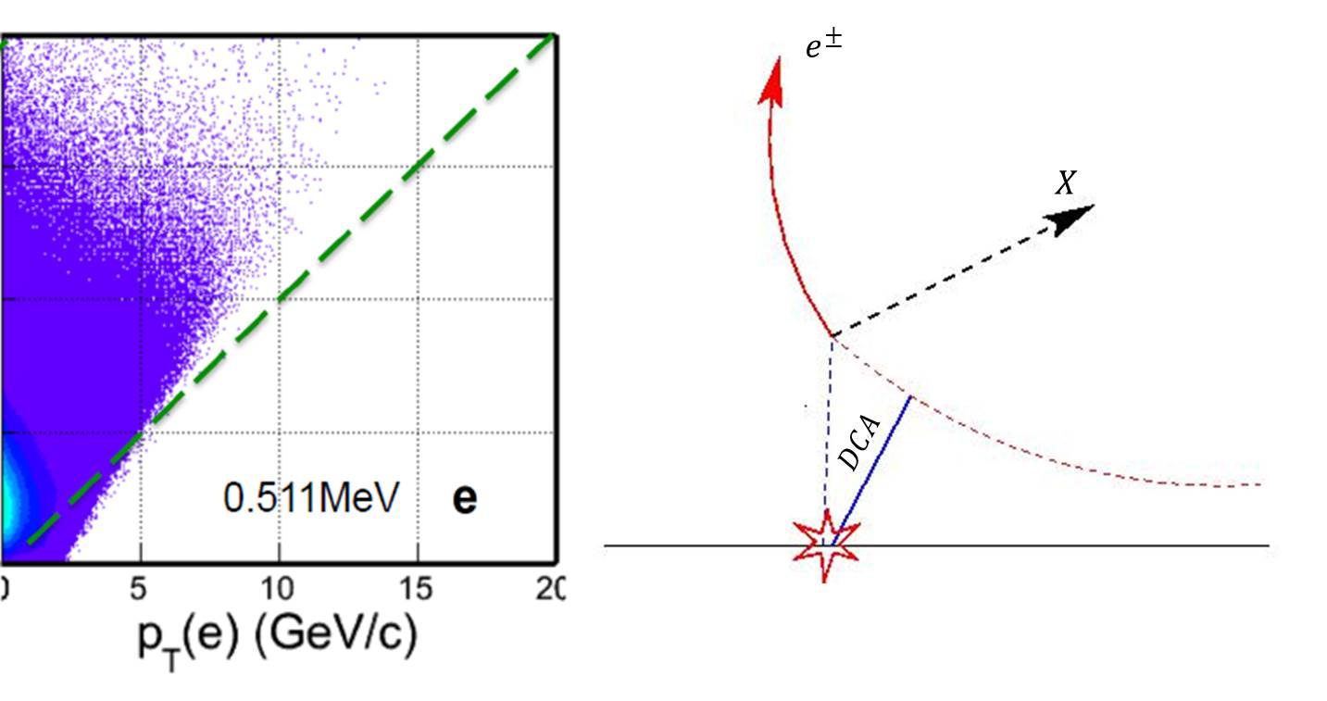
Figure 7: (left) Correlation of B meson pT and the decay electron pT in Be+X channel. (right) schematics of DCA definition.

Figure 8: DCA distribution from B mesons and prompt and feed-down D mesons for pT = 2.4-3.0 GeV/c (left) and pT = 4.8-5.4 GeV/c (right).

Figure 8 shows the distribution of electron impact parameters at 2.4 < pT < 3 GeV/c (left panel) and at 4.8 < pT < 5.4 GeV/c (right panel) for D0→e (red), D+→e (green), B→e (blue) and B→D→e (purple). The background from Hijing events is shown as the dashed curve (what is this?). The black solid curve presents the total electron DCA distribution, which was normalized to the STAR measured non-photonic electron spectrum. For intermediate pT, the yield of B-decay and D-decay electrons are similar. For higher pT at large DCA, B –decay electron dominate. The DCA distribution of D mesons can be well constraints since STAR can directly reconstruct all D mesons. We can thus subtract the D meson contribution from the DCA distribution and fit the remaining spectra with expected shaped of DCA distributions from Be, BDe and background (what is it?) to obtain Be and BDe (NOTE: Be and BDe can be both used for RAA. Why only Be is considered? )

Measurement Projections:

Figure 9 left panel shows the projected Rcp as a function of electron pT in 0-10% central and 60-80% peripheral Au+Au collisions. The estimation is made using ??? as a template by assuming we can collect 5 million minimum bias Au+Au collisions and can sample 5 nb^-1 using HT triggers in |Vz| < 5 cm. The actual HT trigger efficiency and rejection factor is taken into account here (need some more details here). We expect to have accurate measurements up to pT = 8 GeV/c. Figure9 right panel shows the projected Be v2 measurements with 5 billion minimum bias Au+Au collision in |Vz| < 5 cm assuming v2 = 0. We expect to be able to measure Be v2 with a precision of ~2%. The combination of the expected Rcp and v2 measurements will provide large discrimination power against different model prediction and can thus provide crucial inputs in understanding energy loss mechanism (NOTE: need to have different model prediction on Be for more physics conclusions).
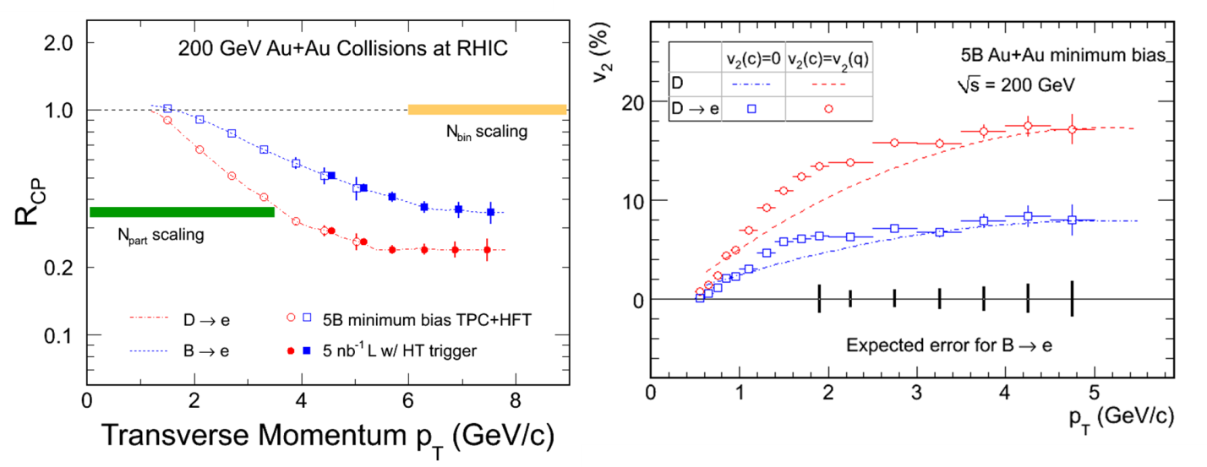

Figure 9: Projection of Belectron RAA (left) and v2 (right) as a function of electron with 30 pb^-1 of p+p collisions and 5 billion minimum bias Au+Au collision in |Vz| < 5 cm.

NOTE: the following RAA depends on how the new L1 trigger work and need to be revisited when the performance of the new trigger is clearer.
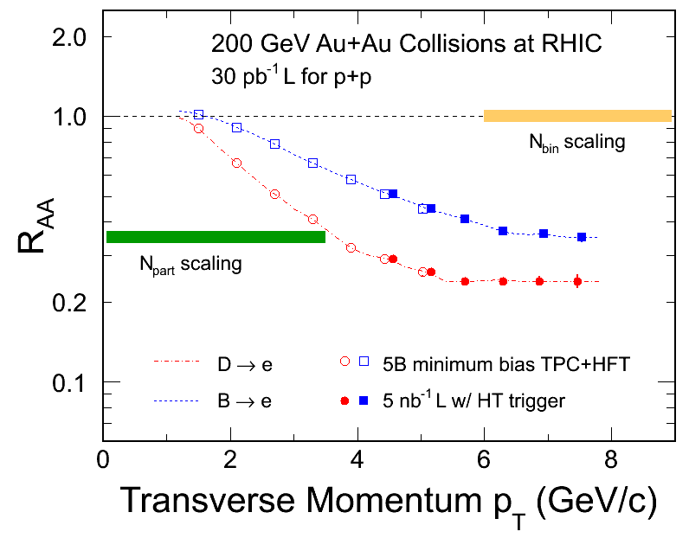

http://www.star.bnl.gov/protected/heavy/ullrich/pythia8/
Ramona CEM calculation

