RR May 2001
SS Dec 2001
PHYS 342 Laboratory

Black-body Radiation: The Stefan-Boltzman Constant

Objective: To measure the energy radiated by a black-body cavity as a function of temperature.

References:
1. Experimental Atomic Physics, G.P. Harnwell and J.J. Livingood, McGraw-Hill, NY (1933), pgs. 50-58.
2. Modern Physics, 2nd Edition, Kenneth Krane, Wiley and Sons, NY (1996), pgs. 77-83 and pgs. 320-322.

Apparatus: Electrical furnace, NiCr-Ni thermocouple, variac, CASSY interface, computer, water pump, Moll’s thermopile.

Introduction:
Following Maxwell’s unification of electricity and magnetism in the late 1860’s and his prediction of electromagnetic radiation, an intense effort followed to both generate and detect this new type of radiation. After the realization that light itself was an electromagnetic wave, there was an explosion of interest to understand in detail how light was generated. This lead to series of fundamental studies of the characteristics of many different types of light sources. The results of these studies where so puzzling that they in turn paved the way to the formulation of quantum physics.
One subject of particular interest during this time was the characterization of light emitted from a hot object. As known from prehistoric times, any object heated to a high enough temperature emits visible light. The radiation emitted from a well-characterized object like a hollow cavity came to be known by a variety of names such as black-body radiation, temperature radiation, or cavity radiation. It was discovered that such radiation depends only on the temperature of the cavity and this fact differentiates it from other types of radiation such as that emitted from a glow discharge tube. It was quickly realized that black-body radiation emitted in the visible region of the electromagnetic spectrum only becomes appreciable when the temperature of the cavity is above 500-550 C (about 800-850 K). Black-body radiation emitted at lower temperatures must be detected by other than optical means.
A breakthrough occurred when it was realized that even though a theory describing the radiation emitted from a hot object is difficult to construct without a microscopic knowledge of the exact processes involved, considerable progress can be made using the general principles of thermodynamics coupled with Maxwell’s predictions for the radiation pressure of electromagnetic radiation.
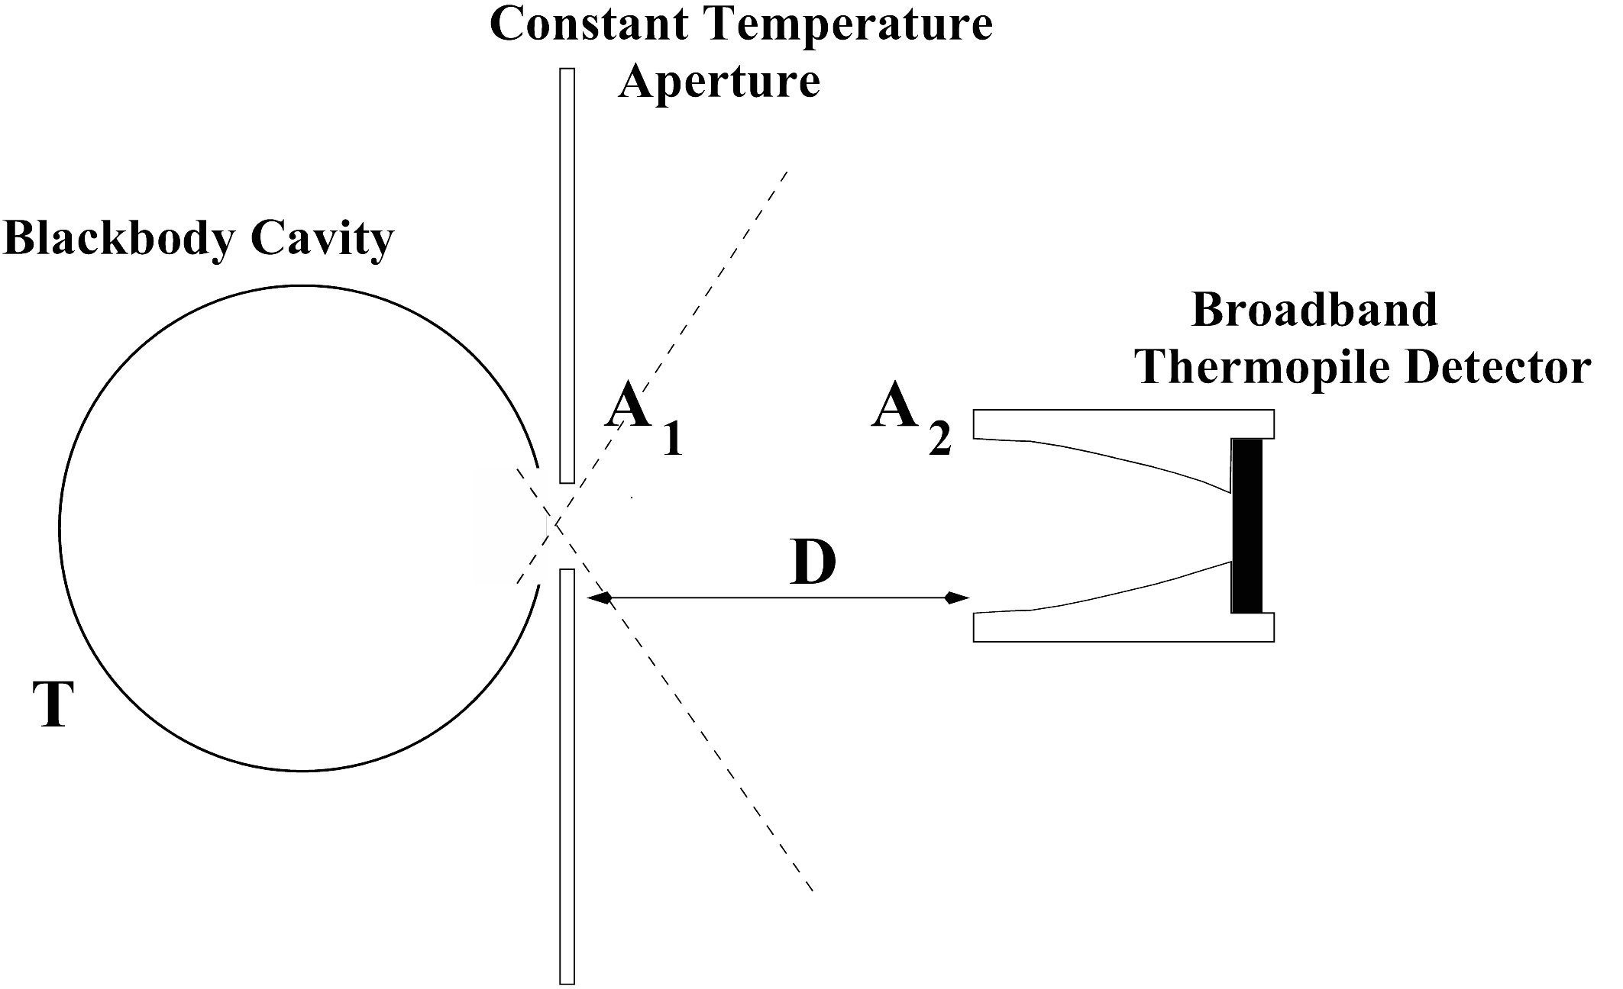
Figure 1: A schematic diagram showing the essential ingredients of the Stefan radiation experiment. A cavity held at temperature T is shielded by a constant temperature shield with an aperture area A1 from a broadband radiation detector having an active area A2.

The first quantitative measurements of the energy transferred by radiation between a body and its surroundings were reported by John Tyndall in 1867. Whereas traditional transfer of energy between two objects via convection and conduction process requires an intervening material medium, heat radiation does not. The energy is transferred by electromagnetic waves. A diagram illustrating the essential features of such a radiation experiment is given in Fig. 1. In 1879, Josef Stefan’s work suggested that the radiance R (often called the radiant emittance i.e. the power emitted per unit area in W/m2) of a black-body cavity varied with the temperature of the cavity as T4, giving an empirical relationship known as Stefan’s Law

R=σT4 (1)

where σ is a proportionality constant now known as the Stefan-Boltzmann constant.
No fundamental understanding of this empirical result was achieved until Boltzmann produced a thermodynamic argument in 1884 that gave the correct temperature dependence inferred by Stefan. The significance of σ was not appreciated until later, when Planck realized that it could be expressed in terms of a combination of fundamental constants in 1900. Experimentally, σ was measured with increasing precision from the 1890’s (σ=5.45×10-8Wm-2K-4) to the 1930’s (σ=5.737±0.017×10-8Wm-2K-4). Thus knowing σ and the surface area of any object (assumed to be a blackbody), the power emitted into a vacuum can be calculated.
In this experiment, you will repeat Stefan’s measurements using computer-assisted data acquisition techniques and you will obtain an estimate for the Stefan-Boltzmann constant σ.

Theory:
The principles of thermodynamics provides a simple understanding of the physics underlying the T4 behavior found in the Stefan-Boltzmann radiation law. Planck’s microscopic theory, which is discussed in most textbooks, provides even further insight into the nature of black-body radiation.
The first law of thermodynamics states that a body in a given thermodynamic state has an internal energy U associated with it. The difference in internal energy between two thermodynamic states is independent of the history of the body. If an amount of heat energy is added to the body, it will change the internal energy by an amount dU and it may also do an amount of work ΔW. If energy is conserved, we have the first law of thermodynamics

ΔQ=dU+ΔW . (2)

In this equation ΔQ and ΔW are not differentials of Q and W. The integral of ΔQ and ΔW between two states is not uniquely defined, but depends on the way the body passes from one state to the other, i.e. on the path of integration.
The second law of thermodynamics defines a function S known as the entropy of a body. Entropy is a measure of the ‘unavailable’ energy in the body and is defined by the equation

$\text{dS}≡\frac{ΔQ}{T}$ (3)

where T is the thermodynamic temperature in Kelvin. The second law requires that entropy will always increase for a closed system, an equivalent way of stating that heat always flows from a hot to a cold body.
Combining Eqs. 2 and 3 to eliminate ΔQ gives

$\text{dS}=\frac{\text{dU}}{T}+\frac{ΔW}{T}$ (4)

Boltzmann showed that these two general principles of thermodynamics can be applied to the black-body problem by considering an empty cavity filled with black-body radiation. Imagine the radiation is contained within a perfectly reflecting, closed cavity equipped with a movable piston. If the volume of the cavity is V and the temperature of the cavity is T, there will be an energy density U (in J/m3) inside the cavity such that the total radiation energy in the cavity is U⋅T. The position of the piston at any instant in time defines the volume of the cavity which, in turn, is determined by the radiation pressure p exerted on the cavity walls and moveable piston.
If the piston is allowed to move in such a way as to increase the volume of the cavity by dV, an amount of work ΔW=PdV will be done. After the piston has moved, the total energy of the system will increase by the total differential of UV, VdU+UdV. From Eq. 2, we have that the amount of heat required for this expansion is

ΔQ=(VdU+UdV)+PdV. (5)
Combining Eq. 5 with Eq. 4, we see that the entropy will change by an amount

$\text{dS}=\frac{\text{VdU}+\text{UdV}}{T}+\frac{\text{PdV}}{T}$. (6)

For isotropic radiation, Maxwell’s Equations predict that the radiation pressure is given by P=U/3, so Eq. 6 can be re-written as

$\text{dS}=\frac{V}{T}\text{dU}+\frac{4U}{3T}\text{dV}$. (7)

Since dS is a total differential and a function of U and V, it follows that

$\text{dS}=\frac{∂S}{∂U}|_{V}\text{dU}+\frac{∂S}{∂V}|_{U}\text{dV}$ (8)

where, by comparison with Eq. 7, we now have

$\frac{∂S}{∂U}|_{V}=\frac{V}{T}$ (9)
and
$\frac{∂S}{∂V}|_{U}=\frac{4U}{3T}$ . (10)

Differentiating Eq. 9 with respect to V and Eq. 10 with respect to U, and equating the two values of $\frac{∂^{2}S}{∂U∂V}$ gives

$\frac{∂}{∂V}\left(\frac{V}{T}\right)|_{U}=\frac{∂}{∂U}\left(\frac{4U}{3T}\right)|_{V}$. (11)
Since U depends only on T, T will not change with V when U is held constant, so the left side of Eq. 11 just equals . This gives

$\frac{1}{T}=\frac{4U}{T^{2}}\frac{\text{dT}}{\text{dU}}$ , (12)
which simplifies to

$\frac{\text{dU}}{U}=\frac{4\text{dT}}{T}$ . (13)
Upon integrating, the relationship between the energy denisty inside the cavity and the temperature of the cavity is found to be

U=bT4 (14)

where b is the constant of integration known as the radiation constant.
It now remains to find a relation between U, the intrinsic energy density inside a cavity (what we calculate from theory), and the extrinsic total emissive power K of an object. K defines how much energy is radiated into a solid angle by a surface with a given area over a specified period of time. This calculation can be performed by considering a small volume V located near the center of a spherical cavity of radius r held at a temperature T (see Fig. 2).

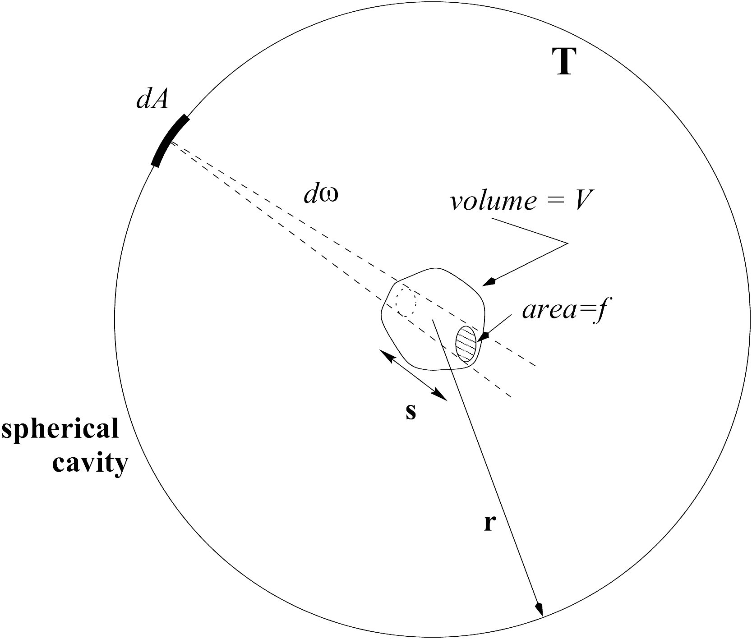

Figure 2: A schematic diagram showing the geometry required to relate the total emissive power of a spherical cavity of radius r at a temperature T and the energy density inside the cavity.

Consider a patch of area dA on the wall of the cavity as shown in Fig. 2. How much energy does the surface area dA emit into the volume V? The total solid angle subtended at dA by V may be broken into a sum of infinitesimally small solid angles dω=f/r2 where f is the area on the volume V subtended by dω.
Calculating the radiant energy over all wavelengths emanating from the surface element dA and entering a small cone of solid angle dω= (whose axis is normal to the element dA) in a time dt defines the energy emitted by the surface dA on the cavity wall

KdωdtdA , (15)

where K is defined as the emissive power of the surface dA.
If s is the length of the small truncated cone cut from V by dω, then the time taken by radiation traveling at a velocity c from dA to pass through V is dt=s/c. We therefore have an expression in terms of K for the total energy contained in the truncated cone subtending dω

$K\frac{\text{fs}}{r^{2}c}\text{dA}$ . (16)

This result must be summed over the entire solid angle subtended by V, giving

$K\frac{\text{dA}}{{\text{cr}}^{2}}\sum{\text{fs}=K\frac{\text{dA}}{{\text{cr}}^{2}}V}$ (17)

for the energy emitted from the surface area dA contained in the volume V. To find the energy content due to all dA’s covering the entire cavity, we must integrate over the cavity. For a spherical cavity, this gives

$\text{Energy in V}=\frac{\text{KV}}{{\text{cr}}^{2}}\int_{0}^{2π}{dφ\int_{0}^{π}{{πr}^{2}\text{sin}θdθ}}$ . (18)

Since the energy density U is defined as the energy in V divided by V, this last equation implies that

$U=\frac{4πK}{c}$. (19)

Finally, using Eq. 14, an expression for the emissive power of a black-body cavity is obtained

$πK=\frac{\text{bc}}{4}T^{4}={σT}^{4}=R$ , (20)
where R is defined as the cavity radiance (in W/m2) and σ≡$\frac{\text{bc}}{4}$ is now known as the Stefan-Boltzmann constant.
Later theories by Planck in the early 1900’s showed that σ could be expressed solely in terms of fundamental constants, with the result that the best value of σ, circa 1986, is given by

$σ=\frac{2π^{5}k_{B}^{4}}{\text{15}h^{3}c^{2}}=5\text{.}\text{67051}±0\text{.}\text{00034}×{\text{10}}^{−8}{\text{Wm}}^{−2}K^{−4}$. (21)

In practice, any object (not necessarily a hollow cavity) heated to a temperature T emits radiation. Experiment shows that the maximum power radiated per unit area comes from a cavity and is specified by Eq. 20. The radiance of any arbitrary object held at temperature T is specified by the non-ideal black-body formula

R=εσT4 , (22)

where ε is known as the emissivity of the emitting object. By definition, an ideal black-body has ε=1. Every material has a characteristic emissivity; for instance, tungsten has ε=0.2.

Experimental Considerations:
It is difficult to accurately measure the total emissive power radiated from a black-body. This would require a detector that collects the radiation emanating from the black-body in all directions. In general, only a small fraction of the emitted energy can be collected. Therefore, careful attention must be paid to the geometrical arrangement of the black-body and detector in order to allow a correct interpretation of the data. Also, careful measurements must take into account any energy absorbed by the intervening air column, which can be difficult to control if air conditioners or fans are continually circulating air through the laboratory room.
In addition, a broad-band detector must be designed to accurately measure the incident power over a wide range of wavelengths. In this experiment, you will use a thermopile to accomplish this function. A thermopile is a blackened disk of known dimension that is thermally anchored to a series of thermocouple junctions. A thermocouple is a junction formed when two wires, each made from a dissimilar metal, are joined together in an intimate fashion. A thermocouple junction is known to develop a voltage across it which depends on temperature. In this way, the temperature of the disk can be measured in terms of a voltage difference that develops across a thermocouple junction. A thermopile refers to a number of thermocouple junctions connected in series (see Fig. 3). This serves to increase the voltage output of the device, allowing more accuracy in any measurement.
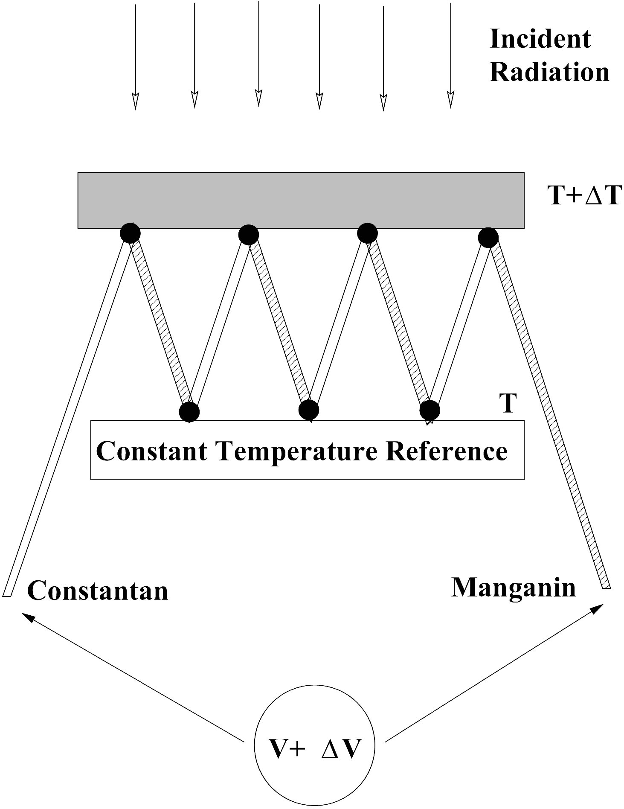
Figure 3: A schematic diagram showing the essential elements of a thermopile comprised of 4 thermocouple junctions made from constantan-manganin wire.

A thermopile must be calibrated by the manufacturer. Using this calibration, a measured thermopile voltage can be converted into an incident power (or energy flux if the active area of the thermopile is known). For the thermopiles that you will use, the calibration is between ∼30 μV/(Wm-2) and ∼70 μV/(Wm-2) for homogeneous irradiance of the front surface (see the Appendix). The Moll’s thermopile has sixteen thermocouples comprised of constantan and manganin wires connected in series. It is sensitive to radiation spanning a range from 150 nm to 15 μm and has a response time of 2-3 seconds.
A schematic diagram of the relevant geometry employed in this experiment is sketched in Fig. 1. A1 is the area of a hole through which the black-body radiation emerges and A2 is the area of the thermopile detector. The detector is separated from the cavity opening by a distance D. The energy leaving A1 in unit time is

Pout=RA1 . (23)

This energy is distributed over a half-sphere. While the radiative emission density within the body is uniform and isotropic, the amount of radiation which escapes from the hole will have angular dependence – it will be largest in the direction which is normal to the plane of the hole, and will decrease as the angle ϕ between the normal and the direction of observation increases as the “observed” crossection of the hole decreases.

Figure 4. The sketch demonstrating that the effective area of the hole depends on the observation angle ϕ.

The power density on the detector W=dP_{in}/dA_{in} will be proportional to the observed area of the hole (Fig. 4):

W(ϕ)=k A₁cos(ϕ), (24)

where k is proportionality coefficient.
Integrating this equation over half-sphere should give total energy leaving black body through the hole:

$P_{\text{out}}=\int_{0}^{π/2}{W⋅\left(2πD\text{sin}\left(ϕ\right)⋅\text{Dd}ϕ\right)}$ (25)
where $\left(2πD\text{sin}\left(ϕ\right)⋅\text{Dd}ϕ\right)$ is the area of an infinitely small stripe on the sphere of radius D at angle σ to the normal. Integrating (25) we have :

$\begin{aligned}P_{\text{out}}=\int_{0}^{π/2}{{\text{kA}}_{1}\text{cos}\left(ϕ\right)⋅\left(2πD\text{sin}\left(ϕ\right)⋅\text{Dd}ϕ\right)} \\ P_{\text{out}}=2π{\text{kA}}_{1}D^{2}\int_{0}^{π/2}{\text{cos}\left(ϕ\right)\text{sin}\left(ϕ\right)dϕ}\end{aligned}$

$P_{\text{out}}=2π{\text{kA}}_{1}D^{2}⋅\frac{{\text{sin}}^{2}\left(ϕ\right)}{2}|_{0}^{π/2}$
$P_{\text{out}}=π{\text{kA}}_{1}D^{2}$ (26)

Comparing (26) and (23) we have $k=\frac{R}{{πD}^{2}}$, and final expression for W is:
$W=\frac{{\text{RA}}_{1}}{{πD}^{2}}\text{cos}\left(ϕ\right)$ (27)

In the case when detector size is small compared to the distance D from black body to the hole cos(ϕ)=1, and expression (27) can be rewritten as:

$W=\frac{A_{1}}{{πD}^{2}}{σT}^{4}$ (28)

Thus a plot of the energy per unit time detected as a function of T4 should be a straight line if Stefan’s Law is true. It follows that the Stefan-Boltzmann constant can be determined from the best slope m through the data using

$σ=m\frac{{πD}^{2}}{A_{1}}$. (29)

Experimental Technique:
First, familiarize yourself with the data acquisition software that you will use with this experiment. The CASSY system is designed to allow flexible and easy data acquisition from this important radiation experiment.
Fig. 4 is a photograph of the assembled Stefan radiation equipment and Fig. 5 is a schematic wiring diagram.
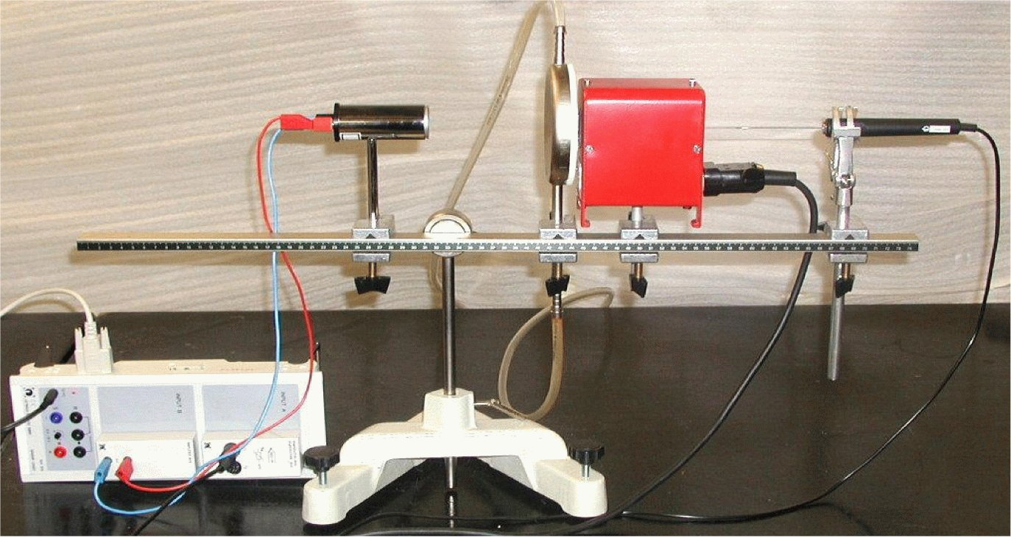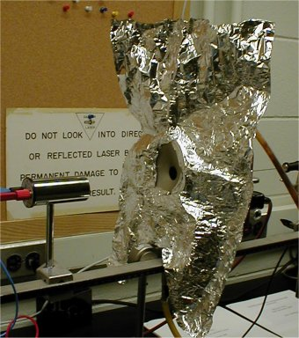
Figure 4: Left: a photograph showing the Stefan apparatus. The additional radiation shield (aluminum foil) is not shown but is essential for acquiring correct data (see text). Right: An additional radiation shield (aluminum foil).

Special black-body insert must be installed into the oven. The metal disk with the hole in front of the oven is cooled by water. Failure to keep it at room temperature will result in additional radiation emitted from the disk and will make the acquired data unusable. Use the small pump to circulate water through the disk. Since some of the parts of the oven are not covered by this disk, an additional radiation shield made of aluminum foil should be attached (Fig. 4, right).
Connect a variac to the oven (the black-body cavity) and insert a NiCr-Ni thermocouple into the back-side of the black-body insert. Position the thermopile approximately 0.15 m in front of the oven. Make sure you remove the protective glass cover from the entrance of the thermopile.
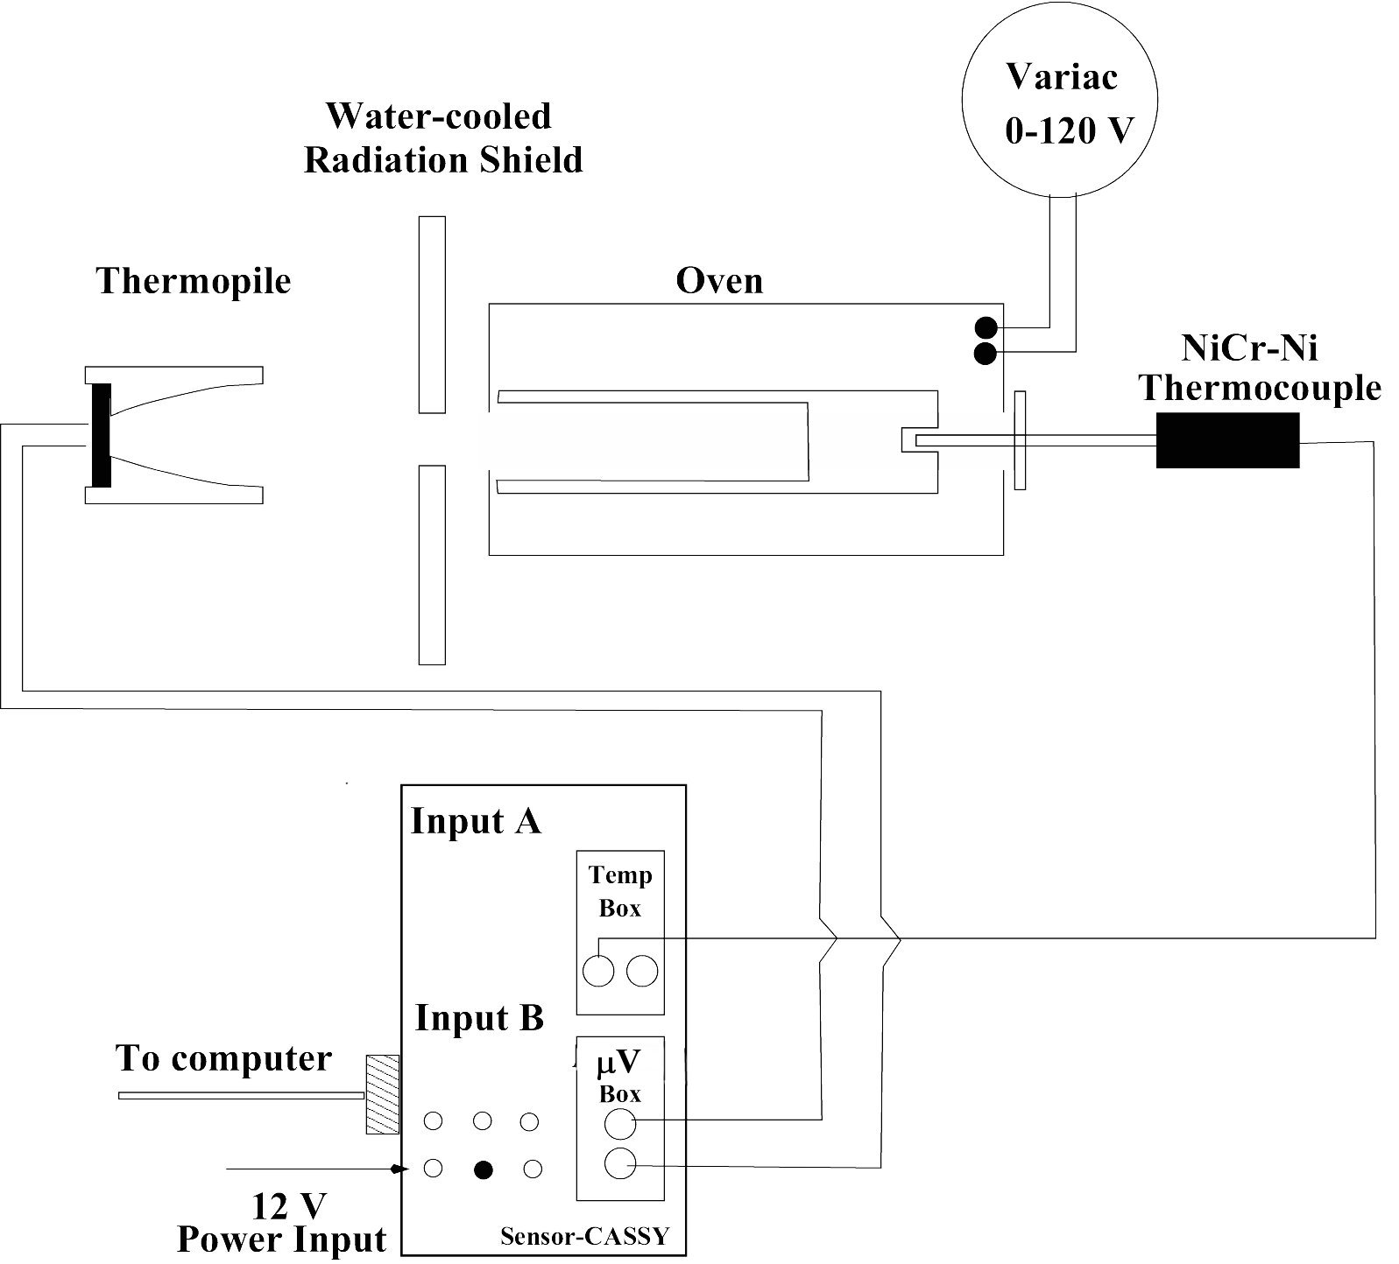
Figure 5: A schematic wiring diagram for the Stefan apparatus.

Data Acquisition Procedure:
(a) Record the thermopile output voltage with the oven at room temperature. At this time, make sure you know how to acquire data with the CASSY system. This measurement serves as the zero-point reference for all your future measurements. Set the distance D between the detector and the cavity opening to about 0.15 m. Also, be sure you write down the ambient temperature of the room.
(b) Set up the CASSY system to record the oven temperature and the thermopile voltage. Set the display to show temperature as x-axis and thermopile voltage as y-axis. Set the measurement interval to 500 ms and the recording condition to N=1 OR DELTA(&JA11)>2. The latter condition means that the measurement should be taken only when the first point is acquired (N=1) or when temperature (&JA11) increases by 2. See that the number of points to be accumulated is left blank, or set it to maximum possible value. Also, set the the measurement mode to Average 100 ms for both temperature and voltage detector. This eliminates your voltmeter noise.
(c) Start the measurement and turn the variac up to ∼100 V. At this setting it will take approximately 20 minutes for the temperature to reach 400 C. At the highest temperatures, the outside of the oven is HOT, so do not touch it. The data will be accumulated automatically.
(d) When the oven temperature reaches a constant temperature of approximately 400 C, stop the measurement and decrease the variac voltage to ~90V. Save the data you just acquired.
(e) See that the temperature stabilizes at ~400C, tune the variac voltage slightly down if temperature keeps rising, or up if it goes down (by few volts). Note that it may take a minute or so before changes in voltage reflect in temperature change. Once temperature is reasonably stable make a series of measurements in which you vary the distance between the thermopile and the entrance to the black-body. Be sure to cover distance between ~5 cm to the full length of the rail and acquire about 20 points. Remember to wait after each move before you take the measurement as the detector has long time constant.
(f) Choose another distance (greater than the 0.15 m used in step (b)) between the thermopile and the entrance to the black-body. Clear the recently accumulated data and set up the measuring condition to N=1 OR DELTA(&JA11)<-2. Start data acqusition, set variac to zero and turn off the variac. The new set of data will be recorded as the oven returns to room temperature.
(g) When you are finished, make sure you turn off the cooling water, replace the protective glass cover over the entrance of the thermopile, and copy any useful data onto a floppy disk for further analysis.

Data Analysis:
(a) Analyze your data as function of distance between the thermopile and the entrance to the black-body. How well does it follow a D-2 relationship expected from Eq. 28? For what values of D would you expect a D-2 behavior to accurately hold? For each distance, calculate the value of σ using equation 28. Plot results for calculated value of T as a function of distance. What can you say about this graph?
(b) Analyze your data as a function of temperature during the warming phase of the oven. Remember to correct your data for the energy radiated away from the thermopile detector at room temperature. This requires you to plot Pin(T)-Pin(TRT)
vs. (T4-TRT4) where TRT is the temperature of the room. From this plot, measure the slope and extract an estimate for the Stefan-Boltzmann constant. Alternatively, you may analyze the original data using equation 28, and estimate the value of σ from that. Calculate the value of σ for several temperatures and plot σ versus T. Is it constant? If not, what might be the reason?
(c) In the same way, analyze your data as a function of temperature during the cooling phase of the oven.
(d) Tabulate your two estimates of σ in a clear way. What is your best estimate for the Stefan-Boltzmann constant? Make sure you include a realistic discussion of errors in your measurements of A2 and D. What is the resulting uncertainty in σ?
(e) Discuss any significant sources of unaccounted error that you believe are relevant to this experiment? Is it possible that these errors account for the difference between your measured value of σ and the accepted value?
Appendix: Moll’s Thermopile Calibrations

specs Calibrated by SS
• Serial No. 999415: 35.5 μV/(W m-2) 52±5 μV/(W m-2)
• Serial No. 009561: 44.3 μV/(W m-2) 66±5 μV/(W m-2)
• Serial No. 009562: 63.4 μV/(W m-2) 92±5 μV/(W m-2)
• Serial No. 009576: 39.7 μV/(W m-2) 59±5 μV/(W m-2)

