RR 9/00
SS 12/01
Physics 342 Laboratory
The Electronic Structure of Solids:
Electrical Resistance as a Function of Temperature

Objective: To measure the temperature dependence of the electrical resistance of a metal and semiconductor and to interpret the observed behavior in terms of the underlying band structure of the solids.

Apparatus: Electrical furnace, NiCr-Ni thermocouple, variac power supply for furnace, CASSY power/interface, current module (524-031), thermocouple module (524-045), computer, Pt resistor, semiconductor resistor.

References:
1. W. Pauli, Z. Physik 31, 373 (1925).
2. E. Fermi, Z. Physik 36, 902 (1926).
3. P.A.M. Dirac, Proc. Roy. Soc. London A 115, 483 (1926).
4. E. Wigner and F. Seitz, Phys Rev. 43, 804 (1933) and Phys. Rev. 46, 509 (1934).
5. N.F. Mott and H. Jones, The Theory of the Properties of Metals and Alloys, Oxford University Press, Oxford, 1936.
6. D. Halliday, R. Resnick and J. Walker, Fundamentals of Physics; 5th Edition, Wiley and Sons, New York, 1997; Part 5, pgs. 1053-69.
7. K. Krane, Modern Physics, 2nd Ed., Wiley and Sons, New York, pgs. 309-29 and pgs. 344-62.

Introduction
An understanding of how much current flows through a conductor for a given applied voltage resulted from Georg Ohm’s thorough work in 1827. The empirical relationship known as Ohm’s Law has remained valid over the years and is still widely used today. Although Ohm’s work focussed primarily on metals, studies by Seebeck in 1821 and by Faraday in 1833 reported anomalies in current flow through a class of materials we now know as semiconductors. Interestingly, the temperature dependence of current flow measured by Faraday in semiconductors was quite different than the temperature dependence of current flow in metals first reported by Davy in 1820. The fundamental origin of this difference remained unexplained for about a century until the development of quantum mechanics.
Following the successful quantum theory of electronic states in isolated atoms, attention turned toward a better understanding of electronic states in molecules and solids. Only with the completion of this effort was it possible to understand the implications of the simple observations about the temperature dependence of current flow made in the early 1800s.
It is now well established that any property of a solid, including its electrical resistance, is in some way controlled by the electronic states of that solid. As a way of introducing the important differences between the electronic structure of metals and semiconductors, you will measure the temperature dependence of the electrical resistance of samples made from these two important classes of materials. Before beginning these measurements, it is useful (without paying undue attention to many of the details) to review i) the modifications to electron states as we move from the atomic to the molecular to the solid state and ii) a simple physical model for current flow in solids.

Theoretical Considerations
A. Electronic Structure
The important features of an isolated atom are a nucleus surrounded by a complement of electrons that are associated with it in a specifically defined manner. The Pauli exclusion principle requires these electrons to be non-uniformly distributed around the nucleus in regions of space, forming ‘shells’ of charge known as atomic orbitals. The total negative charge of the electrons exactly balances the total positive charge contained in the nucleus. Most importantly, the electrons, because they are confined to a limited region of space, acquire quantized energy levels.
As atoms are brought together to form a molecule, the outermost electrons from one atom will interact with the outermost electrons of a neighboring atom. This interaction is subtle and a variety of theories have been devised to explain it accurately. The end result is a profound modification to the allowed energies and spatial arrangement of the electronic states.

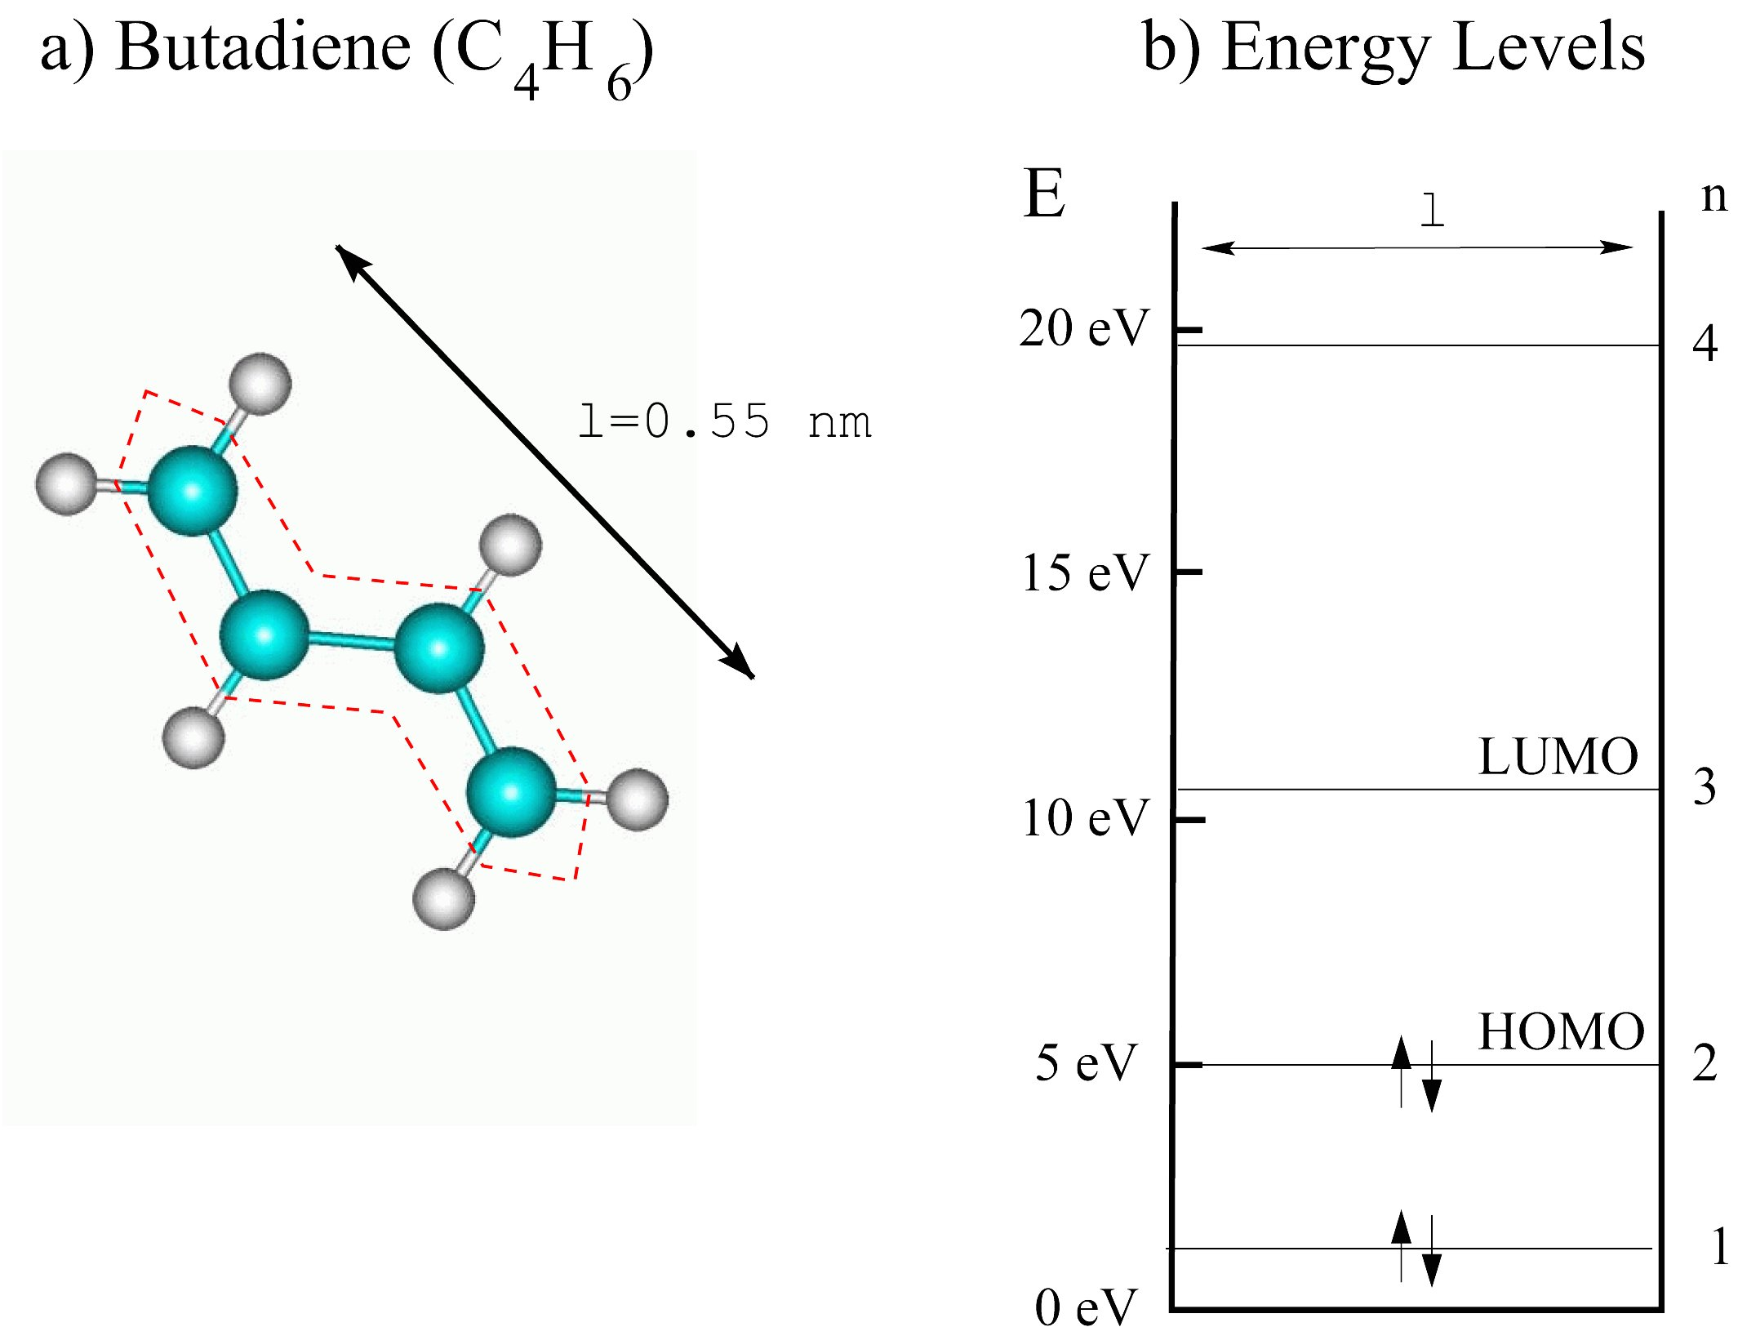
Figure 1: In a), a schematic diagram of a butadiene molecule C4H6. The bonding electrons are indicated by the heavy sticks between atoms. The delocalized electrons, which extend both above and below the plane of the diagram, are schematically indicated by the dotted path along the length l of the butadiene molecule. In b), the allowed energies for the electrons in the molecule assuming l is 0.55 nm. The two lowest states are filled. Higher vacant energy states (n=3, 4, 5 . . ) are available for occupation. The HOMO (highest occupied molecular orbital) and the LUMO (lowest unoccupied molecular orbital) are also labeled.

To understand the nature of these modifications, it is useful to briefly consider a simple molecule like butadiene (C4H6). This molecule is a coplanar arrangement of 4 carbon atoms combined with six hydrogen atoms. Each carbon atom contributes 4 electrons; each hydrogen atom contributes 1 electron. During the synthesis of this molecule, interactions between electrons cause a significant rearrangement of negative charge. Many of the electrons become localized in regions of space that lie between two atoms, forming states known as σ bonds. These states are covalent in nature and are fully occupied, containing a charge equivalent of two electrons. The negative charge carried by these σ bonds effectively screens the electrostatic repulsion that is present between the atomic nuclei.
Each carbon atom brings one more electron than required to form the 9 σ bonds in butadiene. These extra electrons assume the lowest energy configuration possible which results in a delocalized occupied state referred to as a π orbital in the molecule. A schematic picture of these two different electron states is given in Fig. 1(a). As will become clear below, because of the delocalized nature of these π states, one might conclude that the butadiene molecule forms an extremely simple example of a tiny one-dimensional metal. If one could somehow connect clip leads to either end and apply a potential across it, one might expect current to flow through a single butadiene molecule in much the same way as it does through a copper wire!
As suggested in Fig. 1(a), the π electrons are confined to an extended region of space of length l by the attraction of the positively charged nuclei. Within this region of space, the π electrons are free to wander about. Whether this space has a zig-zag nature or is perfectly straight is not of much consequence here. The important point is that whenever electrons are delocalized over a finite region of space, they take on quantized energy values. The allowed energy levels En can be estimated using the well known particle-in-a-box result

$E_{n}=n^{2}\frac{h^{2}}{8{\text{ml}}^{2}}$ (1)

where n is an integer quantum number, h is Planck’s constant and m is the electron’s mass.
Let us now find the number of electrons which occupy the quantized π electron states. If each carbon atom brings 4 electrons and each hydrogen atom brings one, then the butadiene molecule has a total of 22 electrons. Of these 22 electrons, 18 are tied up in forming the σ bonds. Thus there must be four electrons occupying the π electron system. Furthermore, the Pauli exclusion principle allows only two electrons at each possible energy. A schematic of the resulting energy states and their occupation can be sketched as shown in Fig. 1(b).
This simple discussion has a number of similarities with the more complicated situation when ~1023 atoms per cm3 are brought together to form a solid. These similarities include:
• the existence of a pool of delocalized electrons,
• the existence of quantized energy states,
• the occupation of a certain fraction of these quantized states, and
• the presence of an energy gap between the highest occupied molecular orbital (HOMO) and the lowest unoccupied molecular orbital (LUMO).
All of these basic principles are important when qualitatively discussing the electron states of a three-dimensional solid. To simplify the discussion, it is convenient to partition the solid into ‘atomic-cells’ known as Wigner-Seitz cells. Each atom in the solid will be surrounded by a Wigner-Seitz cell which takes on an interesting geometrical shape dictated by the exact arrangement of atoms in the solid as shown in Fig. 2.

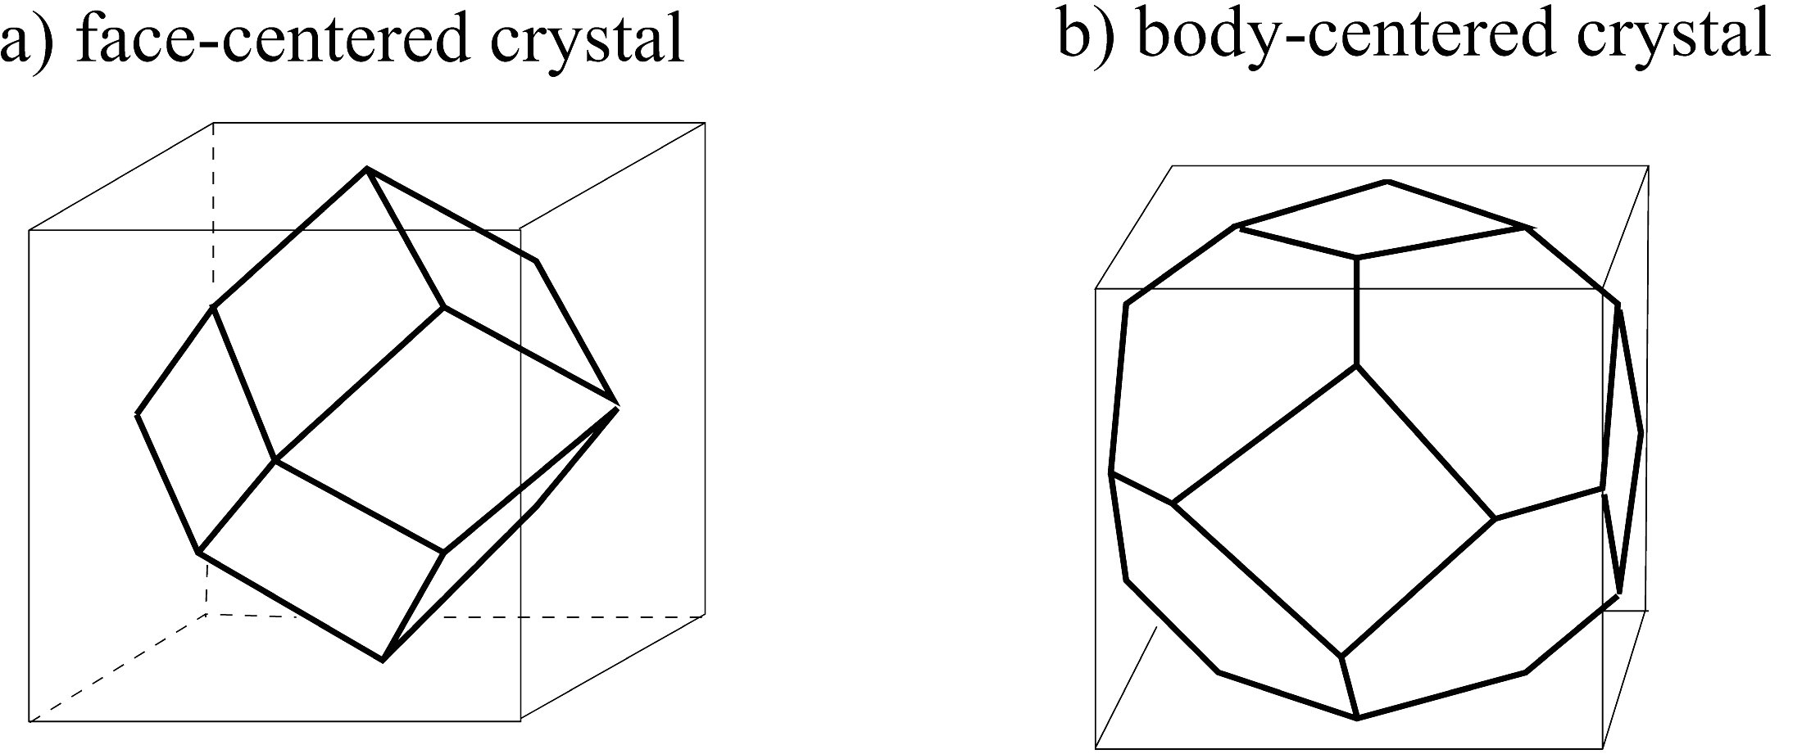
Figure 2: Wigner-Seitz cells for a) a face-centered cubic crystal structure and b) a body-centered cubic crystal structure.

The degree of interaction between all the electrons in the solid is now enormously complicated and depends not only on the shape, range and density of the relevant atomic orbitals but also the exact geometric arrangement of the atoms forming the solid. If it turns out that for a particular atomic shell configuration, certain electrons are localized to a region of space near the center of a Wigner-Seitz cell, then little modification to these electron states will result. These states will be dominated by the nucleus and will strongly resemble isolated atomic states. If, on the other hand, certain electrons become concentrated outside the nucleus, near the boundaries of a Wigner-Seitz cell, then these electron states will be governed by new boundary conditions and their allowed energy levels will change accordingly.
The ability to predict the modifications to different atomic orbitals when atoms are condensed into a solid is now well established, thanks to extensive work spanning a fifty year period beginning in the 1930’s. The results of these studies indicate three predominant orbital types (s/p, d and f) that exhibit different behavior as more and more atoms are brought together. The trends exhibited by these three different orbital types are shown schematically in Fig. 3.
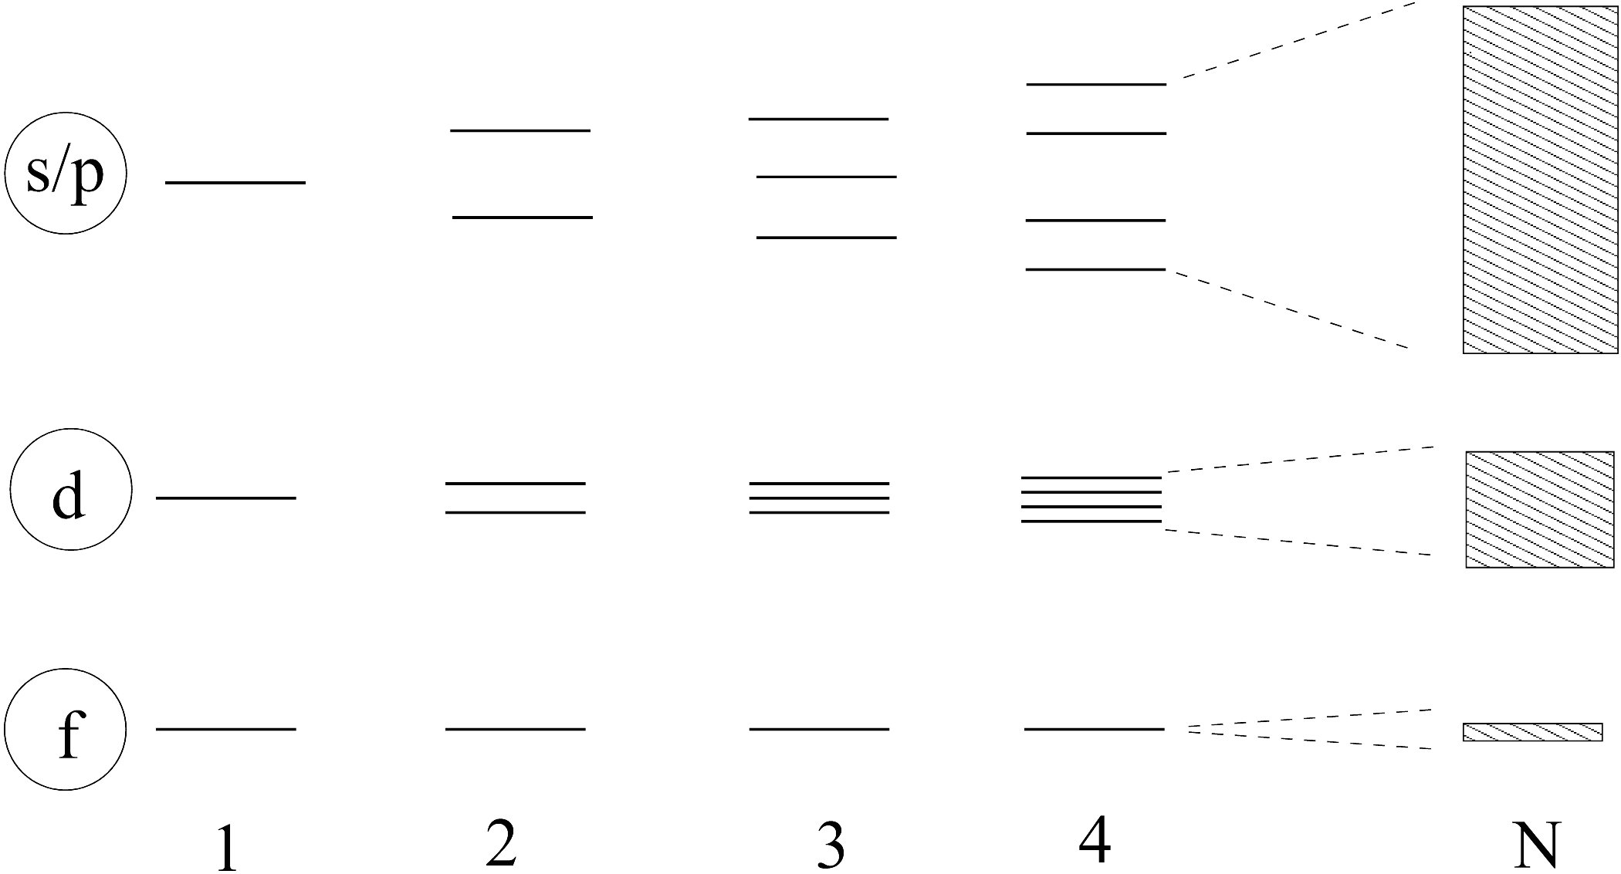
Figure 3: A schematic to illustrate the evolution of energy states in progressing from 1, 2, 3, . . . to N atoms. When N is large, the separation between electron states is so small that a continuous band of energies is formed. The s/p, d, and f classification scheme is not a rigid one, but is useful for descriptive purposes.
For electrons having atomic s/p and and d character, there are appreciable interactions between electrons located in the edges of the Wigner-Seitz cells, causing the energy of each and every atomic orbital to shift slightly from its well defined atomic value. The resulting perturbed states are separated from each other by a very small energy difference (on the order of 10-8 eV). These perturbed states are said to form a continuous ‘band’ of energies between well-defined upper and a lower limits. These energy bands profoundly control the electronic properties of all solids. The width of each band is largely determined by the degree of interaction between the atomic states that populate them. Strong interactions result in wide s/p bands; weak interactions produce narrow d or f bands. The energy gaps between the bands are a reflection of the separation in energy between the discrete atomic states of an isolated atom. The population of each band is determined by the number of excess electrons left over after the bonding of each atom, one to the other, has been accomplished.
A consequence of this picture is that a simple phenomenon, like the passage of current through a material, will depend on what electronic states are available to carry the current. In turn, the available states are determined by whether a band is partially or completely filled. In addition, the statistical nature of exciting an electron from a filled to a vacant energy level must be properly taken into account. Surprisingly, the ability of a specific solid to carry current as a function of applied voltage and temperature is determined by all of these factors discussed above.

B. Ohm’s Law
Electron conduction in a solid is governed by the empirical result discovered by Ohm in 1827 which states that the current density J is related to the applied electric field E by the relation

J=σE . (2)

The proportionality constant σ is known as the electrical conductivity of the solid through which the current flows. (To simplify the discussion, we neglect the inherent vector nature of J and E and the subsequent tensor nature of σ.) Ohms Law is often stated in terms of an applied voltage V and the resulting current I as

$V=\frac{ρL}{A}I=\text{RI}$ (3)

where A is the cross-sectional area (assumed to be uniform over the the length L of the solid) and ρ=σ-1 is known as the resistivity of the material. The factor $\frac{ρL}{A}$ is identified as the resistance R of the material under study.

C. Toward a Microscopic Theory
The first question confronting anyone trying to construct a microscopic model for current flow is ‘How do you treat the electrons? ’ Are they particles or waves? Many models have been developed which answer this question in a variety of different ways. The most complete models are quantum mechanical and treat the electron as a wave. The more intuitive models treat the electron as a particle. In what follows, we adopt this latter approach.
At a microscopic level, current is ultimately related to the directed motion of charge carriers (electrons) having a charge q. An important question is the net number of the charge carriers crossing a fiducial plane per unit time. This question can be answered from rather elementary considerations.
Electrons have a velocity (∼105 m/s) which is related to their energy in the solid. However, these velocities cause no net displacement of the electrons in a material since on average, there are as many electrons traveling in any one direction as in the opposite direction. Thus, the velocity related to the electron’s energy is not effective in producing a net current flow. The situation changes when an electric field E is applied. Now electrons are accelerated by the electric field and each electron acquires an additional component of velocity, vd - the so-called drift velocity (∼5×10-3 m/s in a field of 1 V/m), due to the applied electric field.
The current density can be written as the product of the number of charge carriers per unit volume n and the mean drift velocity vd imposed by the applied electric field:

J=nqvd . (4)

Comparing Eqs. 1 and 2 gives the result that

$σ=\frac{{\text{nqv}}_{d}}{E}$. (5)

Treating the electron’s as independent particles, the equation of motion for a charge carrier of mass m in an electric field is given by

$m\frac{{\text{dv}}_{d}}{\text{dt}}=\text{qE}$ . (6)

Since there are many carriers participating in current flow, it is reasonable to expect that each charge carrier will experience many collisions as it travels through a solid. For this reason it makes sense to statistically define a mean time τ between collisions. Alternatively, you can define a drift mean free path ld=vdτ which is a measure of how far the charge carrier will drift between collisions.
With this definition, an estimate for the mean drift velocity of a charge carrier is given by

$v_{d}=\frac{{\text{dv}}_{d}}{\text{dt}}τ=\frac{\text{qE}}{m}τ$. (7)

One finally has

$σ=\frac{{\text{nq}}^{2}τ}{m}=\frac{{\text{nq}}^{2}l_{d}}{{\text{mv}}_{d}}$ (8)

or, equivalently,

$σ=\frac{{\text{mv}}_{d}{\text{nq}}^{2}l_{d}}{{\text{nq}}^{2}l_{d}}$. (9)

From this expression for ρ, the resistance R of a material can be calculated if the geometry of the sample is known (see Eq. 3).
The task at hand is to develop a model for the temperature dependence of the resistance of a material. This can be accomplished by considering the temperature dependence of each term in Eq. 9.

D. Temperature Dependence of Electrical Resistance for a Metal
To evaluate the various factors appearing in Eq. 9 for a metal, we must have a good model to calculate the relevant quantities. This is difficult when you must take into account ∼1023 electrons per cubic centimeter. Under these circumstances, the best way to proceed is to use statistics.
Since electrons are fermions, Fermi-Dirac statistics must be used (see the Appendix). The mean number of electrons in any state with energy E is given by 2×f(E) where f(E) is the Fermi-Dirac distribution function and the factor of 2 is due to the two available values for spin of an electron. As the energy of the electrons increases above the bottom of a band, the number of available states increases. Each state can hold two electrons. These states are filled until all electrons in the band are used. A rather abrupt transition from filled to unfilled states then takes place at an energy called the Fermi energy. A consequence of Fermi-Dirac statistics is that at 0 K, all states less than the Fermi energy EF are filled and all states above EF are empty.
As the temperature is raised above 0 K, electrons just below EF can be thermally excited to unfilled states just above EF. States affected by this transition are located roughly within a ±2kT range about EF.
An important issue is the location of the Fermi energy with respect to the energy bands of a metal. What we know by counting available states is that for most metals, the Fermi energy is located somewhere inside a band. Furthermore, typical values of EF are much greater than kT for temperatures easily attainable in a laboratory. This implies that only a small number of unfilled electron states within ±2kT of EF are readily accessible by thermal excitation. This important insight is indicated on the schematic diagram in Fig. 4. Under these circumstances, you can show that n is essentially independent of temperature. Furthermore, vd is essentially independent of temperature and very nearly the same for all electrons within ±2kT of EF. It follows that the temperature dependence of ρ is determined by the temperature dependence of the mean free path ld.

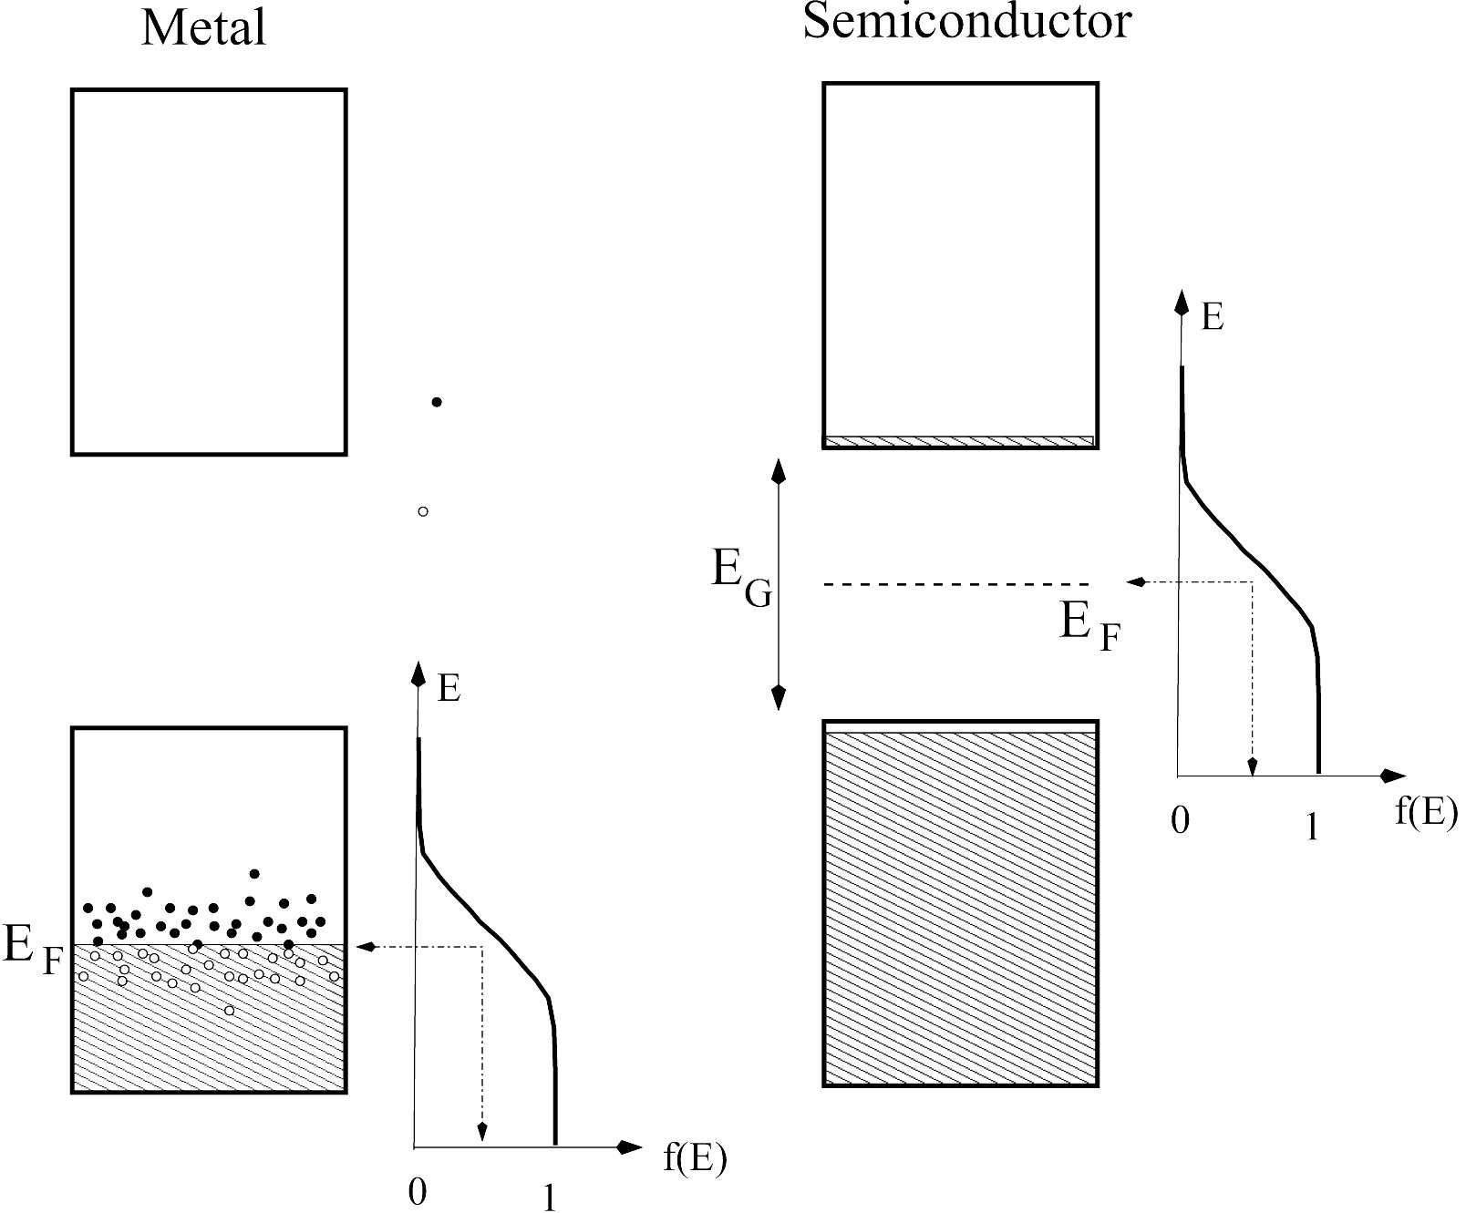
Figure 4: The location of the Fermi energy in a metal and semiconductor. The Fermi-Dirac distribution function at finite temperatures is also indicated. As the temperature increases more electrons occupy unfilled states above the Fermi energy. As suggested in the diagram, the main difference between a metal and a semiconductor is the location of the nearest unfilled states.

For temperatures near room temperature, it is reasonable to expect that ld will be determined by scattering from atoms undergoing thermal motion. A simple model predicts that ld is related to the cross-sectional area A occupied by atoms vibrating in the solid due to thermal motion. An estimate of this area can be obtained by assuming that an atom undergoes a rapid random vibration from its rest position by some amount r. It follows that

$A≃{πr}^{2}$. (10)

Treating the vibrating atom as an harmonic oscillator, the average potential energy of such an oscillator is proportional to the square of its displacement, r2. From the equipartition theorem, the average potential energy is also known to equal kT/2. It follows that A∝r2∝T. Since the mean free path will decrease as A increases, we might expect that ld∼1/A∼T-1. Thus in a metal, you might anticipate that the temperature dependence of the resistivity ρ will be given by

ρ(T)∝T . (11)

E. Temperature Dependence of Electrical Resistance for a Semiconductor
For a semiconductor, the situation is a bit more complicated. Semiconductors are characterized by filled energy bands. The nearest unfilled states to carry current are separated from the filled states by an energy gap EG (see Fig. 4). If EG>>kT, then n, ld, and vd all become temperature dependent.
Under these circumstances, Fermi-Dirac statistics in principle still apply except the Fermi energy is now located at a distance EG/2 above the edge of the filled band (often called the valence band). This situation is shown in Fig 4(b). For energy gaps such that EG>>kT, the number of electrons in the unfilled states is quite small and the Fermi-Dirac distribution is well approximated by the Maxwell-Boltzmann distribution function as discussed in the Appendix.
Using Maxwell-Boltzmann statistics, the carrier concentration follows a thermal excitation model since no unoccupied states are available unless an electron is excited across the energy gap. Within this model, the probability of an electron being excited by an energy W is given by

n=noe-W/kT (12)

where W, the activation energy, turns out to equal EG/2.
Because the nearest unfilled states that carry current are now far up the tail of the Fermi-Dirac distribution curve, a Maxwell-Boltzmann analysis of the most likely drift velocity is required. It is well known that this analysis gives a most probable velocity that scales as T1/2. Equivalently, for a dilute gas of electrons, the drift velocity vd can be estimated from an equipartition of energy argument which also gives vd proportional to T1/2. The mean free path may again be taken proportional to T-1, following the same arguments given above.
Putting all this together gives the temperature dependence of ρ for a semiconductor as

$ρ\left(T\right)\text{\sim }T^{3/2}e^{{E_{G}}/2\text{kT}}$ . (13)

Note that for small variations in T, the temperature dependence of the exponential term is usually the dominant factor.
It should be mentioned that this discussion is approximately valid for a pure semiconductor (often called an intrinsic semiconductor). If the semiconductor contains significant impurities, then additional energy levels are introduced and the above discussion must be modified to take them into account.

F. Summary
An understanding of the temperature dependence of the resistance of metals and semiconductors requires an appreciation of the energy states in a solid. In addition, a transport model for current flow must be in place. In the discussion above, a number of simple approximations have been used in order to give a framework for estimating the temperature dependence of the resistivity. The striking difference expected for the temperature dependence of the resistance between metals and semiconductors forms the motivation for the measurements that will be performed.

Experimental Considerations
There are a number of techniques to measure electrical resistance R of an unknown resistor and each technique has its advantages and disadvantages. The two most common methods employed in accurate measurements of R are known as the 2-wire and 4-wire techniques as illustrated in Fig. 5. Although it may seem trivial, it is important to understand the differences between these two techniques.

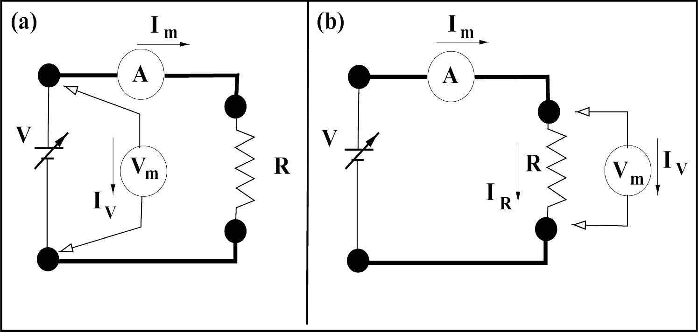

Figure 5: (a) A 2-wire measurement of resistance (note only TWO wires are connected to the resistor) showing the relative position of the ammeter and voltmeter with respect to the resistor R. The voltmeter reads a voltage Vm and the ammeter reads a current Im. (b) A 4-wire measurement of resistance. Note that FOUR wires are connected to the resistor. Once again, the voltmeter reads a voltage Vm and the ammeter reads a current Im. In both cases, the heavy lines represent the lead wires from the voltage source to the resistance being measured.

In the 2-wire method (see Fig. 5(a)), a voltmeter is connected across a voltage source and the current flowing to a resistor R is measured with an ammeter. If the voltmeter measures a voltage Vm and the ammeter measures a current Im, then the measured resistance Rm is given by Vm/Im. Ideally, Rm should equal R, but this may not be the case. The difficulty is that the ammeter has an internal resistance ra and the wires between the voltage source and the resistor have a resistance rw. Thus, Vm includes not only VR, the voltage dropped across the resistor R, but also va, the voltage dropped across the ammeter, and vw, the voltage dropped across the wires in the circuit. So, Vm=VR+va+vw, and the measured resistance will not be R but

$R_{m}=\frac{V_{m}}{I_{m}}=R+(r_{a}+r_{w})$ . (14)

From this we see that the resistance measured using a 2-wire method inevitably includes the resistance of the ammeter and lead wires. If the sum of these two resistances is comparable to R then serious inaccuracies will result. The common ohmmeter uses this 2-wire technique and gives an accurate measure of R only if R is large compared to rw.
In a 4-wire scheme, the voltmeter is connected directly across the resistor R and now the reading on the voltmeter, Vm, is the voltage drop across the resistor. The ammeter measures Im, the total current flowing through the circuit. However, because the voltmeter is in parallel with the resistor R, the measured current Im splits (see Fig. 5(b)) into two parts: IR, the current through the resistor, and IV, the current through the voltmeter. Clearly, Im=IR+IV. Since the voltmeter is connected in parallel across the resistor, the voltage drops across these two objects must be the same. This gives IVRV=IRR, where RV is the internal resistance of the voltmeter.
Again, the measured resistance Rm is given by Vm/Im. This implies that when using a 4-wire technique, the measured resistance is not simply R but

$R_{m}=\frac{V_{m}}{I_{m}}=\frac{V_{m}}{I_{R}+I_{V}}=\frac{R}{1+R/{R_{V}}}≈R(1−\frac{R}{R_{V}}+\text{.}\text{.}\text{.})$ (15)

As long as RV is considerably greater than R, the difference between Rm and R is small. Note that the 4-wire technique removes any inaccuracies introduced by the resistance of lead wires and ammeters (see Eq. 14).
From this discussion it should be clear that difficulties can arise when ammeters and voltmeters are connected to circuits. In principle, the internal resistance of the voltmeter should be much higher than the resistance of any resistor that it is connected across. In addition, the internal resistance of the ammeter should be much less than the resistance of any resistor that is under study. If these conditions are not satisfied, then the presence of the meters might seriously perturb the measurement of resistance. Modern digital voltmeters and ammeters have internal resistances that usually satisfy both these conditions.

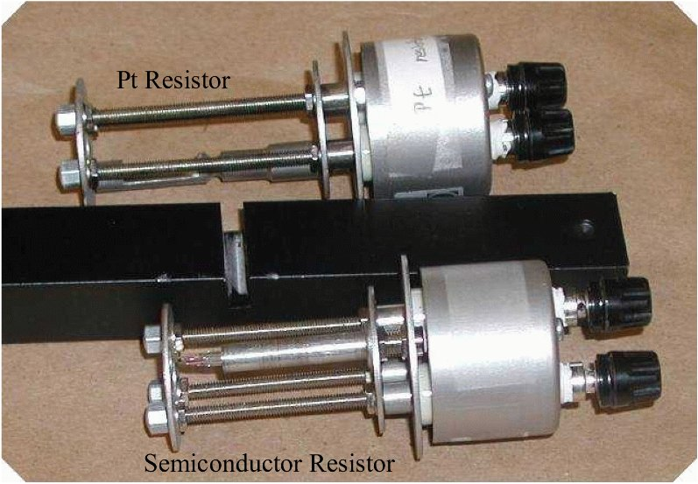
Figure 6: A photograph of the Pt and semiconductor resistors and sample holders.

Experimental Equipment
In this experiment, you will measure the temperature dependence of a Pt wire and a commercially available resistor made from semiconducting material. Fig. 6 is a photograph of the sample holders used in this experiment. These holders must withstand the high temperatures that will be used in this experiment. The Pt and semiconducting resistors are mounted at the left-hand end of these holders.
Fig. 7 is a photograph of the experimental apparatus showing the heating furnace with sample inserted, the thermocouple, a variac for heating the oven, and the CASSY interface that will be used to acquire data.
Make sure you know how the computer-controlled measuring apparatus works. What current is applied to the sample? Is it constant throughout the course of the experiment? Are you using a 2-wire or 4-wire technique?

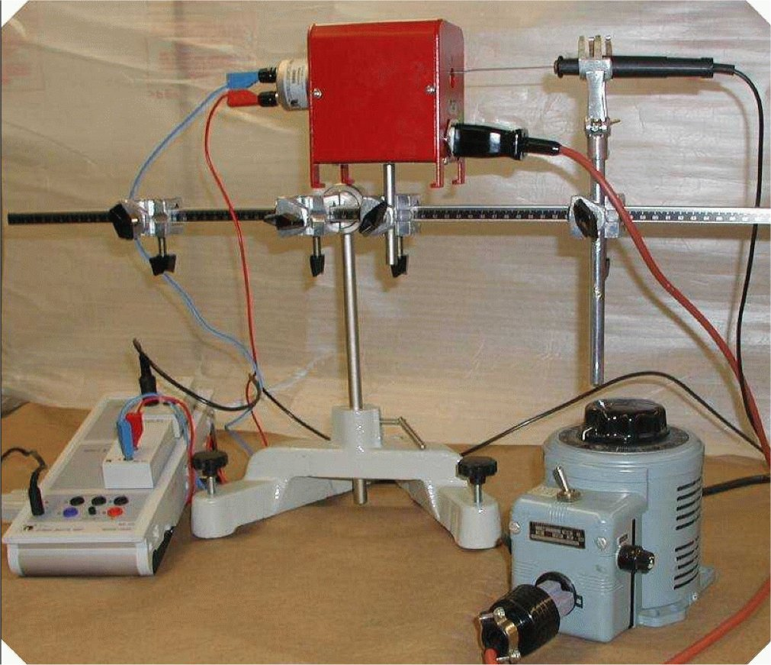
Figure 7: A photograph of the apparatus

Experimental Procedure
1. Measure the resistance of the Pt resistor as a function of temperature between room temperature and 350° C. Don’t exceed this temperature as damage to the Pt sample might result.
a) Insert the Pt resistor assembly into the oven. From the other side insert a thermocouple. You may want to insert it at some angle so that its end would touch the inside of the metal tube which houses the Pt resistor. This way the temperature of the thermocouple end will be as close to the temperature of the resistor as possible.
b) Set the CASSY interface as follows: display x-axis to show temperature and y-axis to display resistance; data acquisition time to 500 ms and condition to “N=1 OR DELTA(&JA11) > 2” (that will acquire data if it is the first point, or if the temperature becomes at least 2 degrees higher than at the time of previous measurement). Do not define the number of data points, or define maximum possible (16000). Set the CASSY ohmmeter limit to measure resistance of up to 300 Ω. The resistance of the Pt resistor should be about 100 Ω at room temperature.
c) Start the measurement and turn the variac ON and set voltage to ~100 V. The program will start taking measurements, one point for about every 2 C change.
d) Once temperature reaches 350 C turn the variac off, stop the data acquisition and save the acquired data.

B. Measure the resistance of the semiconducting resistor as a function of temperature between room temperature and 200oC. Again, be careful not to exceed this upper temperature limit. The resistance of the semiconducting sample at room temperature should be about 200 Ω. The composition of the semiconducting material used in the fabrication of this resistor is unknown. It is very likely that it is not made from an elemental semiconductor like Si or Ge.
If you decide to measure the resistance as the oven cools down change the measurement condition to “N=1 OR DELTA(&JA11) < -2”. Expect the resistance to change between ~8 and 300 Ohm (set the CASSY ohmmeter limits accordingly).

Data Analysis

A. Analyzing data from the Pt resistor
You may want to analyze the data using your favorite data fitting program, or perform data analysis using built-in CASSY-LAB fitting procedure.

- It is recommended to convert all temperatures from oC to K. If you choose not to do so you must update the fitting equations accordingly.
- Assume the resistance of the Pt resistor varies as R=aTβ (R=a[T+273]^{β} if T is in °C). Make a least square fit to your data leaving a and β free. How close is β to +1.00? Calculate the difference between your measured R(T) and your best fit. Plot this difference as a function of T. Do you find any systematic differences in this plot? Is the data randomly scattered about zero? Explain what you observe.
- Assuming temperatures near room temperature, the resistance change with temperature is usually specified by an equation of the form
$R(T)=R_{0}\left[1+γ\left(T−\text{273}\right)\right]$ (16)
What is the best value for the coefficients R₀ and γ? When you quote these values, make sure you clearly specify the temperature range over which they are accurate. How does you value of γ compare to the value typically listed in introductory physics textbooks (3.9x10⁻³ K⁻¹). Do you find any evidence that a higher order term proportional to T² is required?
- The resistivity of Pt at 273 K is 9.60x10⁻⁸ Ωm. Using this value and the constant R₀ obtained above, determine the ratio of L/A for your wire.

B. Analyzing data from the semiconductor resistor

- It is recommended to convert all temperatures from °C to K.

- Assume the resistance of the semiconductor resistor varies as
$R(T)=R_{1}{\left(\frac{T}{\text{273}}\right)}^{\frac{3}{2}}e^{\frac{E_{G}}{2\text{kT}}}$ (17)
Fit your data using this equation with R₁ and E_{G} as free parameters. Alternatively, you may make a plot of $\text{ln}\left[R(T)/{{\left(\frac{T}{\text{273}}\right)}^{\frac{3}{2}}}\right]$ vs T⁻¹, and use this graph to determine the best values of R₁ and E_{G}.
- What is the band gap energy of the semiconductor? Express this energy in eV units which are conventionally used to measure band gap energy.
- Make a more thorough analysis of your data. Calculate the difference between your data and best fit according to Eq. 17 as a function of T. Do you find any systematic differences between theory and data in this plot? Is the data randomly scattered about zero? Explain what you observe.
Appendix: Fermi Dirac Statistics

In the first studies (early 1900's) of the condensed state of matter, theories relying on a single average energy, a single average velocity, etc. were used to describe the physics of electrons in a solid. Later theories corrected this simplified approximation by using a Maxwell-Boltzmann distribution law to describe a gas of electrons. However, once it was realized that electrons obey quantum mechanics and the Pauli exclusion principle, a new quantum statistics was required. We now know that a gas of electrons (fermions) obeys Fermi-Dirac statistics.

For an ideal electron gas in thermal equilibrium with a heat bath of temperature T, the probability that an allowed state of energy E is occupied is given by

$f(E)=\frac{1}{e^{{\left(E−E_{F}\right)}/{\text{kT}}}+1}$ (18)

where the parameter E_{F} is defined by the energy at which f(E)=$\frac{1}{2}$. A plot of f(E) for three different temperatures is given in Fig. 8(a).

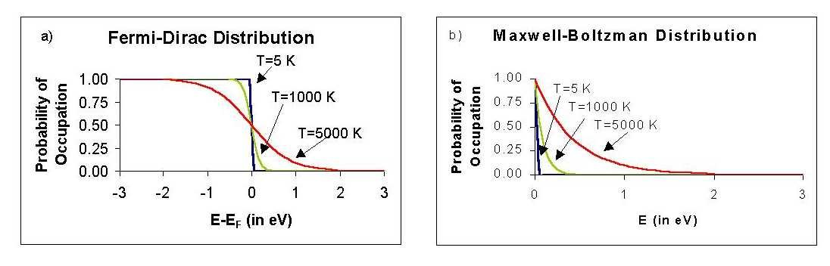
Figure 8. The Fermi-Dirac distribution function and b) the Maxwell-Boltzmann distribution function for temperatures of 5 K, 1000 K and 5000 K.

Note that when E>>E_{F} , the exponential term in the denominator of Eq. 18 dominates the additional factor of +1, and the Fermi-Dirac probability can be written as

$f(E)=\frac{1}{e^{{\left(E−E_{F}\right)}/{\text{kT}}}}=A×e^{\frac{−E}{\text{kT}}}$ (19)

Now f(E) closely approximates the form of the Maxwell-Boltzmann distribution function (see Fig. 8(b)), suggesting that the charge carriers can be viewed as a dilute gas of electrons. It turns out this approximation is valid when discussing electrons in the conduction band of an intrinsic semiconductor and provides a justification for the thermal activation model discussed in the Theory section above.

