RR July 2001
SS Dec 2001

Physics 342 Laboratory

Quantization of the Radiation Field: The Photoelectric Effect

Objective: To investigate how the photoelectric current depends on the intensity and frequency of incident light.

Apparatus: Hamamatsu R807 vacuum phototube in a brass enclosure; Kiethley Model 485 picoammeter, CASSY interface, a 3-volt d.c. battery; 100-ohm helipot; 125-watt General Electric concentrated filament light source and housing; meter stick; Edmund Scientific Interference filters for wavelengths: 546.1 nm, 577.1 nm, 589.6 nm, 656.3 nm, 671.0 nm; a knife switch and assorted hookup wires, flashlight.

References:
1. Hertz, Ann. Physik, 31, 983 (1887).
2. A. Einstein, Ann. Physik, 17, 132 (1905); 20, 199 (1906).
3. R.A. Millikin, Phys. Rev. 7, 362 (1916).
4. A.C. Melissinos, Experiments in Modern Physics, Academic Press, New York, 1966, pgs. 18-27.
5. D. Halliday, R. Resnick and J. Walker, Fundamentals of Physics; 5th Edition, Wiley and Sons, New York, 1997; Part 5, pgs. 987-989.
6. K. Krane, Modern Physics, 2nd Ed., Wiley and Sons, New York, 1996, pgs. 70-77.

Introduction:
In 1887, H. Hertz made the discovery that a metallic surface, when illuminated by light of short wavelength, emitted an electric current. In 1898, Lenard showed that the charge to mass ratio of the particles emitted from an illuminated metal was nearly the same as for the newly discovered electron reported by J. J. Thomson in 1897. Following this result, an enormous amount of data was collected in an attempt to better understand this curious electron emission phenomenon which we now call the photoelectric effect.
It quickly became apparent that the classical (wave) theory of light, developed by Maxwell in the 1860’s, was unable to explain many of the experimental facts surrounding the photoelectric effect. In 1905, Einstein provided a possible solution to this dilemma. In his classic paper discussing primarily black-body radiation, Einstein concluded that a beam of light having a frequency ν can act as if it consists of independent discrete particles (photons) each having an energy hν, where h is a proportionality factor now known as Planck’s constant.
By developing this theory, Einstein was one of the first to quantize the electromagnetic radiation field. Previously, because of the well established wave nature of light, electromagnetic radiation was not considered as a discrete, quantizable entity. Although later work (circa 1927) using classical electromagnetic theory provided alternative theories for the photoelectric effect, Einstein’s bold quantized photon hypothesis has prevailed. The importance of Einstein’s contribution was formally recognized in 1921 when he received the Noble Prize.

Theory:
The photoelectric effect occurs when electrons are emitted from a metallic surface irradiated by a suitable light source. Einstein’s explanation of this effect required the assumption that light is made up of particles, called photons, each carrying a definite energy specified by the formula

E=hν . (1)

A schematic of the photoemission process can best be understood by referring to Fig. 1, which illustrates the important concepts underlying the photoelectric effect.

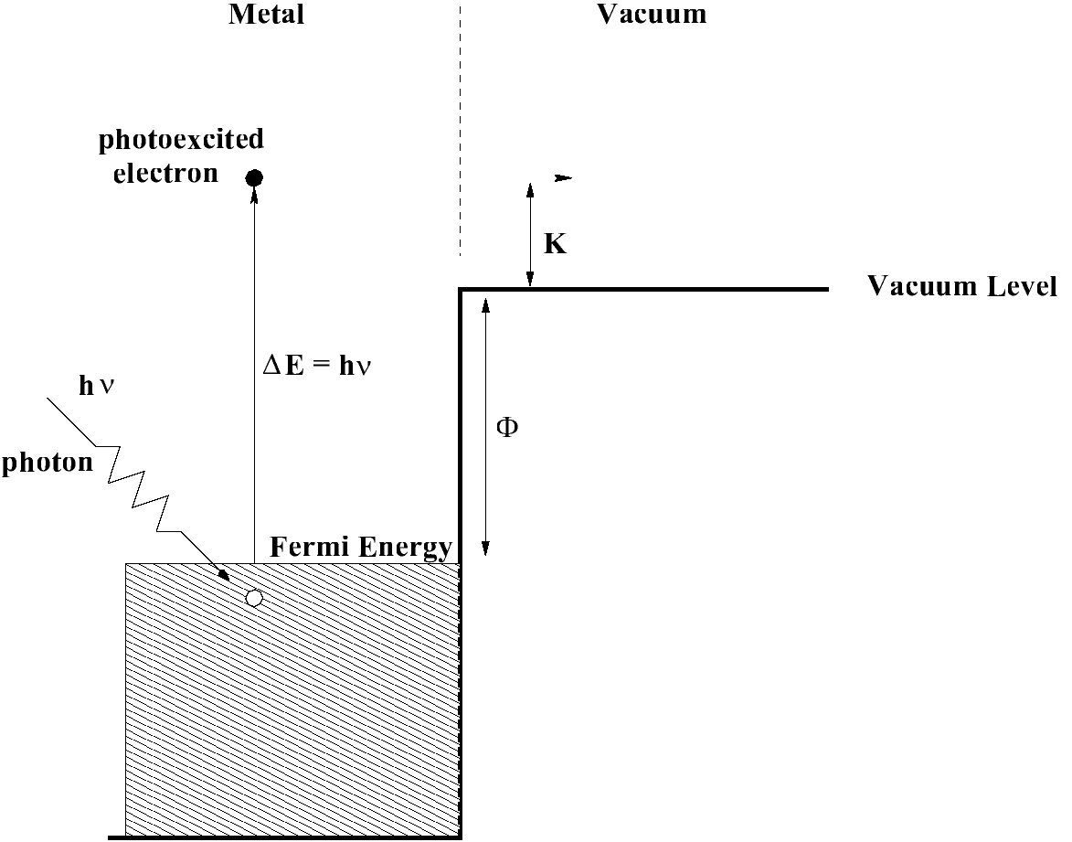
Figure 1: A schematic energy diagram showing the essential concepts underlying the photoelectric effect. The energy of electrons are plotted near a metal-vacuum interface.

This diagram relies on our modern understanding of electron states in metals. We now know that electrons inside a metal reside in many different energy states. Those electrons that are most weakly bound are detached from individual metal atoms and are known as ‘free electrons’ or ‘conduction electrons’. They have the ability to freely move throughout the metal and occupy a continuous range of energies, forming an ‘energy band’ that spans a few electron volts in width as indicated by the shaded region in Fig. 1. At the absolute zero of temperature, the most energetic conduction electrons reside at an energy called the Fermi energy. An electron at the Fermi energy is bound to the metal by a step in energy known as the work function Φ (see Fig. 1). The vacuum level as defined in Fig. 1 therefore provides a convenient zero of energy when discussing the photoelectric effect.
When an incident photon of frequency ν is directed toward a metal, many interactions can take place. One possibility is that the photon is reflected at the metal-vacuum interface. Another possibility is that the photon penetrates into the metal and interacts with a conduction electron. During the course of such an electron-photon interaction, the entire energy of the photon hν can be transferred to an electron. Depending on the initial energy of the electron, the electron after excitation might acquire sufficient energy to pass through the metal surface and escape into the vacuum, where it can be detected and its kinetic energy K with measured respect to the vacuum level. This simple picture can be represented in terms of the reaction equation

hν + e-bound + metal → e-excited + metal .

As shown in Fig. 1, for an electron at the Fermi energy to escape from the attractive binding force exerted by the metal, it must acquire a minimum amount of energy Φ. It follows that the maximum kinetic energy Kmax (with respect to the vacuum level) that an electron can acquire after leaving the surface of the metal is

Kmax=hν-Φ . (2)

This assumes that the electron was in an initial energy state at the Fermi energy and that it suffers no internal collisions inside the metal before escaping through the vacuum-metal interface.
The three surprising experimental results obtained from photoelectric experiments are:
- While the number of electrons photoemitted per unit time is proportional to the incident light intensity, the maximum kinetic energy Kmax of the photoexcited electrons depends only on the frequency of the light source and not on its intensity.
- The photoelectric effect does not occur for incident light below certain cut-off frequency.
- The time lag between the injection of a photon and the emission of an electron is very short.
These three experimental results are at variance with predictions from the classical wave theory of light.
- Classically, the energy imparted by an electromagnetic wave is proportional to the intensity of the wave. In the quantum picture, the energy is proportional to frequency.
- Classically, as long as the light is intense enough, enough energy should be imparted to an electron to allow it to overcome the work function of the metal’s surface. In the quantum picture, since transfer of energy is quantized in units of hν, the cutoff frequency is naturally defined by the condition Φ=hνcutoff. For ν<νcutoff the expression hν-Φ in Eq. 2 is negative. This simply means that the photon does not impart enough energy to the electron to allow it to escape from the metal.
- Classically, the energy imparted by an electromagnetic wave to an object depends on the size of the object and time. In the quantum picture, the energy is imparted on a time scale determined by the electron-photon interaction. Since this interaction time is very short (∼10-9 s), it is virtually impossible to measure any time lag between the illumination of a metal surface and the emission of electrons.
Taken all together, the resolution of these three experimental facts provides compelling evidence that under certain circumstances, light may not be treated as a simple electromagnetic wave.

Experimental Considerations:
In this experiment you will investigate the photoelectric effect by studying the electron emission from a a photosensitive material that forms the cathode of a vacuum diode. The challenge is to measure the kinetic energy of the photoemitted electrons as a function of the frequency of the incident light. One accepted technique for making this measurement is to perform a retardation experiment. This is accomplished by biasing the anode with respect to the photoemitting cathode by a potential Vbias as shown in Fig. 2.

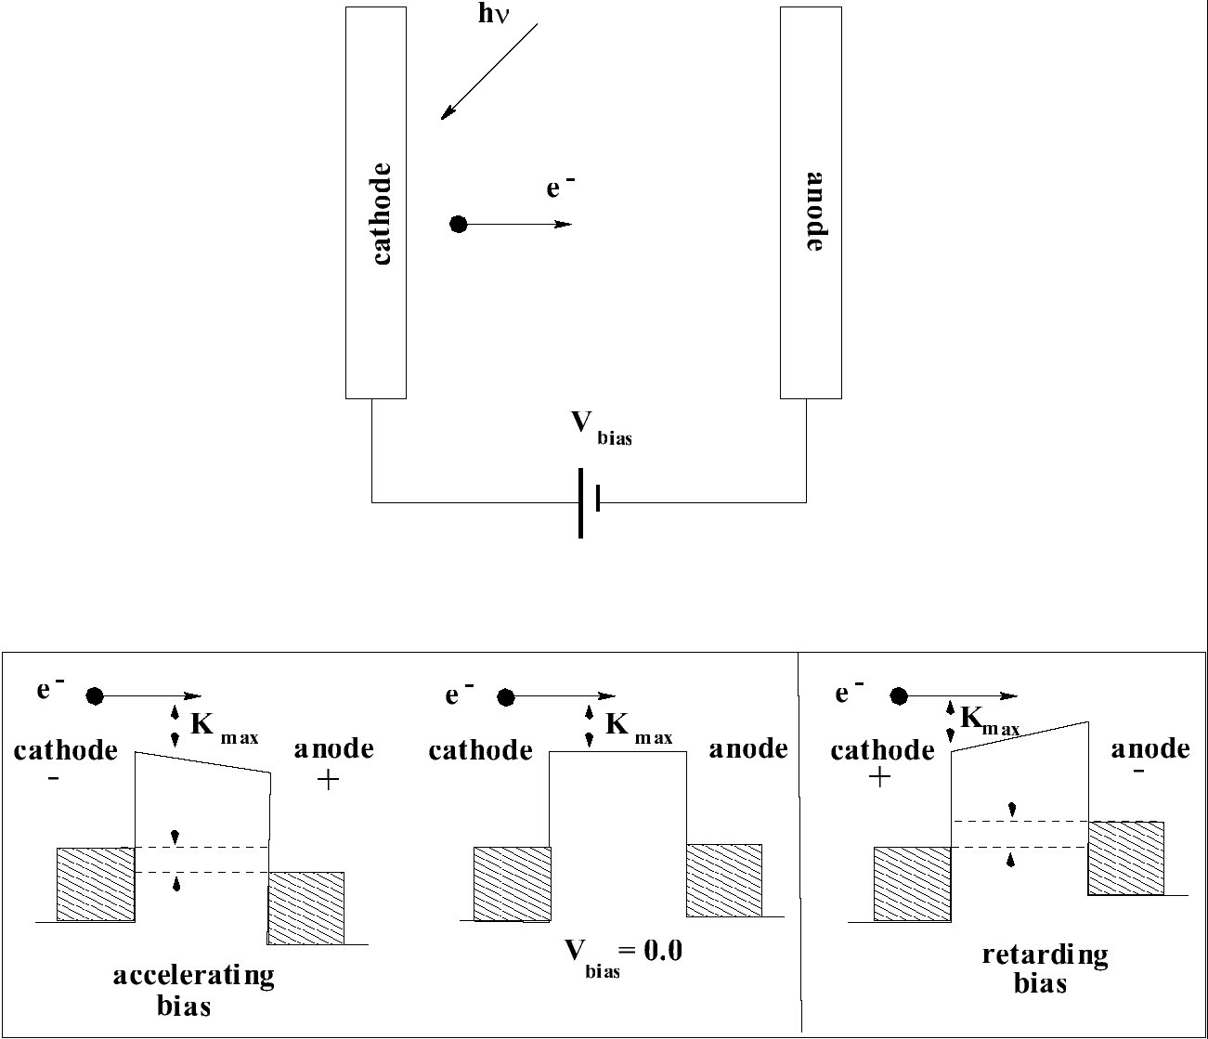
Figure 2: A schematic diagram showing the essential features of a retardation experiment. This diagram makes the simplifying assumption that the work function of the anode and the work function of the cathode are equal. The offset between the Fermi energies of the cathode and anode (dotted lines) is equal to eVbias.

The bottom panel in Fig. 2 shows two configurations in which the electron is accelerated or retarded by the applied bias voltage. As can be seen from the retarding configuration, only those electrons with an energy larger then the height of the retardation potential barrier will reach the anode and contribute to the current flow between the two electrodes. For a certain value of the bias voltage such that Vbias=Vstop, where eVstop is chosen equal to Kmax, no electrons will reach the anode. For this reason, Vstop denotes the potential required to completely stop the photocurrent.
Determining Vstop for different light frequencies will allow a measure of the maximum energy supplied to the electron as a function of light frequency. From the simple model sketched in Fig. 1, you can easily see that

eVstop=Kmax=hν-Φ . (3)

A complication arises if the work function of the cathode and anode are different. Under these conditions, a contact potential Vcontact is said to exist between the cathode and anode. This situation causes the stopping potential Vstop to be shifted from zero by Vcontact. Since Vcontact is not known a priori, it is difficult to know what is the correct value for Vstop to use when analyzing data. This situation is discussed more thoroughly in Appendix B.

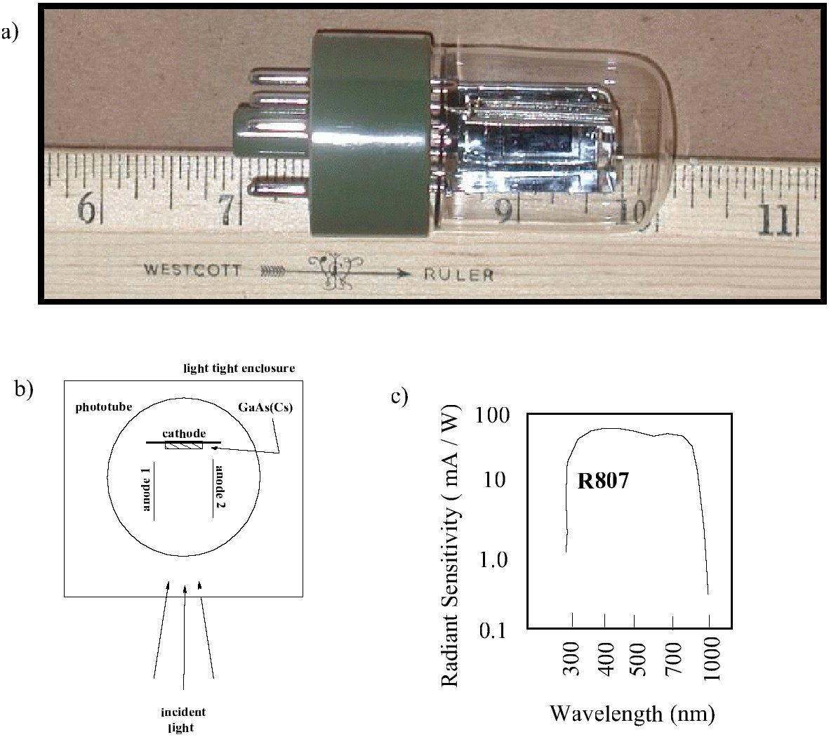
Figure 3: (a) A photograph of the R807 photodiode. (b) A schematic diagram showing the phototube’s electrode configuration as viewed from above. (c) A sketch of the spectral response of the R807 phototube.

Experimental Equipment:
The phototube used in this experiment is a Hamamatsu R807 vacuum photodiode shown in Fig. 3(a). This photodiode has a rectangular emitter (cathode) made from GaAs coated with an alkali metal, endowing the cathode with a low work function Φ. Unfortunately, it is possible for the metal forming the anode to be photoelectrically active and hence emit electrons when illuminated by light. An improperly designed phototube will show a significant reverse emission and will produce unreliable results. To reduce this unwanted emission, a rather unconventional electrode structure is employed as shown in Fig. 3(b). A pair of anode planes are aligned perpendicular to the single cathode plane. This geometry permits light to fall primarily on the cathode when a small aperture is cut in the surrounding light-tight enclosure.
A particular phototube is characterized by its spectral response curve which gives the radiant sensitivity of the tube as a function of wavelength. Fig. 3(c) shows the spectral response curve for the Hamamatsu R807. The tube sensitivity is relatively uniform in the wavelength range of our experiment; 300 nm<λ<850 nm. This property is achieved by a coating the GaAs cathode with Cs. The performance of phototubes can deteriorate for a time after they are exposed to high levels of light. If you are trying to measure small photocurrents, take precautions to avoid intense light expsoures when changing filters.
In general, it is difficult to produce light at a given frequency. Inexpensive sources of light tend to produce a broad spectrum of light spanning a wide range of frequencies. A common technique to select out only a narrow range of frequencies of interest is to pass the light through a bandpass interference filter. Such an optical filter has a characteristic transmission curve specified by a central wavelength, a width, and a peak transmittance. See Appendix A for the transmission curves for each filter. From the data plotted in the Appendix A, the full-width at half-maximum (FWHM) for each wavelength can be estimated. The center wavelength transmitted through the filters is stamped on their brass casings in nanometers. (1 nm ≡ 1×10-9 m). The letters indicate the atomic element which emits this wavelength as an isolated spectral line.
The simplified wiring diagram of the photoelectric apparatus is shown in Fig. 4. The 3V battery and potentiometer provide adjustable bias potential between anode and cathode, which is monitored by a voltmeter.
Figure 4. Simplified wiring diagram of apparatus

The photocurrent emitted from the cathode is small, typically less than 100 nA, so precautions must be taken to insure that accurate measurements can be made. We use a Kiethley Model 485 picoammeter to allow precise measurements of this small current. Picoammeters are sensitive instruments and special care must be paid to the proper shielding and grounding of electrical wires carrying currents in the nA range. It is easy to induce a few nA of noise current in an unshielded cable just by touching it. As a matter of fact, if you would build the apparatus exactly as shown in Fig. 4 the noise generated in wires may exceed useful signal manifold. Whenever possible, wires carrying small signals must be shielded. Moreover, it is of great advantage if the signals can be measured in respect to ground – in this case the signal can be carried to test equipment through coaxial cable. Many high-sensitive instruments are specifically designed to measure signal only in respect to ground and are equipped with coaxial connectors which match coaxial cables. The picoammeter used in this experiment is no exception.
Analysis of the wiring diagram shown in Fig. 4 reveals that the best grounding point would be point where Picoammeter and Voltmeter are connected (denoted by letter G). Indeed, in this case signal to both instruments could be carried by coaxial cables, with the outer shield connected to the G point, and inner ‘signal’ wire connected to cathode in the case of picoammeter, and to anode in the case of voltmeter.
A wiring diagram of the actual apparatus used in this experiment is given in Fig. 5. To reduce the noise picked up by the phototube its outer shielding box is also grounded, as well as the metal case of of the 10-turn 100 Ω potentiometer.

Figure 5: A wiring diagram of the photoelectric effect apparatus

Since the number of data points to be recorded is enormous, we will use computer to record these data for us. The input UB1 of the Cassy interface. The picoammeter is equipped with analog output which generates DC voltage proportional to the measured current. This output is fed into second input UA1 of the interface.
A photograph of the wired setup is shown in Fig. 6.

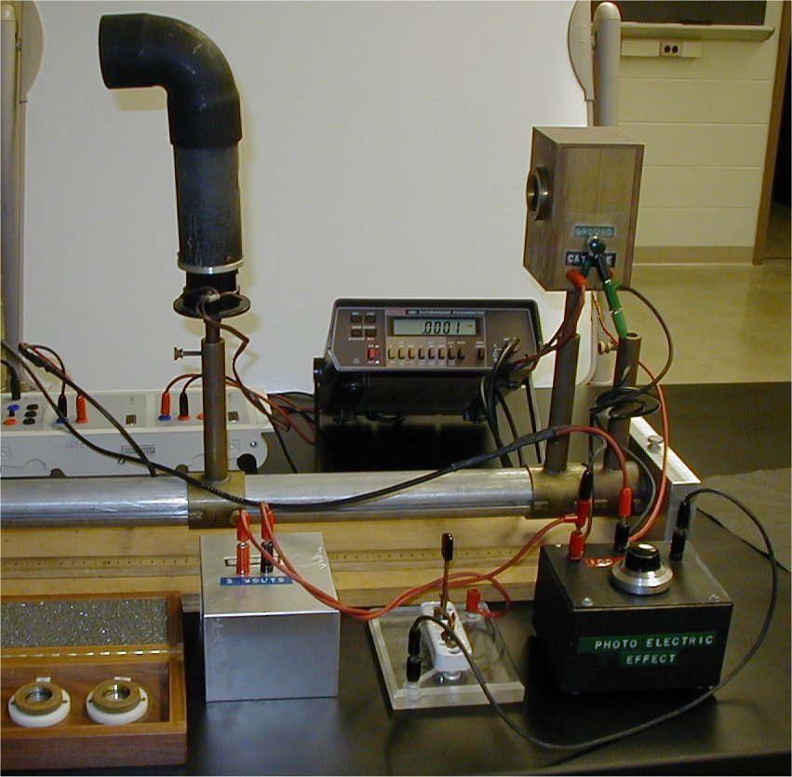

Figure 6: A photograph of the photoelectric effect apparatus.

Setting up Cassy Lab program for data acquisition.
Start Cassy Lab program and initialize both voltmeters. Set the display x-axis to show UB1 (bias potential) and y-axis to show UA1 (photocurrent). Set both voltmeters to measure mean signals, i. e. to average signals during 100 ms. This will dramaically reduce the noise by suppressing lectrical noise at frequencies above 10 Hz. The main source of noise is induced by AC current in power lines (60 Hz). Set the data acquisition period also to 100 ms. Leave total data acquisition time blank. Next, check the Condition box in measurement window and type in the following condition:
n=1 or delta(UB1)>0.005
The above setting tells the proram to take the next data point (UB1, UA1) if the first point is being measured (n=1), or when the UB1 value changes by more than 0.005V. The condition is checked every 100 ms, as specified by data acquisition period.

I. The Relationship Between Intensity of Light and Photocurrent

It is important to establish how the photocurrent depends on the intensity of light falling on the photocathode. It is difficult to precisely vary the light intensity by adjusting the current through the lamp. Since the intensity of radiation decreases inversely as the distance squared from a point source, we can achieve a controllable intensity simply by adjusting the distance between the light source and the photocathode. In this part of the experiment you will record data points manually.

Setup sequence:
- Place the 656.3 nm interference filter into the filter holder on the housing of the phototube
- Set the Kiethley 485 picoammeter initially to the 2 μA scale. Use Cassy Lab program to set UB1 range to ±3 V. Turn the potentiometer to set bias to zero (monitor the Cassy Lab UB1 voltmeter), and then disengage the battery by turning off the switch S (Fig. 5) to ensure zero bias potential.
- Check that the lamp and the photodiode are exactly at the same height. To ensure the same height slide the lamp (while it is off) as close to the phototube as possible and then change the height of the lamp opening to match the height of phototube enrance.
- Slide the 125-watt concentrated filament lamp to a distance 40 cm from the phototube and turn it on. You should measure a photocurrent of about 100 nA on the Kiethley 485. Align phototube angle to be in the middle of the maximum photocurrent signal range.
- Switch off all room lights and use a small table lamp or flashlight while taking data.

Data Acquisition:
Record the photocurrent on the Kiethley 485 when the 125-watt lamp is at 40, 44, 50, 57, 70, and 100 cm from the phototube. Periodically block off the lamp to check the zero of the picoammeter. Don’t forget to estimate errors in your current and distance measurements.

Data Analysis:
- You have measured the photocurrent as a function of d, the source-phototube distance. Plot the photocurrent as a function of 1/d2 where d is the distance from the lamp to the phototube. (Why have these particular values of d been chosen? ) Make this plot while acquiring the data. Do not forget the error bars on your final plot! Interpret your results.
- Show convincingly that the photocurrent in Part I obeys a 1/d2 law. One way to do this is to plot the ratio of i/(1/d²) as a function of d. This is a generic way to test how well data obeys an equation of the form y=mx. By plotting the ratio of y to x vs. x, you can see small systematic deviations that are not evident if you plot the data as y vs. x. The key point is that in plotting the ratio of y to x as a function of x, you need not include the point (x=0, y=0). By supressing zero, you are free to expand the graphing scales to see how well your data really obeys a linear relationship.
Proceed in the following way.
(i) Calculate the mean value of the five measurements $\overline{{\text{id}}^{2}}=\frac{1}{5}d^{2}\sum{\left(i_{j}\right)}$ for each distance.
(ii) Calculate the corresponding standard deviation σ from the mean value of $\overline{{\text{id}}^{2}}$ for each distance.
(iii) Plot the values $\overline{{\text{id}}^{2}}$ with vertical error bars ±σ as a function of the distance d.
(iv) From your plot, calculate the average value of $\overline{{\text{id}}^{2}}$obtained for all distances and denote it by $\overline{\overline{{\text{id}}^{2}}}$. Draw a horizontal dashed line corresponding to $\overline{\overline{{\text{id}}^{2}}}$and check whether the error bars of each data point intersect this $\overline{\overline{{\text{id}}^{2}}}$ dashed line. Interpret your results.

II. The Relationship Between Stopping Potential and Light Intensity

It is important to determine how the stopping potential for the photocurrent depends on the light intensity falling on the photocathode. This is accomplished by measuring the photocurrent as a function of bias voltage for different separations between the photocathode and the light source. A monochromatic photon beam is produced using an appropriate interference filter.

Setup sequence:
- Engage the bias potential by turning on switch S (Fig. 5). Make sure the battery is connected in such a way that a high negative anode voltage (about -1 V) results in zero photocurrent. If photocurrent rises instead – reverse the wires connected to UB1 Cassy input. Then reverse the battery connection.
- Take out the 656.3 nm filter used above and replace it with the 546.1 nm interference filter. Whenever you change the filters turn off the lamp.
- Place the 125-watt concentrated filament light source in front of the phototube at a distance of 30 cm. Do not turn the light source on yet.
- With the light source off, check the zero level of the picoammeter.
- Turn on the 125-watt concentrated filament lamp. Perform any alignment that may be required.

Data Acquisition:
- Set the bias potential Vbias to about +3V (reverse the battery polarity if necessary). See that the picoammeter range is set to highest possible sensitivity without overload. Then check the UA1 Cassy Lab voltmeter, and set its range to highest possible sensitivity without overload. Compare the UA1 reading to the picoammeter reading. The UA1 should be proportional to picoammeter reading with the proportionality coefficient 10^{n}, where n is integer. Record this coefficient as it will be needed later for converting data accumulated by Cassy software to actual current.
- Inverse battery polaity and set the Vbias to about –1V. Check that the data recording software is set in condition mode (see Setting up Cassy Lab program section above for details).
- Start data acqusition. Immediately the first data point should appear (something like (–1.002, 0.002). If more points appear then stop the data acquisition and ask your instructor to check data acquisition settings.
- Slowly (!) change stopping potential toward zero. As the bias voltage increases (becomes less negative) by about 0.005 V the new point is taken by the software automatically. Continue turning potentiometer toward zero to accumulate the whole current-versus-bias curve. When zero bias is reached (potentiometer is at one end) reverse the battery polarity (don’t stop the data acquisition!) and start slowly increasing bias voltage bringing it to ~3V. Be sure to scan slowly so that only few poins are measured every second. Remember – the program checks for changes in bias potential only every 100 ms, if you scan faster than 0.005 V per 100 ms you will loose data points. While turning potentiometer and accumulating data don’t change your position or touch any wires or boxes, that may induce noise.
- Stop the data acquizition and and check if your data looks similar to the one shown in Fig. 8 a. If not – ask your instructor for help. Save your data.
- Perform preliminay analysis of the data – estimate contact and stopping potential as described in Appendix B.
- Reverse the battery polarity and set the V_{bias} to about –1.2V. Set the picoammeter to highest sensitivity (2 nV). Start data acquisition and record current dependence on bias voltage until photocurrent reaches ~1.5 nA. Stop the measurement and record the data. This second set of data recorded with higher sensitivity will be later used to determine stopping potential with greater precision.
- Estimate the stopping potential based on these data. Is it the same as determined in step f)? If not, can you explain the difference?
- Repeat the measurement described above for a source-phototube distance of 70 cm.
- Repeat the measurement described above for a source-phototube distance of 100 cm.
- Do not leave the lab until you have analyzed plots of your results and found them reasonable.

Data Analysis:
Plot the photocurrent as a function of the bias potential Vbias for the three different source-phototube distances. To what accuracy is the stopping potential Vstop independent of the intensity of light?
From this data, you should also be able to estimate the contact potential for the tube that you are using. See the discussion contained in the Appendix B.

III. Determination of Planck’s constant

It is important to establish how the stopping potential for the photocurrent depends on the light frequency falling on the photocathode. This is accomplished by measuring the photocurrent as a function of bias voltage when different interference filters are inserted between the photocathode and the light source.

Experimental Setup:
In Part II above, you already measured the photocurrent as a function of the retarding potential for three different light source-phototube distance, using the 546.1 nm interference filter. Now you will obtain the stopping potentials for the rest of the filters, but only for one light source-phototube distance of 30 cm. To reduce spurious effects, make sure the phototube faces the wall with the room lights off.

Data Acquisition:
Set the source-phototube distance to 30 cm and repeat the data acquisition procedure of Part II for the 577.7 nm, 589.6 nm, 656.3 nm, and 671.0 nm interference filters.
Do not leave the lab until you have made a preliminary plot of your results and found them to be reasonable.

Data Analysis:
- Plot the photocurrent data on one graph as a function of bias potential for all five filters (the –1…+3V range). Before plotting, scale your data so the maximum photocurrent detected is the same for each filter. Do you understand why this scaling is an acceptable procedure in this situation? Make a table that lists the normalizing factors required for this scaling. Use the same scaling factors on corresponding high-sensitivity curves taken with picoammeter in 2 nV range. Plot them on a different graph.
- Devise a graphical technique for determining the best value of Vstop for each wavelength. How do you accurately know from a graph when the photocurrent goes to zero? This is difficult to estimate from a linear graph of photocurrent vs. bias potential. A better way is to plot the logarithm of the photocurrent vs. the applied bias voltage. This procedure allows you to expand the data at low currents, which is of most interest in this part of the experiment (see the discusion in the Appendix B). How do you define zero current experimentally? This issue must be understood before you begin making plots. From this graph, estimate the uncertainty in Vstop for each wavelength. Convert wavelengths into frequencies. Make a table containing these important results.
- Finally, plot stopping potentials Vstop vs. frequency. The interference filters you use have roughly a ±2 nm uncertainity in their central wavelength. How must you take this into account? Also, there is an error in your determination of Vstop.
- Use the method of least squares and fit a line to your data of Vstop as a function of ν (see Eq. 3). From the slope and intercept of the best fit straight line, determine values for h/e, Φ and their errors. Make sure you correct Φ by your best estimate for the contact potential.
- Knowing the electron’s charge, estimate h. Express your result for h and Φ in units of eV.sec and eV, respectively. (Note that the work function Φ in Eq. 3 is expressed in units of Joules.)
- Compare your results for h with the accepted value h=(4.13571±.00003)×10-15 eV× sec.
Appendix A: Characterizing the filters
The spectral response of each filter was measured by placing the light source from this experiment, a 125-watt GE concentrated filament and housing, 7cm away from the entrance slit of a Triax 180 monochromator. The Triax 180 uses a cross Czerny-Turner configuration. It has an aspherical mirror to correct for astigmatisms in the Czerny-Turner configuration. Its spectral resolution is 0.3 nm. The filter was placed directly over the entrance slit of the monochromator.
The plot below shows the relative intensity transmitted through representative filters. In addition, the relative intensity emitted by the unfiltered light source is also plotted.

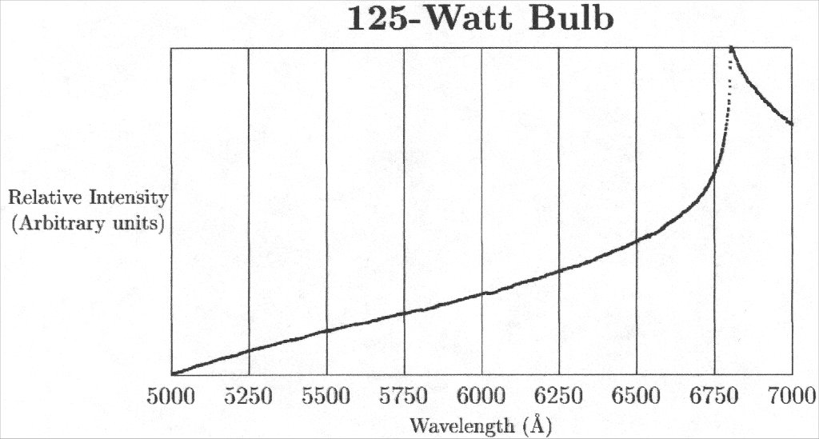
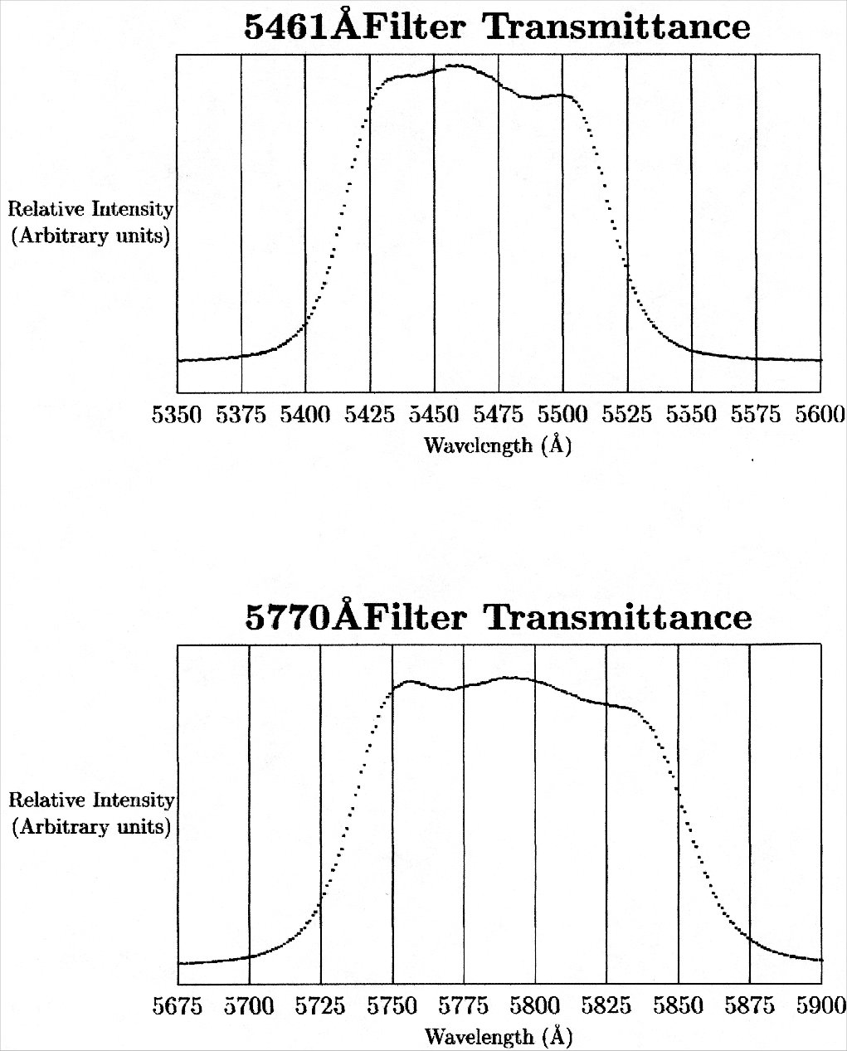

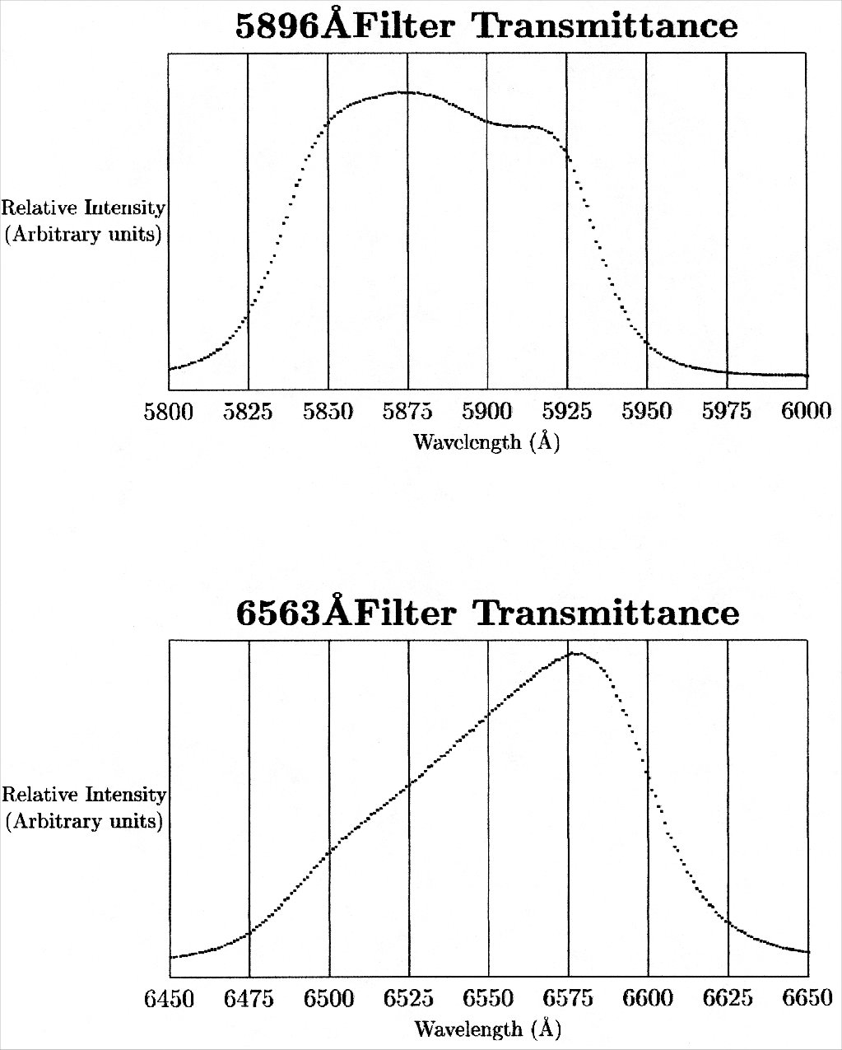
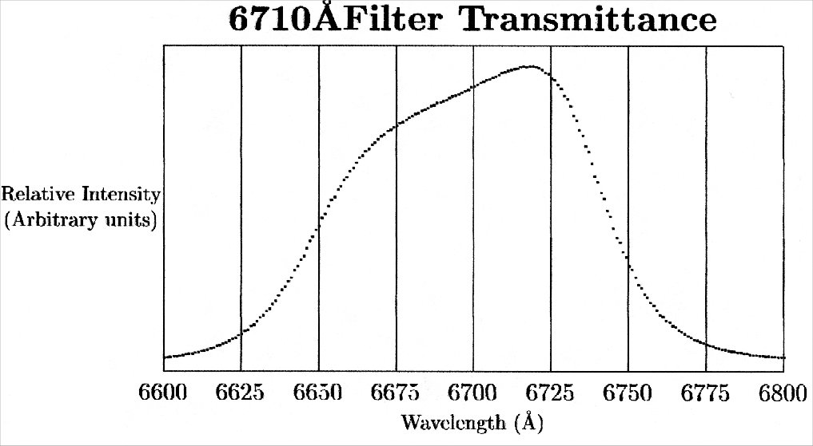

Appendix B: Estimating the contact potential

If the work function of the anode and cathode are different, a contact potential is said to exist between the two objects. For the discussion that follows, assume Φanode > Φcathode (see Fig. 7(a)). The contact potential is defined as the potential difference between the two electrodes when they are wired together (this ensures that the two Fermi levels are equal):
Φanode - Φcathode = eVcontact.

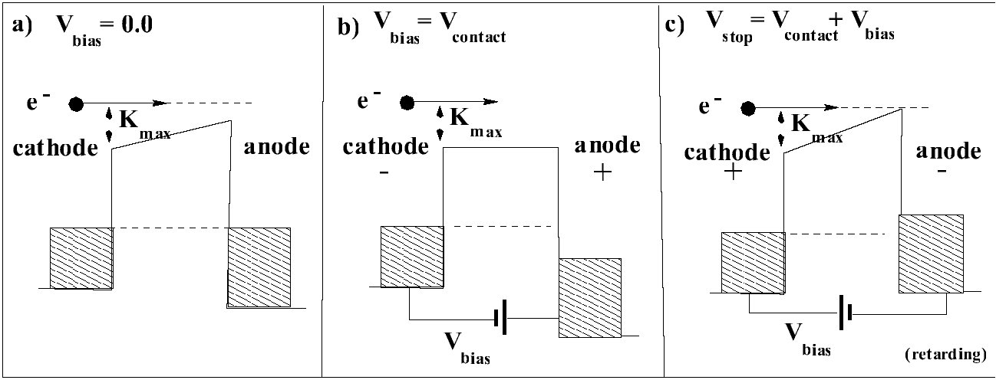
Figure 7: A schematic diagram illustrating the contact potential problem for the photoelectric effect. In this figure, we assume for the sake of discussion that
Φanode > Φcathode

The existence of a contact potential shifts the zero of potential. In effect, the true zero of potential will now occur at an applied bias such that all electrons emitted from the cathode are just collected by the anode (see Fig. 7(b). When this occurs, the photocurrent will saturate at a constant value as the applied bias is further increased. The onset of this saturation should produce a sharp signature in the measured photocurrent as a function of Vbias, but (i) electrons reflecting from the anode and (ii) non-ideal geometrical effects often prevent this break from being sharp and hence easy to identify.
To reduce the photocurrent to zero, the polarity of the bias potential must be reversed as indicated in Fig. 7(c). The bias voltage applied to obtain the condition in Fig. 7(c) is identified as the stopping potential. To be accurate, it must be referred to the true zero in potential which is defined in Fig. 7(b). In other words, all applied potentials are increased by the contact potential.
A systematic method for determining the true zero in potential is to locate the point where saturation of the photocurrent with respect to the applied bias potential first appears. This bias voltage is then a best estimate for Vcontact. Applied potentials must then be increased by |Vcontact| in order to obtain accurate estimates for the work function of the emitting cathode (see top scales in Figs. 8(a) and 8(b)). It is easy to construct a similar argument for the condition Φanode<Φcathode. In this case, all stopping potentials will be decreased from the applied bias by the contact potential.
Think about how the contact potential affects your photoelectric data? How will it influence your determination of Planck’s constant and Φ, the work function of the cathode?
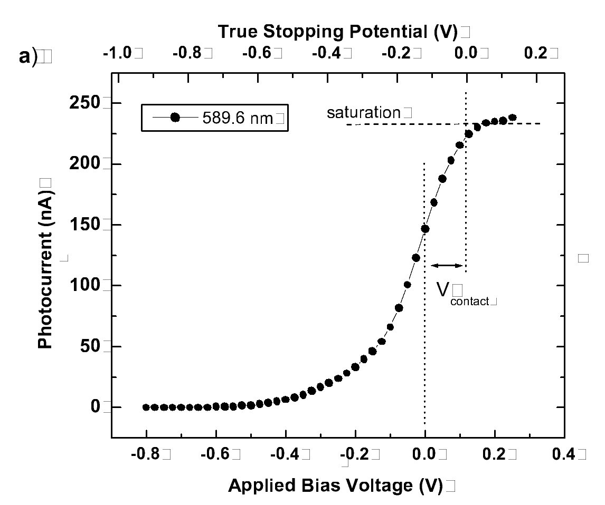
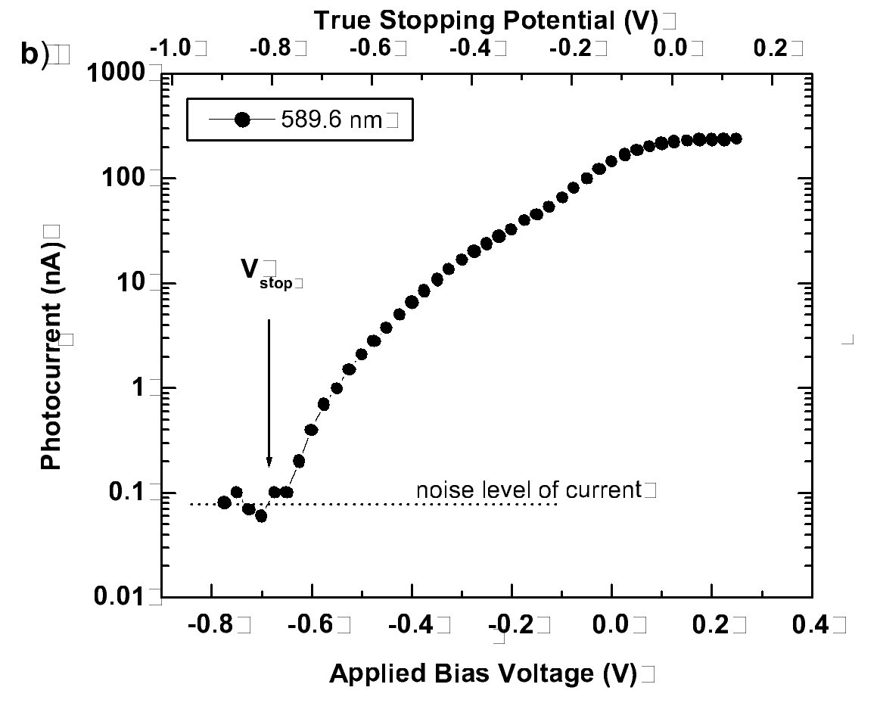
Figure 8: a) Typical data taken with a 589.6 nm filter showing how to identify the contact potential. The values plotted on the upper abscissa have been shifted by the contact potential Vcontact. b) Representative photoemission data taken with a 589.6 nm filter showing the advantage of using a log plot to identify the stopping potential in the photocurrent.

