PHYS 342L

Procedures and Practices

Spring Semester 2001-2002

Purdue University
PHYS 342L Course Syllabus; Spring Semester, 2002

Week | Dates | Activity | Due dates
1 | Jan. 7 - 11 | Course Introduction
2 | Jan. 14 - 18 | Data and error analysis discussion
3 | Jan. 21 - 25 | Start e/m
4 | Jan. 28 – Feb. 1 | Finish e/m
5 | Feb. 4-8 | Stefan-Boltzmann | e/m report due
6 | Feb. 11-15 | Stefan-Boltzmann
7 | Feb. 18-22 | Photoelectric Effect
8 | Feb. 25-Mar. 1 | Photoelectric Effect
9 | Mar.4 – Mar.8 | Frank-Hertz | Photoelectric  Report due  Notebooks due
10 | Mar. 11-15 | Spring break
11 | Mar.18 - 22 | Frank-Hertz
12 | Mar. 25-29 | Compton Scattering
13 | April 1-5 | Compton Scattering | Pick experiment of your choice for the next week
14 | April 8-12 | Your choice:  1. e-diffraction  2.light diffraction  3. electronic conduction in solids | Notebooks due
15 | April 15-19 | Your choice:  continue
16 | April 22-26 | Lab Record Check - NO LABS | Compton report due

1. Grading

PHYS 342L is a writing intensive course in which a variety of modern physics experiments are performed, analyzed and written. All lab data and lab notes will be recorded in a computation notebook Avery Dennison No. 43-648 or equivalent, available at the University Bookstore. Scraps of paper with data scribbled in a hurried way will NOT be tolerated. Your lab notebook will be collected periodically during the semester and graded for content. In addition, you will be required to write three formal lab reports discussing three experiments you have performed. During the semester, the maintenance and production of a high-quality written notebook will be emphasized. In addition, it is expected that the three formal lab reports will be clearly written in a concise and thoughtful manner. See the section below on a ‘writing emphasis course’.
In addition to the notebook, the text book PRACTICAL PHYSICS by G.L. Squires will also be required. Copies of this book are available at the University Bookstore.
You will also be required to have one floppy disk (PC formatted) clearly labeled PHYS 342L and listing your name. This will facilitate transfer of data from the lab computers.
A final grade will be determined using the following scheme:
15 pts e/m Lab Report due February 5 before 5 PM
15 pts First Notebook reading due March 5 before 12 noon
20 pts Photoelectric Lab Report due March 5 before 5 PM
20 pts Second Notebook reading due April 9 before 12 noon
30 pts Compton Scattering Report due April 23 before 5 PM
100 pts TOTAL POINTS POSSIBLE
A copy of the checksheet that will be used while reading your written reports and notebooks is provided in the Appendices.
In a University setting, late assignments are always a problem. One fact that seems irrefutable is that conscientious students always seem to get their assignments in on time. The following paragraph is not intended for them.
It is a good idea to have a published procedure on how the PHYS 342L staff will handle late reports. The due dates and times for all assignments are listed above. Any changes in these times will be clearly announced in class. Late assignments will be penalized as follows: 2 points off final score for every calendar day late. A score of zero will be recorded for any assignment that is submitted more than one week after it was due. For your own benefit, be sure that your report is stamped by one of the designated receivers with a time and date of receipt.

2. Notebook Keeping

The details of laboratory notebook-keeping are patterned after standard notebook-keeping practices in professional physics research organizations. If these practices seem excessively legalistic, it is because they are, in part, to insure that notebook records of research and development will be legally binding to protect the inventor’s claim to an original discovery. Countless legal contests have been decided by a properly kept, properly witnessed research notebook. Learn to do it correctly now and it will be a life-long value to you.

Type of Notebook — A Bound, “quadrille-lined” (coarsely gridded graph paper) computation notebook Avery Dennison No. 43-648 or equivalent is required for this course. The two important aspects are its bound nature, which makes it more lasting and prevents pages from being removed, and the quadrille ruling, which facilitates quick plotting of graphs and sketching of apparatus.

General Rules — Every page of your notebook should be numbered. All entries must be dated on each page, written in ink and in serial order, i.e., no blanks are to be left for filling in later. Any additional loose information sheets, such as ideas jotted down on separate paper at odd time, computer graphs or graphs on millimeter paper, occasional photocopies of pertinent tables or figures, etc., must be permanently affixed, preferably with glue or transparent tape. No erasures, white-outs or scribble-outs are allowed. Corrections are done by putting a line through the erroneous entry and writing the correct entry above or to the side. Large mistakes, i.e., many lines or an incorrect drawing, can be marked by an “X” across the whole thing, with a dated comment on why it is X’d out.

Table of Contents — The first few pages of the notebook should be reserved for a table of contents. At the very least it should contain the starting page number of each experiment. Greater detail would be useful in looking up material about which you or the instructor have questions.

Dates — Every page should be dated. This assures that the diary aspect of the notebook is maintained. It is also essential from the priority aspect. Do not write on a page with an earlier date. Exceptions: i) If there is an interruption of thought or experiments, you can insert on the old page directions to the continuation. ii) If you discover some material on an old page is wrong, you can line it out and give directions to a current page explaining why it is wrong. If you wish to add columns to an earlier table, you can photocopy the table (reduced in size if you wish), glue it to the current page (state the page from which it was copied), and write in your new columns. If you summarize previous results into neater form, be sure to state which pages are being summarized.

Units — All dimensioned quantities must have units associated with them.

Uncertainties — Not only should a numerical value be given but also a justification for that value; e.g., “smallest division is 0.1 mm and I can interpolate to 1/4 division so error is about .03 mm”. If there is a parallax error add that in also. If there is a systematic error, note that too; e.g., “end of tape was broken off so starting point was 2.5.”

Significant Figures — A recorded value such as (3.04175±.021)×108 m/s shows a lack of understanding of the concept of significant figures. Reporting a number in such a way casts great doubt on your credibility as a competent scientist or engineer. Great emphasis is placed on this idea, so if you are unsure about it, see the staff.

Pre-Class Preparation — When beginning a new experiment, pre-class preparation involves reading the handout and the pertinent references. Subsequently, it means “digesting” what you have done and planning what to do next. In your notebook, record the references you read (page numbers, etc.) and outline the basic theory behind the experiment and make a rough outline of the procedures you will follow. Diagrams are usually helpful for describing procedure and/or theory. If the experiment requires a piece of apparatus unfamiliar to you, attempt to describe its operating characteristics as best you understand them. Your instructors may want to examine your preparation before you start an experiment. If pre-class preparation is made on the same day as in-class work, it is to your advantage (in other words, it is a good practice) to distinguish these with a note telling were the work was done.
Pre-class preparation is one of the most important parts of the experiment. In the real world of science, preparation and planning for an experiment take a large share of the time. Building and debugging the apparatus, data analysis, and writing the results take much of the rest of the time. Actual data taking usually often occupies very little of the time. This is why Advanced Lab students are expected to devote a considerable amount of time to work done outside the lab.

In-class Lab Work — There is a strong tendency for students at this stage to collect tables full of data but postpone trying to use them – or, if using the data produces strange results, attempt to “solve” the problem by taking more data. Instead, it is often more worthwhile to think and try to discover what might possibly be wrong. Books of bad data will not yield results of much value. Attempt to understand what you are doing before you start taking data. Then after getting some early data, use it to see if your results seem reasonable. Consider the best way to analyze your data. The best way to acquire a few points of preliminary data may be different from the best way to acquire a large quantity of data. Insight into the method of analysis might alter your data taking procedure. You might find that more attention must be paid to certain values of the parameters than to others. It is especially important that you go through a thorough analysis of the data at home before the next lab period. Otherwise you could return to the lab and continue repeating a mistake and thus waste an entire lab period. It is for this reason that the staff will constantly be urging you to make preliminary graphs of your results.
After you have completed an experiment, make sure you show the instructor your notebook so he or she can judge whether you really are finished taking data and whether you are interpreting it correctly.

Formula Derivations — Ideally, the derivation of the expressions describing the experiment should be your own, starting from first principles to show that you understand the physics of the situation. Use caution if you pattern your theoretical analysis on the manufacturer’s write-ups or other cookbook discussions on file. They are sometimes clumsy, omit steps and otherwise follow an approach different from what you learned in your other physics courses. It is better to think of tackling the problem as a homework assignment in the appropriate course. Copying a derivation from a book is better than no derivation at all, but it would be better to look at several sources and then do your own. If possible, start out with as realistic a model as possible, then make the necessary approximations; that way you can estimate the influence of the approximations on your results.
Try to put as much physics into your derivations as possible. Don’t be afraid of revealing your misunderstandings. Show your calculations to the staff early on so things can be cleared up before you proceed with a wrong idea. The finished product is what counts here, so make your mistakes early and learn from them.

Description of Experimental Set-Up — This should include two parts: the overall set-up and notes about the specific equipment.
For the overall set-up, the description could be a plan view, circuit diagram, etc. It should be detailed enough to allow someone else to reproduce your work. Several sketches may be necessary, such as a general view plus several details. If dimensions are to be measured, use a separate detail with enough clarity that one can know whether you are measuring to the front face or back face – or whatever. If algebraic symbols are to be used, they should be indicated on the diagram as well as listed in a table. For the specific equipment you use, it is not a bad idea to include the company name and model number the first time it is referred to. A drawing of the apparatus is among the first things done when beginning a new experiment. A drawing made by you is much preferred to a taped-in photocopy from the handout or other source. The very act of making the drawing forces the experimenter to think about details of the apparatus that might not at first be obvious.

Preliminary Data Graphing — As soon as you get some results, graph them on the spot and make a rough calculation to see if your results are reasonable. Many people have spent hours collecting beautiful lists of worthless numbers because they omitted this step. Make sure things are going right before you continue too far. The preliminary graph need not be a work of art. When you do your final analysis at home, you should re-draw the graph on good graph paper or do a computer plot, with (possibly) more suitable scales, better captions, etc. More about this later!

Tables — Whenever possible, try to incorporate tables into your notebook. Good tables are both compact and easy to follow. They call attention to the numbers and relations between them. Head each column with a name and/or symbol. Don’t forget to label the table columns with units. Tables are especially effective in collecting together the important results of an experiment. Don’t be afraid to use them.

Sample Calculations — Demonstrate your method of data analysis by showing a complete sample calculation. The rest of the data may be analyzed on scrap paper, calculator or computer, but all of the results should be tabulated. The sample calculation should not be just a string of numbers and combinatorial signs but should give a description of what you are doing and why. The latter is especially important if there is more to be done than substituting into an expression derived in the introduction. You should tell which data table your values came from so that the procedure can be quickly verified. This will be most helpful when you get unreasonable results.

Diary Function — A little before the end of each lab session you should write a brief diary or journal entry describing in a few sentences what has been done during the period. Along with a description of what you have accomplished, be sure to record difficulties, equipment problems, discussions with the staff and other matters that may have taken up your time. Your diary becomes a continuing record of your progress and understanding. If you get used to being a diarist both in this lab and out (as many of the world’s most successful people have been) you may find it to be an enriching experience in your life.

End-of-Class Check — At the end of each lab session you are required to have your notebook entries briefly examined and initialed by one of the staff. Although time will not allow them to thoroughly review your work, certain helpful comments and suggestions may be made at this time. This is not simply a legalistic watch over what you are doing. In a sense it is proper research notebook procedure followed by all good research organizations in one form or another. In order to insure legality of the notebook priorities, notebook entries are signed and dated by an independent person or persons who understand the contents.

Final Write-up — This should be done before starting a new experiment, or at least in the week that you start the next experiment. It should be a summary of the experiment you just completed in not more than two pages. It should include your best value for the experimentally determined quantity and your best assessment of the uncertainty on this value. There should be a comparison with the “accepted” value taken from handbooks or other sources. It should include a discussion of the appropriateness of the procedure as you see it, difficulties you had, sources or error and their magnitude, and your major source of error with possible ways to reduce it. It is here that you should apply any known corrections to your raw value, giving adequate justification for the corrections. You are offering the world an experimental value and you are now justifying its merit, accuracy and precision. It is frequently appropriate to suggest, based on your experience in doing the experiment, how one could improve on the experiment in the future.
Although the final write-up should not exceed two pages, it may make reference to notebook pages where more details can be found. If done properly, the final write-up paves the way toward easy production of a formal paper on the experiment. It will also be examined first and with the most scrutiny by graders who may not have time to examine every other detail of your notebook.

3. Notebook Problems

It is easy to list some common problems when trying to keep a good lab notebook. The items listed below are indicators that your efforts to succeed in this course may not be paying off.
• You spend no time writing in your notebook before starting a new lab.
• The entries in your lab notebook are essentially dated one week apart.
• You make no attempt to re-derive important equations in your notebook.
• You staple many graphs (or spreadsheets) onto one page of your notebook.
• No error estimates are included when you quote your final result.
• There is no final write-up. Remember, you should analyze and organize everything in your notebook first before trying to write a final report. Feel free to appear disorganized and make mistakes; but be prepared to reorganize your thoughts in a better way on the next page!
• You attach graphs (or data tables) to your notebook without giving them an identifying number, e.g. ‘Graph 2’ or ‘Plot 4’ or ‘Table II’.
• You spend time copying data from ‘loose’ data sheets into your notebook. (Note: If your lab partner records data during a lab period while you adjust the apparatus, we can make you a photocopy of the data before you leave the lab that can be pasted into your notebook.)
• You are overly concerned when your values do not match accepted results. In fact, when this happens, you actually have a real opportunity to learn something! By tracking down the source of the discrepancy, you will learn how to design and carry out effective experiments.
In most instances, the habit of keeping a good notebook is just as important as the acquisition of good data. In fact, these two activities are closely related.
4. Formal Paper Requirements

All students are required to submit three formal lab reports. These formal reports should resemble scientific papers to be submitted for publication. Examples of such papers are available in the Advanced Lab file at the main desk in the Physics Library. In addition, you are encouraged to read a few published papers in the American Journal of Physics. It is important that you gain an understanding of the contents and style of these papers. When in doubt, you should follow rules for manuscripts submitted to the American Journal of Physics. A copy of these rules is also available in the Physics Library.
The formal paper should have the following items in the order shown:
I. Title page containing:
1. Title
2. Authors’ name, affiliation, and address
3. Abstract
II. Text containing divisions such as:
1. Introduction
2. Theory
3. Experimental apparatus and procedure
4. Data, analysis, results and uncertainties
5. Discussion of results
6. Conclusion
7. Acknowledgment
III. List of references in the required order and style
IV. Additional information containing:
1. Appendices (if necessary) containing detailed theoretical derivations, error analysis, etc.
2. Tables with table captions
3. List of figures with figure captions
4. Figures

Note: You may insert figures and tables with captions into main text at appropriate locations as it is done in journals. However, most journals require figures, tables and captions to be attached to manuscripts on separate pages. You can do either way.
Page Limits: Although there is no page limit on your formal papers, they should be complete, organized and concise. In the real world of science, many journals have page limits and others require page charges. Use Strunk and White’s Element of Style to learn how to be concise.
Graphing: Graphs of data should be neatly drawn, preferably using a computer. Each of graph should be well labeled and identified by a figure number. Make sure the axis labels are easy to read and in a large enough font to be legible. Examples of acceptable and unacceptable graphing procedures are attached in Appendix A.
Neatness: We encourage the use of word processors in the writing of the papers, but it is not required. Neatness does count.
5. Description of Contents in Each Section

Abstract
Summarize your lab report in one paragraph. Your abstract should be limited to roughly 250 words. It should contain the essence of your paper, including the results. It should help your reader to decide whether to continue reading or not. Write this last, after you know exactly what you have done.

Introduction
Introduce the subject matter and then your paper. Define “what” and show “why”, but leave “how” to the main text. Provide a brief historical and conceptual background with a set of helpful references to help your reader dig deeper. Emphasize the significance of the subject matter in science and its relation to your present work. Outline your paper so that your reader knows what to expect and could skip and select more easily, especially if it is a long paper.

Theory
Experiments are meant to 1) test the predictions or extend the realm of predictions of theories, or 2) measure indirectly some physical quantities by way of theoretical relations between quantities that can be measured directly. Purpose 1) may be accomplished by comparing the result of 2) with other known or verified quantities or values. Display the relevant theory. Express what is to be tested or measured in a working equation or a set of working equations. Derive these equations. Relate the equations to the variables or parameters to be measured. Use conceptual or schematic diagrams to help clarify your derivations. Cite references to any facts or arguments you have adopted. Move the derivation to an appendix if it is too long.

Experimental apparatus and procedure
Describe the means through which each of the variables and parameters you have identified in the working equation(s) is to be measured. Use geometrically and conceptually accurate diagrams and figures to help your verbal description. Give all necessary quantitative information with proper units and reliable uncertainties. Use tabular form if appropriate. Cite references for each piece of special equipment, so a reader could procure the same if so desired.

Data, analysis, results and uncertainties
Describe what you did with the data and present the results. Use graphics to make your work more easily understood in view of what you have presented in the previous sections. Tabulate only important information that cannot be presented graphically. There is no need to waste your time to reproduce endless tables of numbers in a formal lab report! Avoid this procedure at all costs. Short tables of final results are acceptable, especially if you think they might be of use to other researchers. Move detailed analysis and sample calculations into appendices. Be very careful with significant figures and uncertainties.

Discussion of results
Compare your results to accepted or expected values. Evaluate any discrepancy in terms of accuracy and precision of your measurements. Propose plausible consequences of your results on the theory. Suggest possible improvements for the next generation of experiments.

Conclusion
Summarize the impact of your results on the present status of the topic. Be realistic here and don’t make extra-ordinary claims.

Acknowledgment
Give credit to institutions and individuals that made your work possible and successful; e.g., who provided you with the necessary equipment, the setting up and execution of the experiment, discussions, and encouragement. Normally, your lab-mate and you should be co-authors of your formal report, but for this course, each writes his or her own paper. So, do not be afraid to acknowledge your lab-mate. Please remember, however, that this is a scientific paper, acknowledging your dog for keeping you company while writing up the report is not acceptable. Here is an example of an acknowledgment:
Acknowledgment: I would like to thank Prof. J. Hsieh from the Physics Department at the University of Arizona for providing a copy of the University of Arizona’s advanced lab manual. Much of the material found in Secs. 4-6 of the PHYS 342L document ‘Procedures and Practices’ are adapted from the write-up which Prof. Hsieh has provided.

References
The citing of references serves two purposes. First, it’s a good way to give credit to the workers who came before you, and second, it provides a valuable lead to workers who come after you. Many journals have their own specific format for citing references to published literature, so considerable variability can be found from journal to journal. For many physics-related journals, an appropriate format for citing references is as follows:
Journal article:
[citation number]. Author1, Author2, Author3, Journal’s abbreviated name, Journal volume (usually in bold face print), page (year). For example, an acceptable journal reference might look like this:
1. J. Jones, K.L. Mack and K.B. Stuart, Phys. Rev. 77, 2084 (1962).
Book:
[citation number]. Author1, Author2, BookTitle (usually in italics), publisher, city where published, year when published, page numbers (if appropriate). An acceptable book citation might look like this:
2. S. Datta, Electronic Transport in Mesoscopic Systems, Cambridge University Press, Cambridge, 1995, pgs. 20-37.

Appendices
Details that require extensive space to derive or issues that might break the logical flow of the paper belong in the appendices. Appendices must be referred to in the main text of the paper.

Figures and tables. Fiures and tables are traditionally attcched to the manuscript on separate pages, one figure/table per page to make future copying easier. Captions are also listed on a separate page. We would ask you, however, to place captions on the same page with corresponding figure or table. You may also choose to insert figures/tables into main text at appropriate place as it is done in final print of the paper as it is done in lab manuals.

6. What is a Writing-Emphasis Course?

The writing-emphasis portion of PHYS 342L is inherent in the required formal papers and notebook keeping that you will perform during the semester.
The formal papers will be judged in two ways with approximately equal weight: i) the quality of the scientific content and ii) quality and clarity of the writing. The scientific content will be judged by the quality and appropriateness of the theory, experimental procedures, data analysis, and error analysis. The writing will be judged by the organization into a proper format, acceptable to a scientific journal (like American Journal of Physics), by details such as spelling, grammar, sentence structure, figures, tables, etc. but most of all by whether the student has clearly and concisely presented the information and arguments required to interpret and report the results of the scientific work.
To be honest, you will be repeating some ground-breaking experiments that have been performed in the past. Your research will not be original and you should make no attempt to claim that it is. It is a fair question to ask ‘Why should I repeat old experiments? ’ Repeating classic experiments is an excellent way to better place time-tested results into a context which has meaning for you. In addition, you will learn some useful experimental techniques that will be of value to you in the future, especially if you maintain an interest in highly technical subjects.
The writing of a good formal report and the keeping a good notebook is perhaps the most difficult aspect of this course. It requires a careful, thoughtful approach which is difficult to teach. You will always be able to obtain some experimental data, but properly analyzing the data and understanding the context in which the data should be viewed is challenging. It is important to realize that performing an excellent experiment can only be achieved by a long process which requires you to make many decisions. Each decision by itself may seem insignificant, but a thoughtful sequence of decisions will lead to a good notebook and an excellent lab report. The only way to learn this process and become proficient in it is to immerse yourself in the task at hand. Those willing to commit the time to PHYS 342L will learn this valuable research skill.
Grades in the notebook(s) will not be intentionally divided into separate parts. Quality of the writing (clarity, grammar, sentence structure, and spelling), however, will account for about one-fifth of the notebook grade. Write so that if you opened your notebook 30 years from now, you could still understand what you did.
The text, Elements of Style by Strunk and White, is recommended for the purpose of learning how to write clearly and concisely.

7. Use of Spreadsheet Programs

This course will require you to extensively analyze data and fit data to theoretical expressions. The use of computer spreadsheet programs like Excel are invaluable in this regard. Newer versions of Excel (like Excel 97) also have graphing capabilities that are compatible with the expectations of this course. Tutorials in the use of spreadsheet programs will not be included in this course, since this skill is often taught in a high school curriculum. If you have any questions about how to use spreadsheet programs to analyze or plot your data, please see the PHYS 342L staff as soon as possible.

8. A Few Useful References Worth Consulting

1. Philip R. Bevington, Data reduction and Error Analysis for the Physical Sciences, McGraw-Hill, New York (1969).
2. Louis Lyons, A Practical Guide to Data Analysis for Physical Science Students, Cambridge University Press, Cambridge (1991).
3. John R. Taylor, An Introduction to Error Analysis, 2nd Edition, University Science Books; Sausalito, CA, (1982).
4. G.L. Squires, Practical physics, 3rd edition, Cambridge University Press, Cambridge (1985).
5. G.P. Harnwell and J.J. Livingood, Experimental Atomic Physics, McGraw-Hill, NY (1933).
6. A.C. Melissinos, Experiments in Modern Physics, Academic Press, New York, 1966.
7. D.C. Baird, EXPERIMENTATION: An Introduction to Measurement Theory and Experiment Design, 3rd edition, Prentice Hall, New Jersey (1995).
Appendix A: PHYS 342L Graphing Standards

A graphical comparison between data and theory is a very convincing way to demonstrate that you have correctly taken a set of data and that you understand its significance. A sloppy graph casts doubt on your ability to carefully take data and analyze it correctly. In addition, using today’s spreadsheet programs for graphing, there is really no excuse for a poorly drawn graph.
The Fig. 1 shows examples of an unacceptable and acceptable graph. The unacceptable graph lacks a graph title, does not have units on the x and y axis, makes use of too small of a symbol to represent the experimental data, does not have include error bars on the data, and does not indicate the significance of the line through the data. Formal reports containing such untidy graphs will be marked down accordingly.
In the case when the number of data points is very large and/or error levels are very small compared to data values marking error bars may be omitted. In this casethe scattering of data points on the graph (‘noise’) provides a visual measure of error level. Any additional error should be, however, clearly mentioned in text or figure caption (see Fig. 2 for example).
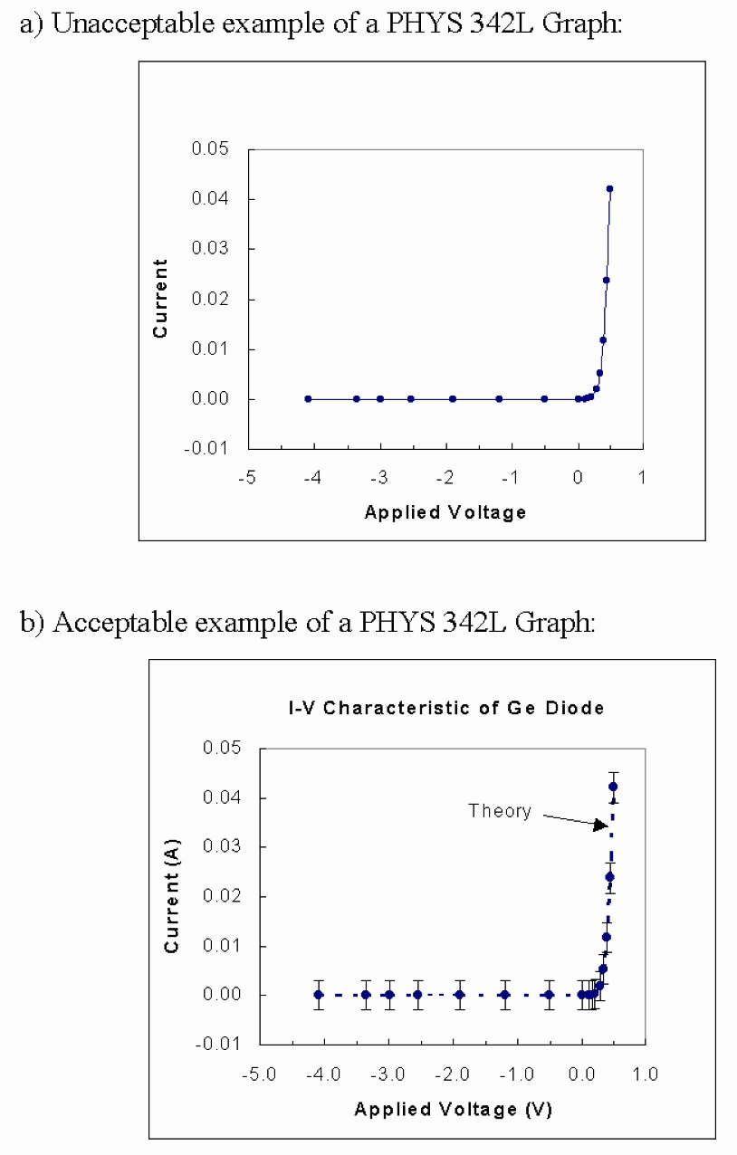

Figure 1: Examples of (a) unacceptable and (b) acceptable graphs.

Figure 2. Examples of acceptable graphs with >100 data points. Due to the large number of points ‘noise’ in the measurement is visible without error bars. In the case of multiple curves each curve is denoted by a letter which must be explained briefly in figure caption.
Appendix B: PHYS 342L ‘Formal Report’ Checklist

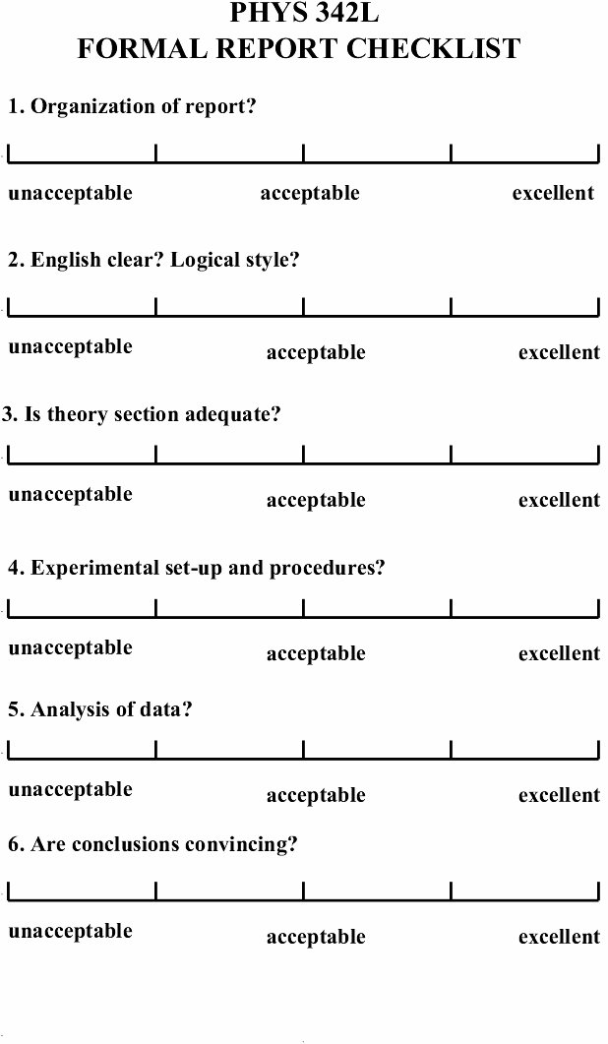
Figure 2: This check list will be used when grading your formal lab reports.

Appendix C: PHYS 342L ‘Notebook’ Checklist

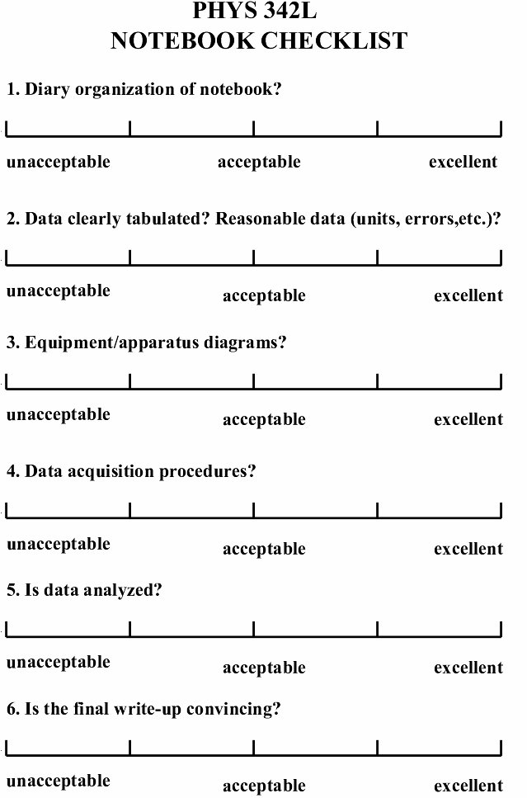

Figure 3: This check list will be used when grading your lab notebooks.

