RR August 2000
SS December 2001

Physics 342 Laboratory

Discrete Electron States in an Atom:
The Franck-Hertz Experiment

Objective: To measure the first excitation potential and the ionization potential of mercury atoms and to show that the energies of bound electrons are quantized.

References:
1. J. Franck and G. Hertz, Verhand Deut. Physik Ges. 16 ,10 (1914).
2. A.C. Melissinos, Experiments in Modern Physics, Academic Press, New York, 1966, pgs. 8-17.

Apparatus: Franck-Hertz tube, furnace, Kiethley Model 485 picoammeter, Wavetek Model DM2 digital voltmeter (optional), CASSY interface, 10 KΩ potentiometer, a.c. power supply for the furnace (Variac), two 1.5 V batteries, 0-100V d.c. power supply to accelerate electrons, 0-10 V d.c. Lambda power supply for heating the filament, Fluke Model 51 digital thermometer.

Introduction
An electron bound in an atom does not behave like a classical mechanical system, which can absorb arbitrary amounts of energy. Instead, as suggested by Bohr in 1913, an electron in an atom can exist only in definite discrete stationary states, with energies Eo, E1,... . In this model, atomic excitations are represented by transitions of an electron, bound to the atom, from its ground state energy to a higher level. Excitation to increasingly higher energies is facilitated by energy levels that lie closer together. Eventually, excitation beyond the ionization energy of the atom produces an electron which is no longer associated with the atom. Such an electron enjoys a continuum of available energy states. The essential features of this scheme are represented by an energy-level diagram as shown schematically in Fig. 1.
Horizontal lines in this figure represent “allowed” values (measured along the vertical axis) of the total energy (Ekin+Epot) of the most weakly bound electron in the atom. Notice that these discrete values are negative, indicating that these states are “bound” states of the electron; i.e. work has to be done in order to remove the electron from any of these states or “levels”. In particular, the lowest lying level E(0)ground, called the “ground state”, has the largest negative energy. When not excited, the electron and thus the atom stays in the ground state. Removal of an electron from an atom is called “ionization”. Thus, in order to ionize the atom in its ground state, an amount of work equal to -E(0)ground (or larger) has to be supplied to the atom.
“Excitation” of the atom occurs when the electron in its ground state absorbs energy, after which it is promoted to one of the higher bound states E(i)excited. Electrons in atoms can be excited in a number of ways, such as bombarding atoms by free electrons or illuminating atoms by light.

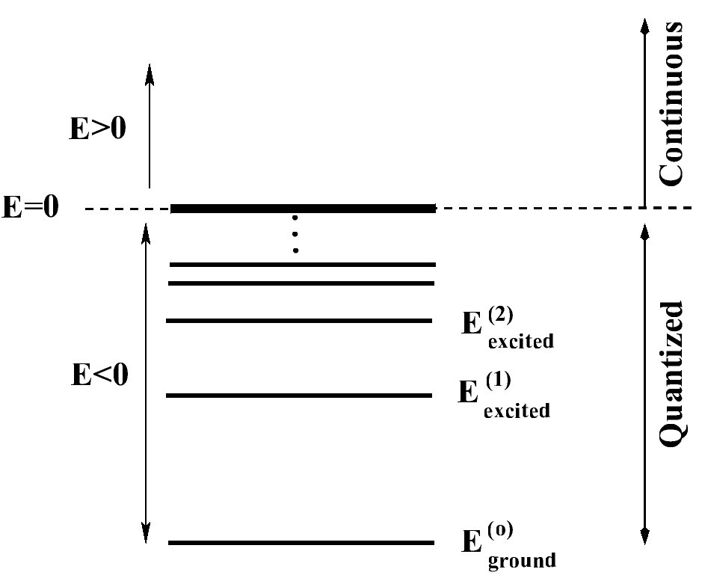
Figure 1: A schematic diagram showing the energy levels of an atom. The heavy solid lines represents the vacuum level and separates the quantized states from the continuum.

If an atom is supplied with energy by excitation from a free electron, then a bound electron can take up energy from the free electron only in quantized amounts ΔE equal to the difference in energy between the excited level and the ground state.

$${ΔE}_{i}=E_{\text{kin}}^{(\text{before})}−E_{\text{kin}}^{(\text{after})}=E_{\text{excited}}^{(i)}−E_{\text{ground}}^{(0)}$$

$E_{\text{kin}}^{(\text{before})}$ - kinetic energy of the bombarding free electron before collision,
$E_{\text{kin}}^{(\text{after})}$- kinetic energy of the bombarding free electron after collision,
$E_{\text{excited}}^{(i)}$- i-th excited state of the atom, and
$E_{\text{ground}}^{(0)}$ - ground state of the atom.

If an atom is bombarded with electrons whose kinetic energy are less than the first excitation energy of the atom, no exchange of energy between the bombarding electrons and the electrons bound to the atom can take place. (This of course neglects any small amount of energy that may be transferred in elastic collisions when the whole atom recoils without being electronically excited.) Thus, the electron in the atom remains in the ground state $E_{\text{ground}}^{(0)}$. If $E_{\text{kin}}^{(\text{before})}$ is equal to or greater than $E_{\text{excited}}^{(i)}$-$E_{\text{ground}}^{(0)}$, the electron in the atom can be promoted into the first excited state.
If a free electron is accelerated through mercury vapor having an appropriate atom number density, the probability of exciting the ΔE1 transition is much larger then exciting any other ΔEi transition. Thus in a sequence of n collisions with n different mercury atoms, the bombarding electron can convert nΔE1 energy into atomic excitations. Bohr’s quantum ideas were well supported by many studies of electromagnetic radiation from atoms where photons with definite energies were either emitted or absorbed. The historical significance of the Franck-Hertz experiment is that it provided convincing proof that energies of atomic systems are quantized not only in photon emission and absorption but also under particle bombardment.

The energy levels of Hg
In this experiment, you will probe the energy levels of a Hg atom. A neutral mercury atom has 80 electrons. These 80 electrons are distributed in a configuration specified by

1s2,2s2,2p6,3s2,3p6,3d10,4s2,4p6,4d10,4f14,5s2,5p6,5d10,6s2.

It is convenient to divide these 80 electrons into two broad categories often referred to as inner shell and outer shell electrons. We know that 78 of these electrons reside in inner shells (1s,2s,2p, etc.) and 2 of these electrons reside in the outermost 6s shell.
At low energy bombardment, only one of the two outermost electrons in the 6s shell is promoted to an excited state referred to as a triplet 6 3P1 state as shown in Fig. 2. The most probable excitation to this triplet state requires a 4.86 eV energy transfer to the bound electron of the mercury atom. The probability of excitation to higher levels of the 6s electrons or the probability of excitations of any inner shell electron is very low and need not concern you in this experiment.

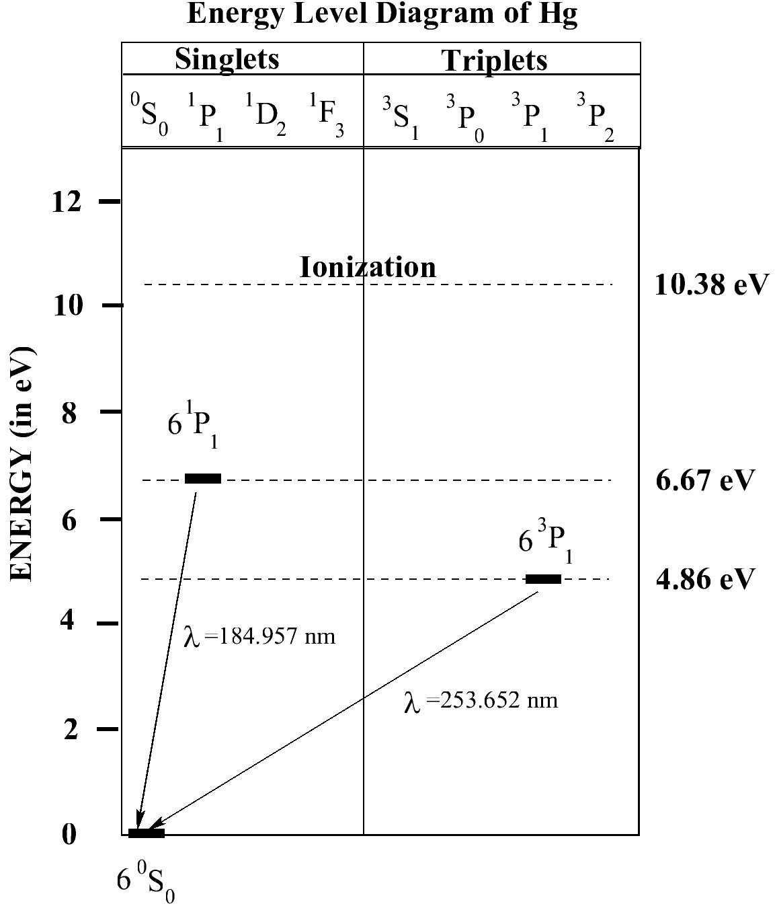
Figure 2: A term diagram showing the lowest lying energy levels for a mercury atom.

In general, the excited states are unstable, and the atom exists in that state only for a short time, typically 1 to 10 nanoseconds. When it returns to the ground state, an amount of energy =E(i)excited-E(0)ground=ΔEi is released in the form of electromagnetic radiation. The wavelength of the radiation emitted when the first excited state decays into the ground state (ΔE=4.86 eV) is 255 nm.

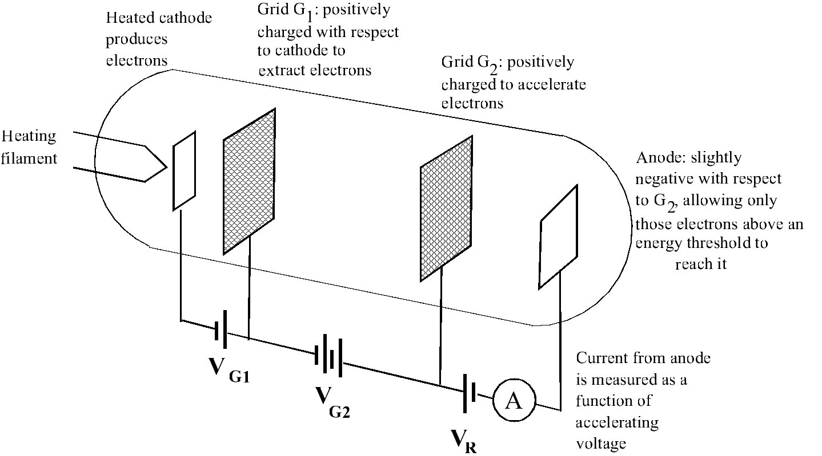

Figure 3: A schematic diagram illustrating the essential features of the Franck-Hertz experiment.

Experimental Considerations

The experiment described below is essentially the same as that performed by J. Franck and G. Hertz in 1914. Suppose a beam of electrons is produced between a heated cathode and an extraction grid G1 which is biased positively with respect to the cathode. Electrons passing through G1 are accelerated toward the grid G2 in a vacuum tube which has been evacuated of air molecules (See Fig. 3) by a positive voltage VG2 applied with respect to G1. At the grid G2, the kinetic energy of the electron is Kkin=eVG2, where e is the magnitude of the electron’s charge and VG2 is the potential difference between G1 and G2. Because of this kinetic energy, most electrons pass through the grid and reach the anode after being decelerated by the retarding potential VR, provided that |V_{R}|<|V_{G2}+V_{G1}|.
Now suppose mercury vapor at low pressure is let into the tube. This can be achieved by inserting a drop of mercury into a heated vacuum tube. As long as eVG2<ΔE1, the accelerated electrons may undergo many “elastic” collisions with Hg atoms, but they do not lose much energy because the Hg atom is much heavier than the electron. The electrons thus drift to the anode, through G2, causing an anode current Ia.
However, when ${\text{eV}}_{G2}={ΔE}_{1}=E_{\text{excited}}^{(1)}−E_{\text{ground}}^{(0)}$, it is possible to transfer the free electron’s kinetic energy to an internal electronic excitation of the Hg electron. Thus the incident electron is left with zero kinetic energy, i.e. zero velocity. If the collision takes place close to G2 the electron cannot re-gain enough speed to reach the anode.
To accomplish this, a slight retarding potential VR must be maintained between the G2 and the anode (see Fig. 3). Note that VR is retarding only for negatively charged particles. This prevents electrons which suffer inelastic collisions close to G2 from reaching the anode. The collective effect of many electrons suffering one such inelastic collision is the appearance of a minimum in the anode current Ia when plotted as a function of the accelerating potential VG2.
As the accelerating potential becomes larger (VG2>ΔE1/e), an electron can excite an atom at larger distances from G2. Thus after an inelastic collision, the electron can accelerate towards G2 and gain again enough kinetic energy to overcome the retarding potential and reach the anode. As a result, the anode current should then increase. Now suppose VG2=2ΔE1/e. At a point approximately halfway between G1 and G2, the electron reaches an energy ΔE1. This electron may undergo an inelastic collision, midway between cathode and grid, with a Hg atom. After colliding with the Hg atom, the electron is left with zero kinetic energy in the electric field, halfway between G1 and G2. Since the electron is half way between the grids, it will accelerate and gain ΔE1 energy as it approaches the second grid G2. In the vicinity of the grid it may again make a second inelastic collision with a second Hg atom, giving up its energy. This electron will be unable to reach the anode. This results in a second dip.
This reasoning makes it understandable that Ia not only decreases at VG2=ΔE1/e but in general at VG2=nΔE1/e. Between the values (n-1)ΔE1/e and nΔE1/e the current Ia increases monotonically with increasing VG2. The dips that occur at discrete potentials is an indication of the quantized character of the energy loss process. The first dip corresponds to the case when there is one inelastic collision in front of G2 with one Hg atom, the second when there are two inelastic collisions with two different Hg atoms, one is half way between G1 and G2, the second at G2, etc.

Experimental Technique:

A specially designed vacuum tube shown in Fig. 4 contains a small amount of Hg that is partially evaporated when the tube is heated inside a furnace. By heating the vacuum tube, the vapor pressure of of Hg can be adjusted. Besides the anode, the acceleration grid G2 and the cathode, the tube has an extractor electrode - grid G1. This grid helps to removes the charged cloud of electrons that forms in the region of the heated filament and cathode. The space charge cloud impedes electron emission from the cathode and thus reduces the flow of electrons towards the grid G2.

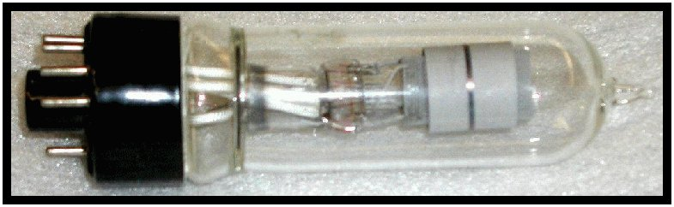

Figure 4: A photograph of a modern Franck-Hertz tube.

The temperature of the oven is measured using a Fluke Model 51 digital thermometer. This instrument measures the voltage from a thermocouple junction and converts the voltage to a temperature using a calibration table stored inside the instrument. Make sure that the junction is in the proper position i.e. approximately 5 cm down from the lid between the tube and inner copper cylinder. If the thermocouple junction touches the heating element and it is not insulated, it may cause a short circuit.
A photograph of the apparatus is given in Fig. 5

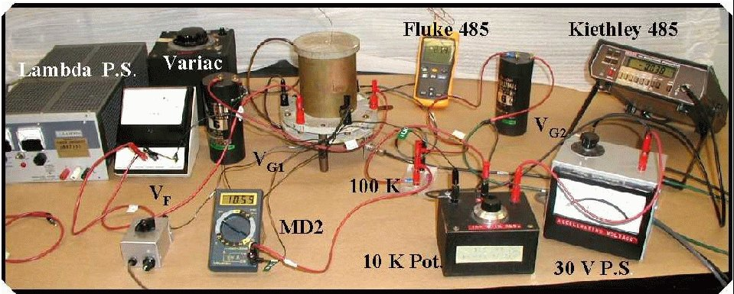
Figure 5: A photograph of the apparatus used to measure the first excitation energy for Hg atoms shown with optional Voltmeter MD2. To record data using computer attach CASSY interface (not shown) as follows: connect UB1 in parallel with (or instead of) voltmeter MD2, and connect analog output of the picoammeter Kiethley 485 to UA1 (voltmeter) input of CASSY interface.

Setting up Cassy Lab program for data acquisition.
Start Cassy Lab program and initialize both voltmeters. Set the display x-axis to show UB1 (V_{G2}) and y-axis to show UA1 (proportional to current). Set both voltmeters to measure mean signals, i. e. to average signals during 100 ms. This will dramaically reduce the noise by suppressing lectrical noise at frequencies above 10 Hz. The main source of noise is induced by AC current in power lines (60 Hz). Set the data acquisition period also to 100 ms. Leave total data acquisition time blank. Next, check the Condition box in measurement window and type in the following condition:
n=1 or delta(UB1)>0.05
The above setting tells the proram to take the next data point (UB1, UA1) if the first point is being measured (n=1), or when the UB1 value changes by more than 0.05V. The condition is checked every 100 ms, as specified by data acquisition period.

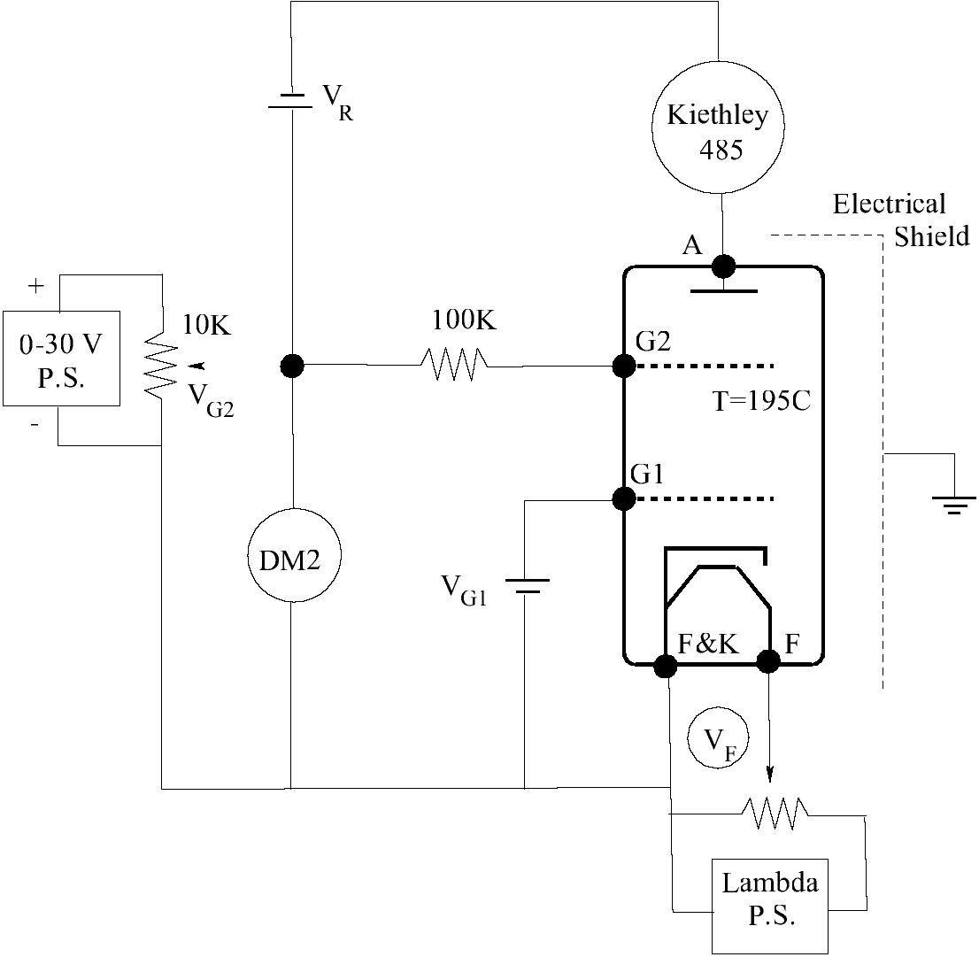
Figure 6: A wiring diagram to measure the first excitation energy for Hg atoms. For computerized data acquizition, CASSY interface UB1 is connected in parallel with (or instead of) DM2, and Kethley 485 picoammeter analog output is connectet to UA1 voltmeter input of the Cassy interface.

MEASUREMENT OF FIRST EXCITATION POTENTIAL OF MERCURY
Set-up Sequence:
(a) Turn on the Kiethley 485 picoammeter and the Lambda power supply. Make sure the Lambda power supply is set to the 7V range.
(b) Turn the oven Variac to 40 V and then switch it on. When the temperature reaches about 170° C reduce the setting to what is marked on each Variac by an arrow so that the temperature increases slowly to 195oC. Under no circumstances let the oven temperature exceed 210oC. The tube will explode. The final Variac setting and temperature should be such as to allow you to obtain three to five good peaks in the anode current as the grid voltage VG2 on G2 is varied. Always vary the oven power gradually, not by more than 4 divisions on the Variac at a time.
(c) Wire the circuit as shown in Fig. 6. Do not connect the batteries and do not plug in the filament power supply at this time. Set the Wavetek Model DM2 (if used) to the 20 V d.c. scale, and set the UB1 Cassy voltmeter to ±30V range. Set the Kiethley 485 picoammeter to the 2 μA scale. Since the picoammeter is an extremely sensitive instrument, keep it on the 2 μA scale when taking preliminary data. Set the UA1 Cassy voltmeter (which monitors picoammeter output) to ±3V. Set the d.c. power supply which provides the accelerating voltage to 30 V.
(d) Have your wiring checked by the lab instructor. Make sure the initial setting of the 10KΩ potentiometer is such that VG2=0 V.
(e) Connect the two 1.5 V batteries which are used for VR and VG1. Set VG2 to 20V. Raise the filament voltage VF until the Kiethley 485 reads roughly 0.020 μA (20 nA). DoUnder no circumstances should filament vomtage exceed 7V as it may be permanently damaged! Take your time because the tube filament changes temperature slowly as the the voltage across it is adjusted. The final value of VF will be somewhere between 4V and 7V, depending on the age of the tube.
(g) After adjustment of VF the anode current should remain rather constant when the circuit is wired correctly, the contacts are tight, and the vapor in the tube is in thermal equilibrium. If the current fluctuates wildly, tighten the wire contacts on the banana plugs and panel-jacks and wait for thermal equilibrium. See that the heater shield wire is connected to common ground.

Data Acquisition:
(a) When the current has stabilized, increase the acceleration voltage V_{G2} to 30 V. Select the highest sensitivity range on picoammeter in which there is no signal overload. Check that the Cassy UA1 voltmeter range is suitable for measuring picoammeter output voltage. Record the conversion factor between UA1 reading and actual current, you will need it later to convert the data accumulated by Cassy Lab program to current.
(b) Decrease the acceleration potential VG2 to zero.
(c) Start data acqusition program. Immediately the first data point should appear (something like (0.001, 0.002). If more points appear then stop the data acquisition and ask your instructor to check data acquisition settings.
(d) Increase V_{G2} up to 30V at a moderate pace (~1 V/s). As As V_{G2} rises by >0.05V the next data point will be measured by the program automatically, you should be able to see the graph I_{a} versus V_{G2} as it is being measured. Stop data acquisition as you reach 30V. Rescale the Cassy graph if necessary for better view. You must be able to observe at least 2 oscillations in current. If you do not see them consult your instructor. If everything looks right proceed to the next step.
(e) Discard the data you have acumulated, set the V_{G2} to 0 again, start data acquisition and repeat the measurent. But ths time increase V_{G2} slowly to 30V. See that not more than few points are measured every second (i.e. spend ~5 minutes for the whole range), as the condition is checked only 10 times a second. The anode current (Ia) as function of VG2 will be recorded automatically. Save your data.

Data analysis.
(a) Make a preliminary print of your data and insert it into your notebook. Don’t forget to record all the conditions alongside the graph: oven temperature, V_{G1}, and the filament voltage V_{F}.
(b) Based on this graph, roughly estimate the first excitation potential of the mercury (ΔE₁) by measuring the distance (in Volts) between the local maxima preceding the first and second local minima in the anode current. Also, estimate the standard deviation in measuring ΔE₁ from your measurements. Check whether the accepted value for ΔΕ₁=4.86 eV falls within the range that you found experimentally.
(c) From the same graph, determine the contact potential V_{contact} between the cathode and G2 by subtracting the value of the first excitation potential ΔE1 from the value of VG2 at the first local maximum that you measured. Estimate the error involved. The contact potential is caused by the difference in work functions between the materials used to fabricate the cathode and G2.
Note: for final report you must convert UA1 voltage into actual current. Don’t forget to record conversion factor in your notebook!

Repeat measurement for lower anode current:
(a) Set the V_{G2} to 20V and reduce the filament voltage until the Kiethley 485 reads roughly 0.005 μA (5 nA). Repeat the measurement of I_{a}(V_{G2}) as described above.
(b) Perform preliminary analysis of your data. Do the values for ΔE₁ and V_{contact} depend on anode current (filament voltage)?
MEASUREMENT OF THE IONIZATION POTENTIAL OF MERCURY
If a free electron is given sufficient energy, it is possible to excite an electron from the ground state of a Hg atom into the continuum, thus producing a positive Hg ion. Since a Hg ion is quite a bit heavier than the bombarding electrons, it’s velocity will be small and it will have a shorter mean free path between collisions than the bombarding electrons. In order to detect these ions, you must therefore reduce the vapor pressure of the mercury inside the tube by lowering its temperature. In this experiment, you will measure the onset of the ion current produced by Hg ions formed during the collision of electrons with mercury atoms. To measure this quantity, the anode is made slightly negative with respect to the cathode. Thus, the electrons cannot reach the anode, which becomes a positive ion collector (See Fig. 7).

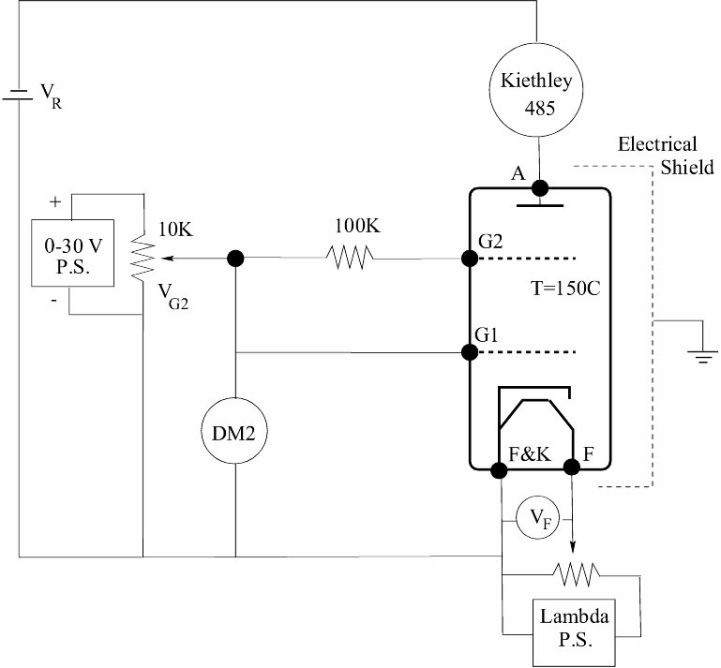
Figure 7: A wiring diagram for measuring the ionization energy of Hg atoms. Conection to CASSY interface is the same as in the previous experiment (not shown).

Set-up Sequence:
(a) Lower the Variac setting to obtain a stable oven temperature of 150o C.
(b) Remove the battery VG1.
(c) Reconnect VR as is shown in Fig. 7.
(d) Change the measuring condition in the Cassy Lab program to:
n=1 or delta(UB1)>0.02
(accumulate data points every 0.02V).
Data Acquisition:
Set V_{G2} to zero and set picoammeter sensitivity to 2 nA. Record the ion current I_{i} versus V_{G2} as described in the first part. Increase V_{G2} slowly while observing I_{i} value. At ~12V I_{i} will suddenly rise very rapidly. Stop measurement when I_{i} reaches ~1.5 nA. Save the data and estimate the Swictch picoammeter to 20 nA and repeat the measurement, this time let the current rise to 15 nA. Don’t forget to record conversion factors for coverting Cassy voltmeter values to actual current.

Data Analysis:
(a) You have measured the ion current Ii as a function of the accelerating potential VG2. Plot these measurements on a Ii vs. VG2 graph. You do not need to show error bars since there are ~500 points in your graph, the error can be estimated visually by the scattering in data points.
(b) In most cases, the current Ii remains zero for small VG2 then suddenly increases dramatically. Devise a procedure to determine your best estimate for the value of VG2 at which Ii starts rising. From this value subtract the value of the contact potential, you obtained in part 1 for this experiment. The result is the ionization potential of mercury. Estimate the error in your result and then compare it with the accepted value of 10.38 eV. Sometimes, Ii as a function of VG2 behaves somewhat differently. At a value of VG2 smaller than the ionization potential you will measure a small increase in the current. When you increase VG2 further, the value of Ii will remain fairly constant until suddenly the current will start rising very fast. Develop a procedure to determine the value of VG2 for which the dramatic increase in Ii sets in. You obtain the ionization potential by subtracting the contact potential from this value. A good explanation of this phenomenon is given in the book by A.C. Melissinos.
(c) Discuss your errors. How important is the temperature of the tube? How sensitive are your measurements to VF? Do you understand the purpose of the 100 KΩ resistor in the circuits you have constructed? Do you understand why you have used a shielded BNC cable when measuring the anode current? Did the current reverse polarity when measuring Ia and Ii. Why?

Since the energy of an electron accelerated in electric field is proportional to the potential difference, it is often measured in eV (electron-Volts) units, i. e. an electron accelerated by 1 V potential difference acquires energy 1 eV; 1 eV=1.602×10⁻¹⁹ J.

