RR 7/00
SS 12/01

Physics 342 Laboratory

The Determination of e/m for Electrons

Objective: To determine the charge to mass ratio of electrons.

Apparatus: Vacuum tube (Bainbridge); Helmholtz coil pair; calibrated meters to measure current and voltage; 300 V power supply; 6.3V ac power supply; Sargent-Welch interface box.

References:
1. J.J. Thomson, Phil. Mag. 44, 295 (1897).
2. K. T. Bainbridge, The American Physics Teacher 6, 3 (1938).
3. Common Apparatus AAPT Novel Experiments in Physics (Am. Inst. of Physics 1964) pp. 237-41.
4. J.R. Reitz and F.J. Milford, Foundations of Electromagnetic Theory, (Addison Wesley; Reading, Massachusetts; 1969), pgs. 156-57.

Introduction
The first experimental evidence for the granular nature of electricity can be found in Michael Faraday’s work on electrochemical processes in 1839. Prior to Faraday’s work, electricity was considered a ‘fluid’ that could be added or subtracted in a continuous fashion from objects. It was subsequently discovered that metals emitted negative electrical current when heated, illuminated by light, or subjected to a strong electric field. It was shown that the negative current was comprised of particles carrying a negative charge of 1.6×10-19 C. These negative particles were found to be universally detected whenever a negative current was emitted from an electrode. Surprisingly, they were not related to the particular metal from which the emitting electrode was fabricated, thus providing strong evidence for their fundamental nature. In 1874, C. Johnstone Stoney dubbed these particles electrons.
Early attempts to measure the mass of electrons proved futile. To address this issue, various direct experiments were devised. For instance, if a metal sphere of 1 meter radius is charged to a potential of -1×106 V, you can quickly estimate that about 7×1014 electrons must be added. Yet attempts to directly measure the mass increase of such an electrified sphere from the added electrons yielded no conclusive results. As a consequence, it was argued that the mass of an electron must be very, very small compared to any atomic masses that were known in the late 1800’s.
Indirect methods were therefore sought to measure the mass of these negatively charged particles. J. J. Thomson in 1897 was the first to succeed in this endeavor. Since the amount of charge carried by each electron was known independently, the mass of an individual electron could be inferred if the charge to mass ratio was known. Thomson’s experiments combined both ingenious insight and the use of recent advances in vacuum pumps and charge measuring devices (electrometers). Using clever calorimetric techniques, he measured the temperature rise of thin metal targets inserted into a glow discharge (first produced by Faraday, when two metal plates were inserted inside an evacuated glass tube and raised to a high electrostatic potential). This strategy enabled Thomson to calculate the energy imparted to the metal targets by the invisible particles responsible for producing the glow. By assuming the invisible particles followed Newton’s laws of motion (at the time, there was no reason to suspect that this might be the case), he was able to estimate the velocity of the particles responsible for the glow discharge. He also used crossed electric and magnetic fields to further study the motion of these invisible particles.
As a result, Thomson concluded (within the accuracy of his measurements) that a negatively charged particle with a mass to charge ratio of 1.3±0.2×10-11 kg/C was responsible for producing the glow discharge. This mass to charge ratio was roughly 103 times smaller than any ratio previously recorded for atoms or molecules. For this reason, he was forced to postulate the presence of a new particle now called the electron. The modern, accepted value for the mass to charge ratio of an electron is 0.568568±0.000001×10-11 kg/C.
The importance of Thomson’s work was recognized by the Noble Prize in physics in 1906. In this experiment, you will perform a modification of Thomson’s original work. By measuring the deflection that a magnetic field produces on a beam of electrons having a known energy, you will deduce a value for the charge to mass ratio of electrons.

Theory
A charged particle moving in a magnetic field experiences a force $\vec{F}$ given by

$\vec{F}=q\vec{v}×\vec{B}$ (1)

where q is the charge of the particle, $\vec{v}$is the particle’ s velocity, and $\vec{B}$ is the magnetic field. If $\vec{v}$ is perpendicular to $\vec{B}$, the resultant trajectory is circular. Using Newton’s laws of motion, the radius of curvature is given by

$R=\frac{\text{mv}}{\text{qB}}$ (2)

where m is the mass of the charged particle.
Although R and B in Eq. 2 can be measured experimentally, determining the velocity v is more problematic. Progress can be made by using conservation of energy considerations. If a charged particle is initially at rest and is accelerated through an electric potential difference V, then the kinetic energy after acceleration is equal to the the change of the potential energy qV. From the conservation of energy principle we know that

$\frac{{\text{mv}}^{2}}{2}=\text{qV}$ (3)

Eliminating the velocity v from Eqs. (2) and (3), we obtain

$\frac{q}{m}=\frac{2V}{B^{2}R^{2}}$ (4)

Since the charge of an electron is particularly important, we often use its special symbol e instead of q.
To calculate the e/m ratio for an electron we need to know the accelerating potential V, the value of the magnetic field B and the radius R of the circular path of the electron beam. Since it is hard to detect a single electron, we will use a beam of electrons in which all have approximately the same kinetic energy.
Experimental Method
In this experiment, a beam of electrons is produced by an electron gun composed of a filament surrounded by a coaxial anode (i.e., electrode with a positive charge) as shown in Fig. 1. Electrons thermally emitted from the heated filament are accelerated by a known potential difference V between the filament and the anode. The source of electrons in this experiment is a metal plate called the cathode. The cathode is often coated with a chemical slurry comprised of metal carbonates having a low work function. This enhances electron emission from a material in which the free electrons are only slightly bound, producing measurable emission currents for modest filament temperatures. The cathode can be either in thermal contact with the filament or have both the function of the cathode and filament combined. Thus by heating the cathode, electrons gain enough energy via thermal excitation to emerge from the cathode surface as free particles. This process is called thermionic emission. The kinetic energy and velocity of the electron beam may be calculated using Eq. (3).

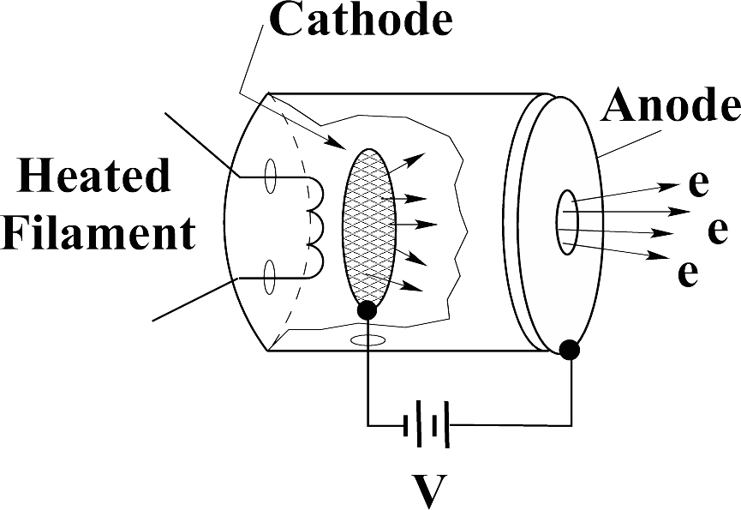
Figure 1: A schematic diagram of a simple electron gun showing the filament (heating power supply not shown), the cathode, the anode and the accelerating voltage V.

During construction, the air in the e/m tube is evacuated and the tube is backfilled with a small quantity of helium gas at a pressure of ∼10-2 mm Hg (approx. 100,000 times smaller than atmospheric pressure) before permanent sealing is performed. The electron beam leaves a visible trail in the tube because some of the electrons collide with helium atoms and promote Hg atoms into electronically excited state. These excited atoms thereafter emit visible light as they return into ground state. This visible light observed in 1838 by Faraday was the faint glow produced when electrons collided with residual gas atoms left inside the tube by the inefficient vacuum pumps that were then in use.

Experimental Equipment
A side view of the e/m apparatus is shown in Fig. 2. The important aspects of this apparatus are a vacuum tube containing an electron gun (see Fig. 3) which produces a narrow beam of electrons of known energy having a velocity perpendicular to an applied magnetic field produced by a pair of coils arranged int he Helmholtz configuration.

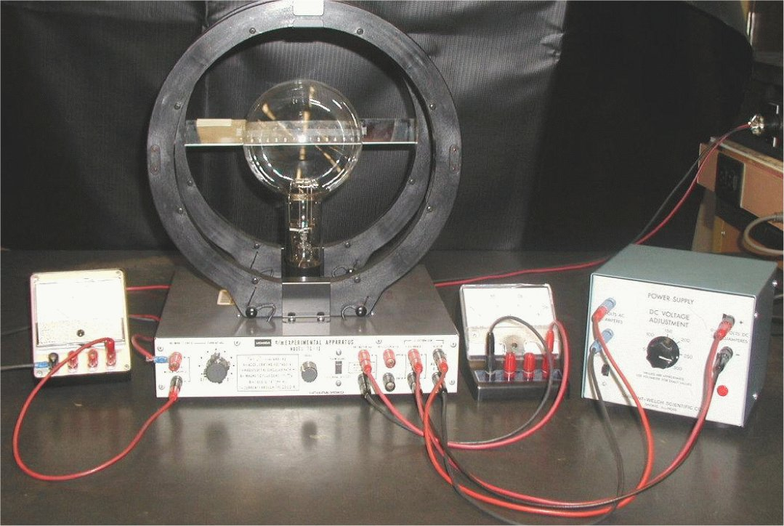
Figure 2: A photograph of the e/m apparatus (side view).

A pair of Helmholtz coils produces a uniform and measurable magnetic field at right angles to the electron beam. This magnetic field deflects the electron beam into a circular path. By measuring the accelerating potential, the current to the coils, and the radius of the circular path of the electron beam, e/m is calculated from Eq.(4).

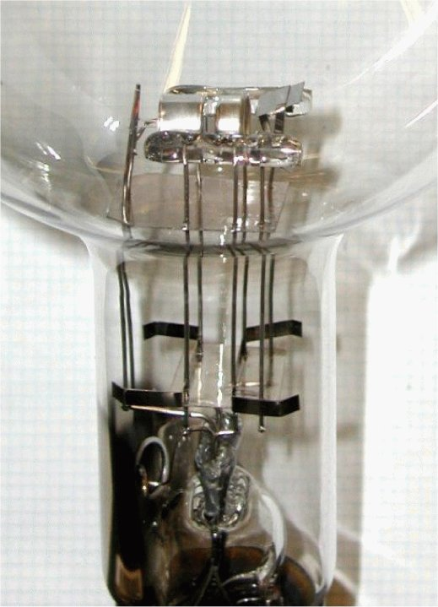
Figure 3: A close-up picture of the e/m electron gun. From this view, the electron beam emerges to the right.

The geometry of a Helmholtz coil pair is dictated by the need to produce a highly uniform magnetic field over an extended region in space. For a Helmholtz coil pair, the radius of the coils is equal to their separation. This geometry is known to provide a highly uniform magnetic field.
The Helmholtz coils for the e/m apparatus you will use each have 130 turns. The magnitude of the magnetic field B produced at the axial mid-point of the Helmholtz pair is proportional to the current through the coils I and is given by the following formula

$B=\frac{8{Nμ}_{0}}{5\sqrt{5}a}I=\text{kI}$, (5)

where N is the number of turns in each Helmholtz coil, a is the radius of each coils in meters, and μ₀ is the permeability of free space (μ₀ =4π×10-7 T.m/A).
The field constant for these coils, k = B/I (in T/A), gives a measure of how many Teslas result when 1 A of current passes through the coils. The ‘A’ wall outlet, connected to a 9V DC power supply, provides the current to the Helmholtz pair. Using the current adjust knob of the e/m apparatus, you can adjust the value of the current through coils between roughly 1 - 2A.
In principle, the magnetic field needed to produce the observed curved paths for the electron beam is small, so the effect of the earth’s magnetic field must be taken into account. One way to minimize any effects due to the earth’s field is to rotate the apparatus so the local earth’s field is parallel to the motion of the electron beam (see Eq. 1). For precise work, the tube and the coils should be rotated in order to achieve the proper orientation. However, within the error margins of this particular experiment the effect of the earth’s magnetic field proved to be unimportant. On the other hand, the effect of permanent magnets may be substantial - any permanent bar magnets should be far removed from the apparatus when this procedure is performed.
The power supply (made by Sargent-Welch) provides two necessary voltages:
- A fixed, low voltage, 6.3V AC voltage (blue binding posts) for heating the filament of the e/m tube.
CAUTION: The voltage to the heater of the filament should never exceed 6.3 volts. Higher voltage will burn out the filament and destroy the e/m tube.
- An adjustable (0 - 300V) DC voltage used for acceleration of electrons between the cathode and the anode. You can adjust the value of that voltage by turning the knob labeled: “DC VOLTAGE ADJUSTMENT”. The scale around the knob is only for estimation purposes. You need to read the value of the accelerating voltage from a separate voltmeter using the 0 - 300V scale.
The control panel of the e/m apparatus is straightforward. All connections are labeled. A mirrored scale is attached to the back of the rear Helmholtz coil. It is illuminated by an automatic lamp that is actuated when the heater of the electron gun is powered. By aligning the electron beam up with its image in the mirrored scale, you can measure the radius of the beam path without parallax error.
The Fig. 4 shows the electrical connections for the e/m apparatus.

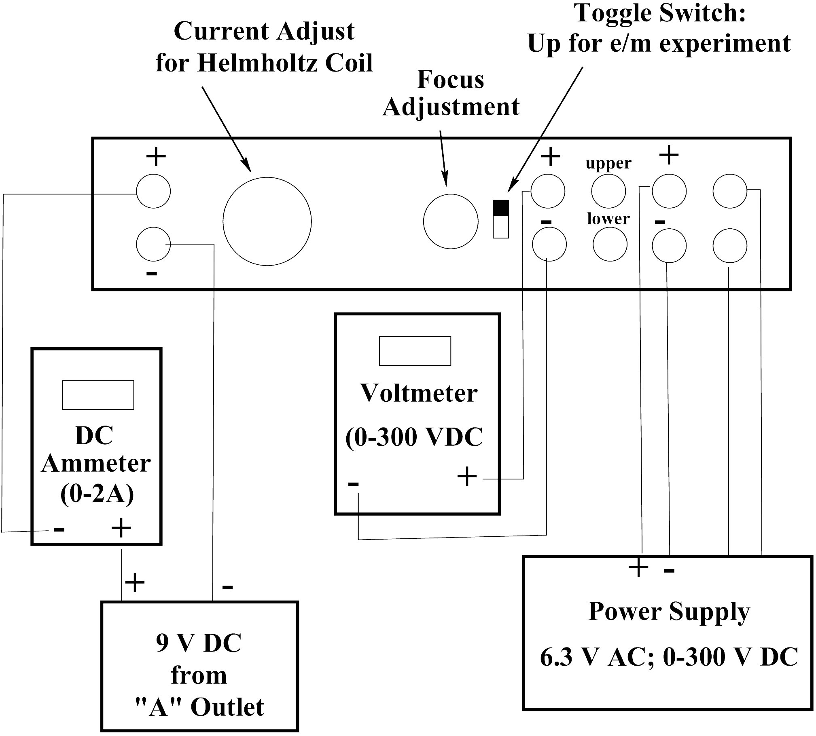

Figure 4: Electrical connections for e/m apparatus.

Experimental Procedure

1. Flip the toggle switch up to the “e/m MEASURE” position.
2. Turn the current adjust knob for the Helmholtz coils and knob labeled “DC VOLTAGE ADJUSTMENT” on the POWER SUPPLY to the zero position (counterclockwise).
3. Before applying any power, check to make sure that all connections correspond to the wiring diagram shown above. If you do not have full confidence that the circuitry is OK - ask your TA to check it for you.
4. Calculate the field constant k of the Helmholtz coils and write it in your lab notebook now.
5. Turn the power supply on. The filament inside the tube should begin to glow red. Then, plug the low voltage (Helmholtz coils) cable into the wall socket labeled “A”.
6. Slowly turn the current adjust knob for the Helmholtz coil clockwise. Watch the ammeter and take care that the current does not exceed 2A. Set the value at 1.4A.
- Wait 2 minutes for the cathode to warm-up. Then apply an accelerating voltage of 200V. You will see the electron beam emerge from the electron gun and it will be curved by the field from the Helmholtz coils. You may need to increase the voltage slightly if the beam does not emerge from the electron gun.
- Check that the electron beam is slightly helical so that it does not strike the back of the electron gun shield on its path. If it strikes the gun the shielding box is charged and the electron velocity emerging from the gun tend to be noticeably lower as it takes some energy to overcome the negative field of the shield. Why is it possible to produce a helical path? If it is not helical and strikes the gun, then ask TA to rotate the tube. As you rotate the tube, the socket will also turn - no need for taking tube out of socket. Adjust the knob labeled “FOCUS” to get the sharpest image.
- Estimate the angle of the emerging electron beam in respect to the magnetic field. Represent the speed of the beam as two of its components – one perpendicular to magnetic field and one parallel to B. The perpendicular component of the speed is to be used in equations 2-4. Is the difference total speed and its perpendicular component significant? If it is so you may need to use the revised version of the equation 4:
$\frac{q}{m}=\frac{2V{\text{sin}}^{2}\left(α\right)}{B^{2}R^{2}}$, (6)
where α is the angle between magnetic field vector B and electron speed v.
10. You are about to measure series of (V,R) parameters which will be later used to calculate e/m. Think of the best way to record your data in your notebook.
11. Set the value of the current through the coils to 1.4A and the accelerating voltage to 200 V. Remember to read the value of the accelerating voltage from the voltmeter - not from the scale on the power supply. Carefully measure the radius of the electron beam. Look through the tube at the electron beam. To avoid parallax error, move your head to align the electron beam with the reflection that you can see on the mirrored scale. Measure the radius of the beam as you see it on both sides of the scale, then take an average for the final result. This procedure is required because the zero of the mirrored scale is slightly shifted from the center of the beam track.
12. Repeat measurements for the same value of current: I = 1.4A, but for the following values of accelerating voltage: V = 220V, 240V, and 260V.
13. Change the value of magnetic field B by setting the current through the coils to 1.6A. Repeat measurements for V = 200V, 230V, 260V and 290V.
14. Change the value of magnetic field B by setting the current through the coils to 1.8A. Repeat measurements for V = 200V, 230V, 260V, and 290V.
15. In order to obtain reasonable estimates for e/m, repeat the above set of measurements two more times.
16. Turn the current adjust knob for the Helmholtz coils and the knob labeled “DC VOLTAGE ADJUSTMENT” to the zero position (counterclockwise).
17. Turn the power off.

Data Analysis
The acquisition of data in this experiment is straightforward. The challenge is to interpret the data in a meaningful way and to arrive at realistic uncertainties for the various quantities that are used in the final computation of e/m. If the experiment is performed as described above, you will have about 13 sets of data from which to calculate e/m. By repeating the data acquisition three times, you will therefore have about 39 independent data sets to estimate a best value for e/m.
Think about how best to present your data. Should you just perform a straightforward average of all 39 independent measurements? If you average the values of e/m obtained under the same experimental conditions, can you obtain an estimate for the accuracy of your experimental techniques? Are the e/m values calculated in your experiment the same as the known value of e/m within the error of experiment? Is there any evidence of systematic error? Note, that there are only three measured values in this experiment: R, B and V. The R measurement accuracy can be easily estimated. Using gaussmeter, we have also checked the actual B values within the vacuum tube area, they turned out to be the same within 5% of the values predicted by Eq. 5. The only parameter which could not be independently verified was the energy of the electrons. If there is considerable discrepancy between the known and measured e/m values estimate the actual energy of the electrons emerging from the electron gun as a function of accelerating voltage V.
Other issues that you might want to consider are estimates of the magnitude of electron’s velocity in this experiment. Are relativistic corrections required? Can you estimate the spread in the energy of the electrons in the beam by estimating the spread in radius of the beam’s trajectory?
These are some of the issues you must consider when analyzing your data and writing your report. Whatever issues you choose to pursue, always try to be as quantitative as possible. At the end of the day, be sure to include a clear and concise discussion of your best estimate for e/m and how it compares to accepted values.

