RR July 2000
SS Dec 2001

Physics 342 Laboratory

The Wave Nature of Light: Interference and Diffraction

Objectives: To demonstrate the wave nature of light, in particular diffraction and interference, using a He-Ne laser as a coherent, monochromatic light source.

Apparatus: He-Ne laser with spatial filter; photodiode with automatic drive, high voltage power supply for the laser, amplifier, computer with CASSY interface (no pre-amp boxes required), slits on a photographic plate, spherical and cylindrical lenses, diaphragm, and a razor blade.

References:
1. D. Halliday, R. Resnick and J. Walker, Fundamentals of Physics; 5th Edition, Wiley and Sons, New York, 1997; Part 4, pgs. 901-957.
2. E. Hecht, Optics, 2nd Edition, Addison-Wesley, Reading Massachusetts, 1974. Chapter 9 on interference, Chapter 10 on diffraction.
3. D.C. O’Shea, W.R. Callen and W.T. Rhodes, Introduction to Lasers and Their Applications, Addison-Wesley, Reading Massachusetts, 1978.

Introduction
In 1678, Christian Huygens wrote a remarkable paper in which he proposed a theory for light based on wave propagation phenomena, providing a very early theoretical basis for the wave theory of light. Because Huygens’ theory could not explain the origin of colors or any polarization phenomena, it was largely discarded for over 100 years.
During the early 1800’s, Thomas Young revived interest in Huygens theory by performing a series of now famous experiments in which he provided solid experimental evidence that light behaves as a wave. In 1801, Young introduced the interference principle for light which proved to be an important landmark and was hailed as one of the greatest contributions to physical optics since the work of Isaac Newton.
The interference principle was independently discovered by Augustin Fresnel in 1814. Unlike Young, Fresnel performed extensive numerical calculations to explain his experimental observations and thereby set the wave theory of light on a firm theoretical basis.
The interference and diffraction experiments performed by Young and Fresnel require the use of a coherent light source. While coherent light is difficult to produce using conventional sources, the invention of the laser now makes intense coherent light readily available. In this experiment, you will reproduce some of Young and Fresnel’s important discoveries using light from a He-Ne laser. In this way, you will become familiar with a few of the basic principles surrounding the wave theory of light. The remarkable successes of this theory explains why it was so prominent throughout the 1800’s and why it was so difficult to challenge, even when convincing evidence for a quantized radiation field began to emerge in the 1890’s.

Theoretical Considerations

Fraunhoffer diffraction, Fresnel diffraction

Diffraction phenomena are conveniently divided into two general classes,

- Those in which the light falling on an aperture and the diffracted wave falling on the screen consists of parallel rays. For historical reasons, optical phenomena falling under this category are referred to as Fraunhoffer diffraction.
- Those in which the light falling on an aperture and the diffracted wave falling on the screen consists of diverging and converging rays. For historical reasons, optical phenomena falling under this category are referred to as Fresnel diffraction.

A simple schematic illustrating the important differences between these two cases is shown in Fig. 1.

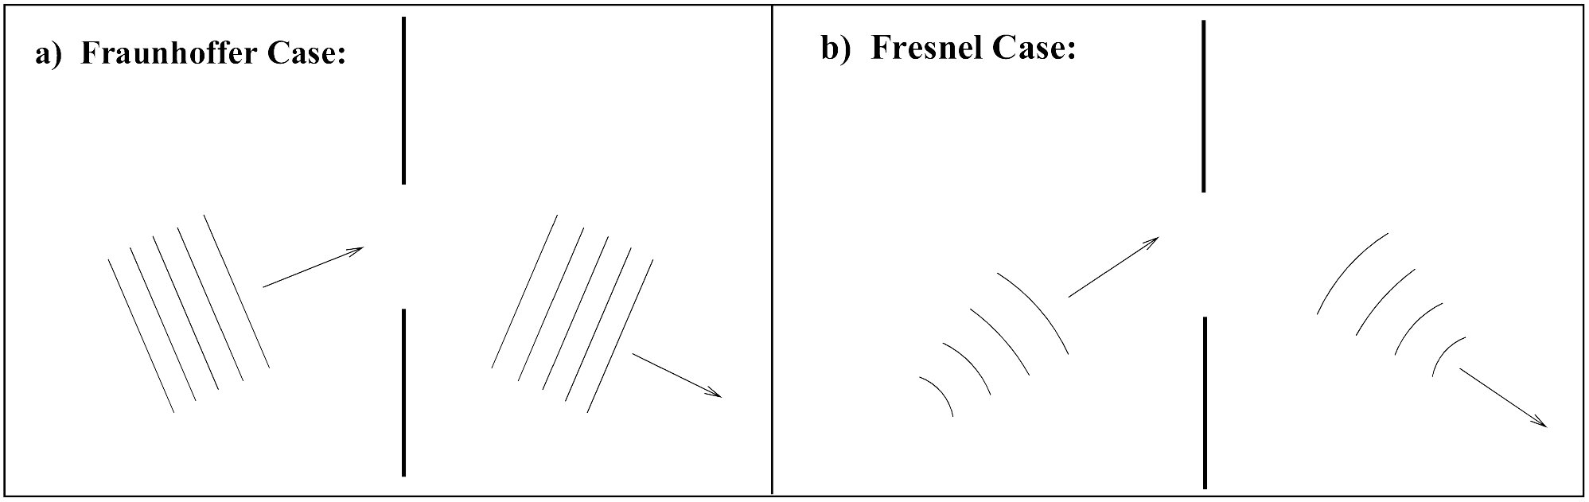

Figure 1: Qualitatively, Fraunhoffer diffraction (a) occurs when both the incident and diffracted waves can be described using plane waves. This will be the case when the distances from the source to the diffracting object and from the object to the receiving point are both large enough so that the curvature of the incident and diffracted waves can be neglected. For the case of Fresnel diffraction (b), this assumption is not true and the curvature of the wave front is significant and can not be neglected.

Fraunhoffer diffraction is much simpler to treat theoretically. It is easily observed in practice by rendering the light from a source parallel with a lens, and focusing it on a screen with another lens placed behind the aperture, an arrangement which effectively removes the source and screen to infinity. In the observation of Fresnel diffraction, on the other hand, no lens are necessary, but here the wave fronts are divergent instead of plane, and the theoretical treatment is consequently more complex.
The important guiding principal of all interference and diffraction phenomena is the phase φ of a light wave. For light having a wavelength λ, the phase of the light wave at a given instant in time is represented by

$φ=\frac{2π}{λ}×d$. (1)
where d is distance travelled by light. If a light beam is equally split and the two split beams travel along two different paths 1 and 2, then the phase difference Δφ between the two beams when they are recombined (after traveling distances x1 and x2) can be defined as

$Δφ=φ_{2}−φ_{1}=\frac{2π}{λ}×\left(x_{2}−x_{1}\right)$. (2)

In the wave theory of light, the spatial variation of the electric (or magnetic) field is described by a sinusoidal oscillation. When discussing interference and diffraction effects, Δφ appears in the argument of this sinusoidal function. Since the intensity I of a light wave is proportional to the square of its electric field vector, the intensity of two beams interfering with each other will be determined by factors proportional to sin2(Δφ) or cos2(Δφ). The exact expression for Δφ depends on the detailed geometry involved, but in general, Δφ=π/λ × (geometrical factor).
A few important cases have been worked out in detail and the relative intensity variation I(x)/I(0) produced by a coherent, monochromatic light beam as a function of position x along a viewing screen are given below. Because of the periodic nature of sinusoidal functions, they exhibit local maximums and zeros as the phase varies. The precise location of the maximums and zeroes can often be established by a calculation of the phase difference Δφ.

Single Slit (Fraunhoffer limit)
If coherent light having a wavelength λ is made to pass through a long narrow slit of width a, then the relative light intensity as a function of lateral displacement x on a viewing screen located a distance R0 from the slit is given by the expression:

$\frac{I(x)}{I(0)}={\left[\frac{\text{sin}\left(\frac{πa}{{λR}_{0}}x\right)}{\frac{πa}{{λR}_{0}}x}\right]}^{2}={\left(\frac{\text{sin}u}{u}\right)}^{2}$ (3)
where:
a = width of the slit
λ = wavelength of radiation
R0 = distance between cylindrical lens and viewing plane
$$u≡\frac{πa}{{λR}_{0}}x$$

Double Slit (Fraunhoffer limit)
If coherent light having a wavelength λ is made to pass through two long narrow slits of width a with a center-to-center separation b, then the relative light intensity as a function of lateral displacement x on a viewing screen located a distance Ro from the slits is given by the expression:

$\frac{I(x)}{I(0)}={\left[\frac{\text{sin}\left(\frac{πa}{{λR}_{0}}x\right)}{\frac{πa}{{λR}_{0}}x}\right]}^{2}{\text{cos}}^{2}\left(\frac{πb}{{λR}_{0}}x\right)={\left(\frac{\text{sin}u}{u}\right)}^{2}{\left(\text{cos}v\right)}^{2}$ (4)
where:
a = width of the slits
b = center-to-center separation between the two slits
λ = wavelength of radiation
R0 = distance between cylindrical lens and viewing plane.
$u≡\frac{πa}{{λR}_{0}}x$.
$v≡\frac{πb}{{λR}_{0}}x$.
The first term in Eq. 4 comes from diffraction through a single-slit as given by Eq. 3 above. The second term is due to interference from light passing through a double-slit.

Knife Edge (Fresnel limit)
If coherent light with intensity Io and wavelength λ is made to pass across a sharp knife edge, then the relative light intensity as a function of lateral displacement x on a viewing screen located a distance Ro from the knife edge is given by the expression:

$\frac{I(x)}{I_{0}}=\frac{1}{2}\left[{\left(\frac{1}{2}−C\left(ω\right)\right)}^{2}+{\left(\frac{1}{2}−S\left(ω\right)\right)}^{2}\right]$ (5)
where:
Io is the intensity of the unobstructed beam
λ = wavelength of radiation
Ro = distance between the knife edge and viewing plane
Rs = distance between pinhole of spatial filter and knife edge
$$ω={\left[\frac{2\left(R_{S}−R_{0}\right)}{{λR}_{S}R_{0}}\right]}^{\frac{1}{2}}⋅x$$

C(ω) and S(ω) are the Fresnel integrals tabulated in Appendix B.
It should be evident from the above discussion that the detailed variation of intensity depends on the geometry of the experimental set-up. It should also be clear that the phase difference plays an important role. Representative plots for the intensity variation are given in Fig. 2.
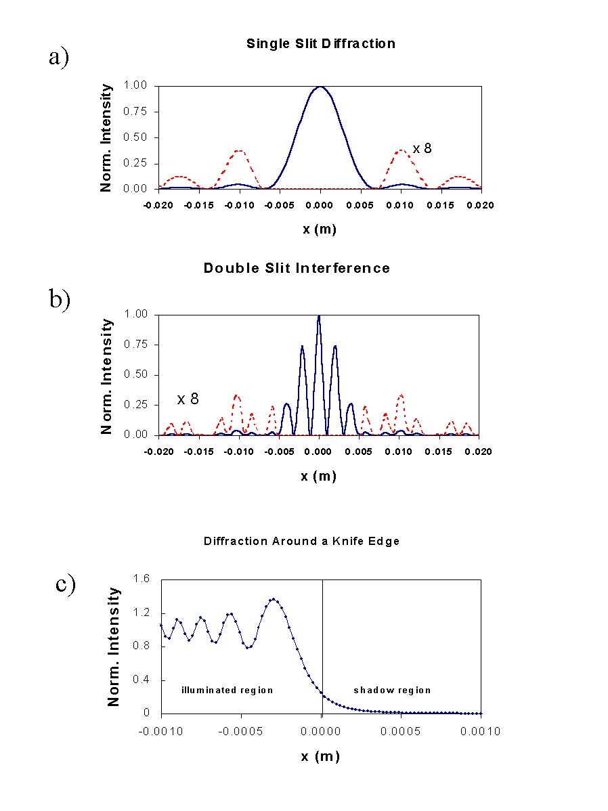
Figure 2: Representative intensity variations produced from (a) diffraction by a single slit (λ= 632.8 nm; a= 27 μm), (b) interference from a double slit (λ= 632.8 nm; a= 27 μm; b= 270 μm), and (c) diffraction from a knife edge. The dashed lines in (a) and (b) are the resulting intensity variation after multiplication by a factor of 8.0
Experimental Considerations
A photograph of the optical set-up of the equipment is given in Fig. 3. This photo shows the relative placement of the He-Ne laser with spatial filter, a focusing lens, an adjustable diaphragm, the slits, a cylindrical lens, and a viewing plane which consists of a scanning photodiode driven by a slow motor. The photodiode is apertured by an adjustable slit which controls the resolution of the detected intensity variations. A schematic diagram of this set-up is given in Fig. 4. A few of the more important details of the equipment are provided below.

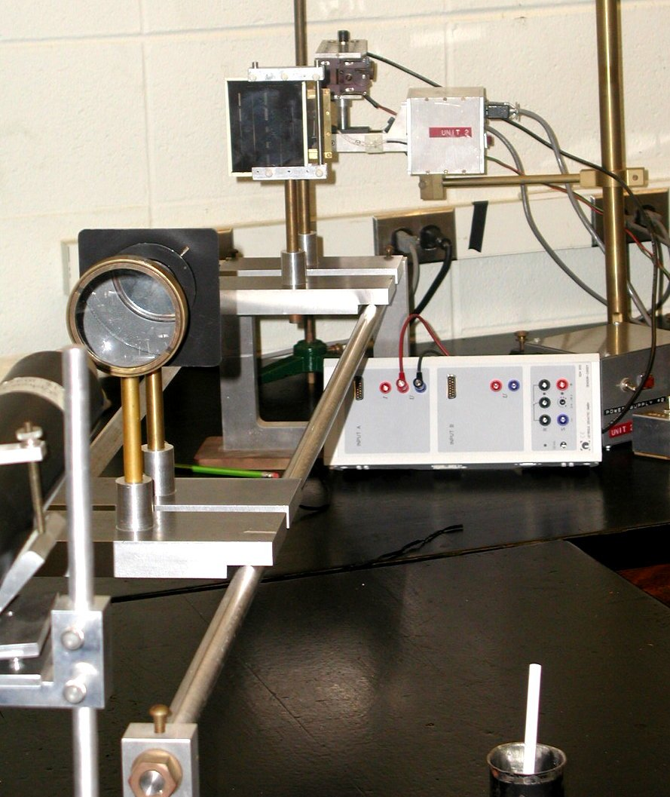

Figure 3: A photograph of the experimental set-up showing the He-Ne laser, the focusing lens, the adjustable diaphragm, the slit plate, the cylindrical lens, the scanning photodiode and the CASSY interface box. The spatial filter is not visible in this photo.

A. The He-Ne Laser
See Appendix A for a more detailed discussion.

B. Spatial filters
An ideal continuous laser produces laser beam which has gaussian intensity distribution in cross-section (see Fig. 11 in Appendix). In our experiment we need to produce plane or concentric waves with minimal intensity variation in the slit area.
Real laser systems often have internal appertures which produce diffraction pattern in output beam. This diffraction pattern resembles Newton’s rings (i.e., a “bull’s eye” variation in intensity) and may not be concentric with the main beam. It is a great nuisance for accurate diffraction measurements.

Figure 4: A schematic diagram of the experimental set-up.

This “bull’s eye” pattern can be eliminated with a spatial filter. (See Fig. 5). The spatial filter is an adjustable arrangement consisting of a strongly converging lens and a small aperture pinhole located in the center of an opaque plate. The laser beam is focused by the lens through the pinhole aperture and the distorted segment of the laser beam is spatially blocked out by the small pinhole.

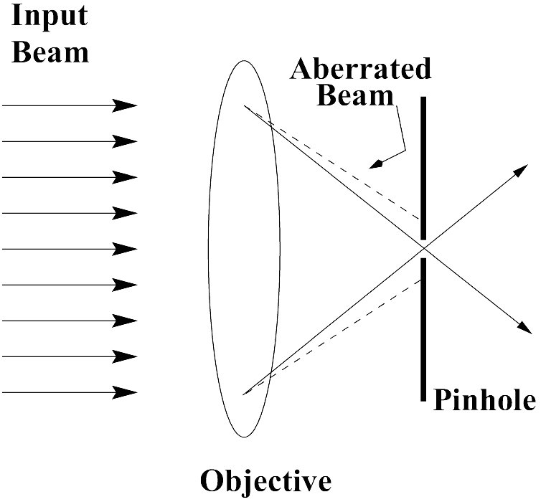
Figure 5: A schematic diagram of a spatial filter showing the incident laser beam, the microscope objective and the pinhole. The pinhole blocks the aberrated part of the beam if it is located precisely at the focal point of the objective lens.

Before you enter the lab, every attempt is made to adjust the spatial filter properly. There are two adjustments. One adjustment centers the converging laser beam onto the center of the pinhole. This adjustment is rather difficult to make. The second adjustment places the pinhole at the focal spot of the laser. Do not touch the screws on the spatial filter because readjustment can be time consuming. If problems arise, call the lab instructor.
Since the spacial filter is itself an apperture, it also creates a concentric “bull’s eye” diffraction pattern at the edges of the beam spot. An adjustable aperture (∼1cm diameter) is used to block all but the central maximum.

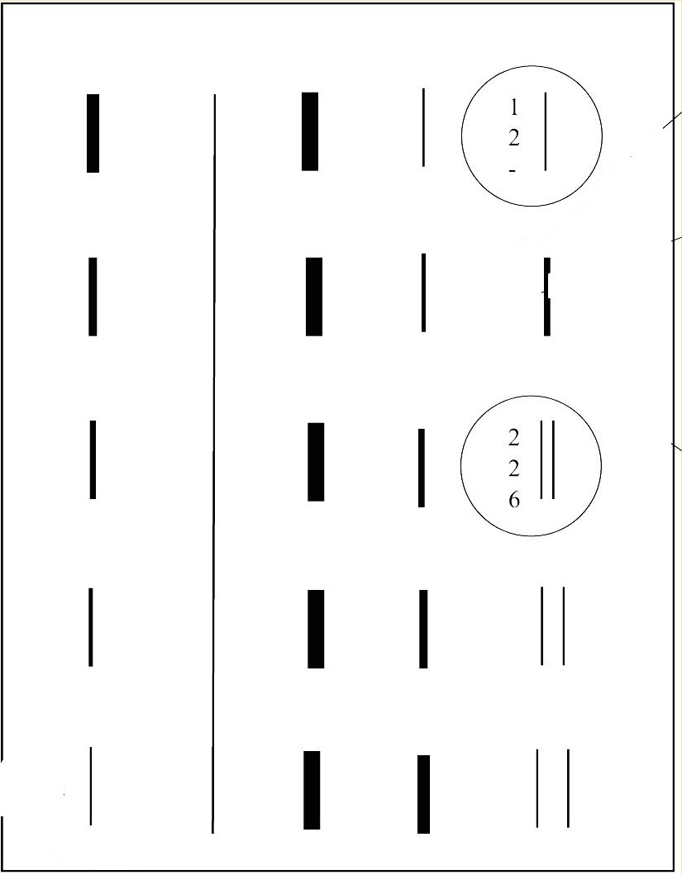
Figure 6: A schematic diagram showing the layout of the slit plate. For this experiment, use only the slits which are circled.

C. Description of the slit pattern.
In this experiment we use transparent slits etched on an opaque film and enclosed between two glass plates (Fig. 6).
The single slit has width in the order of 100 μm and is located in the top-right corner of the plate.
The double slit is located in the middle-right section of the plate, each slit is ~100 μm wide and the distance between two slits is about 300 μm.

D. Description of the photodiode and data acquisition system.
The intensity variation in the diffracted wave are masured with a photodiode that is mounted on an automatic drive moving with a speed of 85×10-6 m/s. The amount of light that can reach the diode is determined by the gap between a pair of jaws (slit) in front of it. One jaw is fixed, the other jaw is spring-loaded and thus adjustable. This input slit also determines spatial resolution of the experiment – the slit size should be significantly narrower than the sharpest features of the measured interference/diffraction pattern.
The signal is amplified and then recorded on the computer using the CASSY computer interface. The time interval between the acquisition of two data points digitized in the time mode can be adjusted through the software. Data points acquired roughly every 0.1 seconds will provide sufficient resolution in this experiment and will result in data files containing ~1000 data point pairs [t, I(t)]. Knowing the speed of the photodiode, these data can be converted to [x, I(x)] and compared with theoretical expectations given above.

E. Alignment of the optical elements.
Note: the alignment described in this section is usually done by the time you enter the lab.
- Position the photodiode at right end of the optical rail. Make sure the adjustable slit to the photodiode is closed (gently!) and that the photodiode power is off.
- Put the laser on its own stand at the other end of the optical bench and the photodiode at the other. Adjust the height and tilt of the laser support in such a way that the laser is at the same height as the photodiode and that the laser beam hits the photodiode.
- Set the adjustable diameter diaphagm as close to the photodiode as possible; make the hole ~1 mm in diameter and adjust its height so that laser beam which passes the hole hits the center of the photodiode. You may need to align the center position of the diode left and right as the diaphragm position can be aligned only vertically.
- Without changing its height, move the diaphragm to the other end of the bench close to the laser. Realign the laser height and tilt so that laser beam passes the diaphragm and hits center of the photodiode.
- Temporarily remove the diaphragm (with its stand) from the bench and position the spherical converging lens ~17.5 cm (focal length) from the laser end. Set the lens height so that center of the laser beam passes through it and still hits center of the diode. Fine tune the distance from the lens to respect to the laser end so that laser beam which emerges from the lens does not change its size on its way to the photodiode. That would ensure that the beam front is parallel.
- Place the stand with the diaphragm behind the converging lens (few centimeters appart). We use the diaphragm to remove all but the center maximum of the interference pattern created by the apperture of the spatial filter. Set the diameter of the diaphragm at about 1 cm.
- Insert the plano-concave cylindrical lens between the photodiode box and the spherical lens with its plane surface towards the laser. Its exact location can be found by the requirement that the image of the laser beam should form a bright narrow vertical line on the slit mounted on the photodiode box. Thus the slit or more accurately the photodiode is located at the focal point of the lens: R0=fc ~32 cm.
- Put the single slit denoted as (1; 2; -) in the beam between the diaphragm and cylindrical lens but as close as possible to the cylindrical lens. Make sure the single slit is in the center of the laser beam and the plate is normal to the laser beam. Adjust the plane of the glass plate until the reflected and incident light beams become parallel.

F. Final Adjustments.
- Always open and close the jaws of the photodiode gently; otherwise they may get stuck shut.
- Start up the data acquisition software and adjust the settings so one data point is collected about every 0.1 second. Position the scanning photodiode box so it is located at the midpoint of the diffraction pattern (brightest area). The scan has two end switches that automatically switch off the motor when the carriage reaches either end of the range of travel.
- Switch on the amplifier. Slowly open the photodiode slit until CASSY voltmeter shows ~ 0.5-1V. Selecting too wide slit in front of the photodiode would compromise spatial resolution of your detector, selecting too narow slit would compromise signal/noise ratio as too little light gets into photodiode.
- R diffraction pattern is close horizontally to and parallel with the vertical slit defined by the jaws on the photodiode box. This will ensure that the diffraction pattern falls within the range of the automatic scan, and that the photodiode box is at the right height.
I. Measuring slit width.
Use a microscope to measure both slit width (and separation). Don’t forget to estimate an error of this measurement.

II. Diffraction produced by a single slit
- With the set up described above, make the photodiode move to one of the ends of the scanning range. Then reverse the scan direction and start data acquisition to scan the diffraction pattern into computer. Your data is usable only if you record the first minimum, the secondary maximum, and in case of optimal line up, the second minimum.
- Record all pertinent data in your lab notebook for future reference.
- Your digitized data should resemble something like Fig. 2(a). Don’t forget to save your data into a file.

Analysis of the single slit data
- Knowing the speed of the automatic drive and the speed of data acquisition (85×10-6 m/s), you can convert digitization times measured on the computer into distances traveled by the photodiode.
- Read your experimental data into a spreadsheet program and generate a plot of relative intensity vs. position. You must shift your data so that the central maximum coincides with x=0. You may want to normalize your data so that the relative intensity at x=0 is unity. You may need to discard some of your digitized data taken far away from x=0 since it may not contain useful information.
- Write a computer program using Eq. 3 and calculate a theoretical fit to your data. Adjust the slit width, but hold the wavelength of the laser fixed. Make a plot of theory and experiment. Make sure your final plot comparing theory to experiment is clearly labeled. What is the best value of the slit width required to fit your data? How close is this measurement to the one done by microscope

III. Interference and diffraction from a double slit
- Change the position of the glass slide in such a way that the center of the laser beam hits the (2; 2; 6) double slit.
- Record the diffraction pattern following similar procedures which are given above. Make sure that the voltmeter is not overloaded in maximum of the interference pattern – since there are now two slits the light intensity in the middle of the pattern might be higher. You must record four secondary peaks on each side of the main central peak in order to observe the first zero of the first factor in Eq. 4.
- Your digitized data should resemble something like Fig. 2(b).

Analysis of the double slit data
- Read your experimental data into a spreadsheet program and generate a plot of relative intensity vs. position. Again, you must shift your data by identifying x=0 and you may want to normalize your intensity so that it is unity at x=0. You may need to discard some of your digitized data taken far away from x=0 since it may not contain useful information.
- Write a computer program using Eq. 4 and calculate a theoretical fit to your data. To optimize the fit, adjust the slit width and slit separation, but hold the wavelength of the laser fixed. Make a plot of theory and experiment. What are the best values required to fit your data? What range of variation in the adjustable parameters can you make before you observe a significant discrepancy between theory and experiment? For that analysis, set the distance between slits to values 5%, 20%, 30% and 50% from its optimal values and repeat the fit changing only slit width. That will give you a measure of precision at which you were able to determine the distance between the slits based on your data. Repeat simila analysis for the width of the slit. Based on the above fits estimate the error range for double slit parameters.

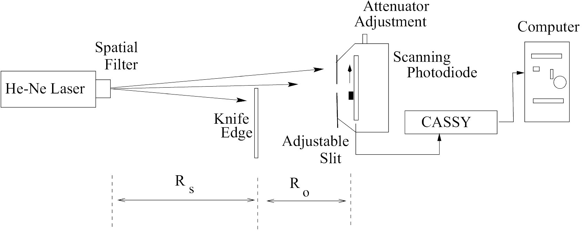
Figure 7: Set-up for Fresnel diffraction around a knife edge.

III. Diffraction from a knife edge
- Remove both the converging lens and the cylindrical lens from the set-up for Fraunhoffer diffraction. This destroys the parallel ray approximation and places you in the Fresnel regime.
- Remove the slit slide and insert a sharp edge of a new razor blade. Make sure the knife edge is parallel to the aperture of the photodiode. The edge should be in the center of the laser beam. Fig. 7 gives a schematic diagram of your set-up.
- Record all relevant data in your notebook for future reference.
- Record the diffraction pattern using the computer following procedures given earlier. You may need to reduce the slit width in front of the photodiode to avoid signal overload.
- Your digitized data should resemble something like Fig. 2(c).

Analysis of the knife edge data.
- Read your experimental data into a spreadsheet program and generate a plot of relative intensity vs. position. Again, the position of your data must be shifted and the intensity may be normalized to unity. You may need to discard some of your digitized data taken far away from x=0 since it may not contain useful information.
- With the help of Table 1 in Appendix B and Eq. 5, calculate I(x)/I₀ as a function of x and plot it on top of your data. Make sure your final plot comparing theory to experiment is clearly labeled.
- In your error analysis, only consider the errors in measuring the distances Rs and Ro. Compare your fit to theoretical expectations. Can you explain the reason for any differences between theory and experiment?
Appendix A: Theory of the He-Ne Laser
The laser is a modern light source with several interesting properties. The name is an acronym for Light Amplification by Stimulated Emission of Radiation. The light coming from a laser is unidirectional, monochromatic, intens and coherent.
Let us try to understand these properties and the laser operation.
In 1916, Einstein worked on the blackbody problem, and in the process of solving this problem he also identified spontaneous and stimulated emission rates. Let us consider the simple system consisiting of atoms which have two nondegenerate electronic states: so called ground state |0>, where the electron resides normally, and excited state |1>, normally unoccupied.
Figure 8. Electronic state diagram. |0> and |1> are ground and excited states, correspondingly. The A₂₁, B₁₂ and B₂₁ are Einstein’s coeeficients for possible electronic transitions.

When light photon with the energy hν equal to energy separation between these two states strikes an atom the probability of the atom in ground state to absorb light is proportional W₀₁~ B₁₂. Once in excited state an electron undergous spontaneous transition into ground state with probability ~A₂₁. The latter process is often accompanied by radiation of a secondary photon. The two processes described so far are responsible for absorption and fluorescence of the the atom. However, if the atom was already in excited state the falling light photon can promote an electronic transition downward with probability W₁₀~B₂₁, in that process a second photon is emitted with the exact energy, phase, polarization and direction of the falling photon. Einstein called this phenomenon “negative absorption” (modern term is stimulated emission), as it is the process opposite to absorption. For several decades it was considered more like nuisance than discovery which may have lead to development of lasers.
According to Einstein B₁₂=B₂₁. Therefore, in order to achieve amplification of incident light in media one need to manipulate the ensemble of atoms or molecules in such a way that the number of atoms in excited state is larger than that in the ground state so that N_{e}B₂₁>N_{g}B₁₂, where N_{e} and N_{g} are populations of excited and ground states acordingly. This, however, turned out to be not an easy task. One can illuminate the ensemble of atoms with a strong light pulse which is in resonance with electronic transition (optical pumping). However, one cannot excite more than a half of atoms in such way. The reason is simple – as the number of atoms in excited state reaches the number of atoms in ground state the same amount of transitions downward and upward will be produced by incident light, and the net change in population will be zero.
In order to solve this problem atoms or molecules with 3 or 4 electronic states can be used.

Figure 9. Electronic state diagram of 4-level system. |0> and |1> are ground and excited states, correspondingly.

In 4-level system (Fig. 9) absorption of a photon creates the nonequilibrium excited state |1*> which rapidly decays into intermediate state |1>. This state, in turn, decays into nonequilibrium ground state |0*> with the emission of a photon hν’, and, consequently, the system returns rapidly into ground state |0>. The pump photon energy hν is not in resonance with the laser transition hν’, and thus pumping light does not cause depopulation of the laser-active state |1>. Besides, the nonequilibrium ground state |0*> is initially not populated, and achieving population inversion (i.e. N_{e}>N_{g}) becomes easy.
Optical pumping is not the only way to prepare laser active media. One may use electrical current to excite optical states, or create molecules in excited state using chemical reactions.
The presence of light-amplifying media is not sufficient for laser operation. One also needs to create a positive feedback in the way it is done in electronic oscillators. In positive feedback, part of the output signal from the electronic amplifier is send back into its input, and as a result oscillaion never stops. This effect is similar to commonly observed phenomenon when a microphone is placed close to the speaker.
The most commonly used optical scheme which provides positive feedback for light oscillator is shown in Fig. 10.

Figure 10. Basic laser design. HR – high reflector mirror, OC – output coupler mirror. The two mirror design resembles Fabry-Perot etalon, which is known for its unique optical properties since 1899.

The two parallel mirrors reflect light back and forth through the laser media where light is amplified. The output coupler lets some of the light through providing usable laser output beam. Initially, there is no laser light. As time passes, some of the photons are emitted by the laser media due to spontaneous transitions (fluorescence). Those photons which are not parallel to the laser axis escape from the media and are not further amplified. However, there is always a probability that a photon is spontaneously emitted along the laser axis. Due to the mirrors, this photon will bounce back and fourth between the mirrors. In each pass additional photons are created due to stimulated emission, these photons in turn are amplified etc. After short period of time the intensity of the beam rises and we have laser operation. Ideally, all the photons in laser would be created from a single initial photon, and therefore have the same energy, direction, phase and polarization.
Since it is impossible in principle to create absolutely parallel laser beam (due to diffraction), the laser mirrors are often curved to compensate for diffraction.

Let us now list the main properties of laser light.
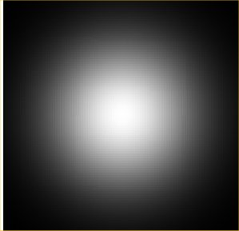
Figure 11. Gaussian beam profile
1. The laser light is highly directional. In best lasers the output beam has gaussian profile, i.e. the laser spot intensity changes as a gaussian function with maximum intensity in the middle as shown in Fig. 11. The advantage of this profile is in its diffration properties – while the gaussian beam overal size will change as it passes through space or optical elements, the functional shape will remain gaussian.

2. The laser light is highly monochromatic, i.e. most of the light intensity is concentrated in very narrow spectral range. One can also produce monochromatic light by passing “white” light through narrow spectral filters (like monochromators). The latter, however, will have extremelly low intensity and its spectrum will be still several orders of magnitude broader than that of narrow-band lasers.

3. The laser light is coherent. That means that there is a fixed phase relationship between different parts of the laser radiation, both across and along the beam.

The lasing medium in a modern He-Ne laser used in our experiment is a mixture of about 85% He and 15% Ne, with Ne providing the lasing action. This mixture is excited in a glow discharge by passing a dc current through the gas. Transition of the Ne atoms to the excited state is not caused directly by the current but by indirect pumping accomplished by electron excitation of He atoms in the glow discharge. The excitation energy of the He is then transferred to the Ne atoms by way of atomic collision. The principle depends on the existence of excited levels in the Ne atom, which are close to the first excited states in He, and can therefore be populated by resonant neon-helium collisions. In addition, the He levels are metastable thus ensuring the most efficient energy transfer to the Ne atoms because the return of the excited electrons to the He ground state by radiative decay is very slow.
The level scheme for the He-Ne laser is shown in Fig. 12. To explain the operation of the He-Ne laser, the notation of levels in Fig. 12 has to be explained. In case of light atoms the spins of the electrons are added vectorially to obtain the resultant spin $\vec{S}$. Next the orbital angular momenta of the electrons are added vectorially to obtain $\vec{L}$. The vector sum of the two is the total angular momentum $\vec{J}$. Levels are labeled then as 2s+1Lj. Thus the ground state and the two relevant excited states of He are denoted as 1 1S0, 2 3S1 and 2 1S0. The symbols S, P, D are denoted by L=0,1,2 respectively. This is called the Russell-Saunders coupling scheme notation. The numbers in front of 1S0 and 3S1 denote the principal quantum number of the excited electron.

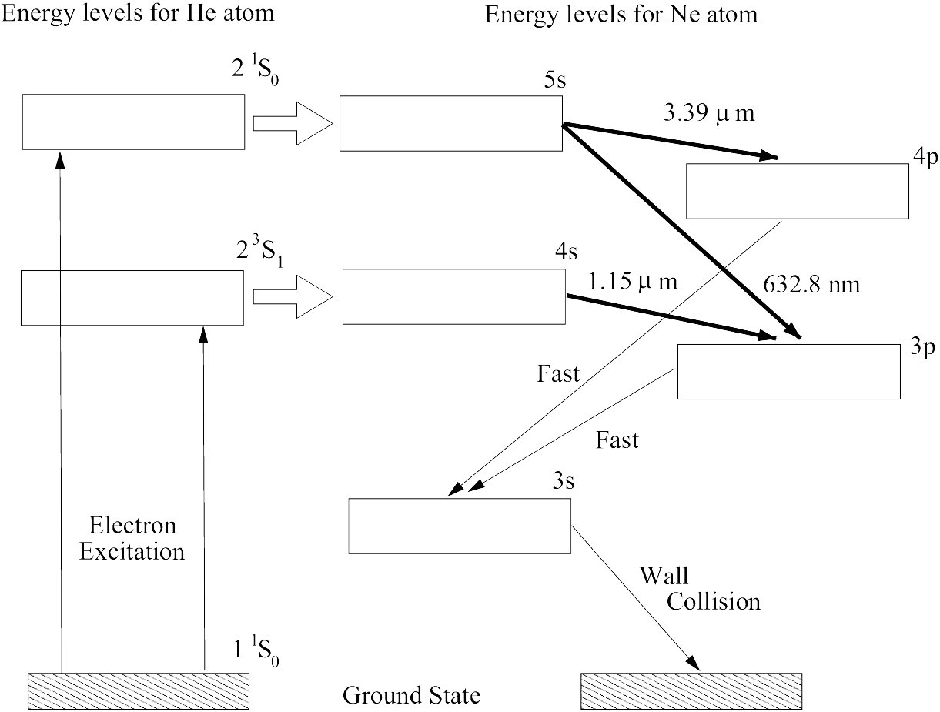
Figure 2: A schematic diagram of the energy level scheme for the He-Ne laser. The three darker solid lines indicate a laser transition.

To describe the excited states of Ne, note the electron configuration of the ground state is 1s22s22p6, where the superscripts denote the number of electrons in each state. The ground state is denoted by the usual spectroscopic notation 1S0 (L=0,S=0,J=0). The configuration in which one of the 2p6 electrons is moved into the 3s,4s or 5s state are denoted by 3s,4s and 5s. Similarly when one of the 2p6 electrons is moved into either the 3p or 4p levels, the states are denoted by 3p and 4p.
Both the excited 2 3S1 and the 2 1S0 levels of He are metastable. The 2 1S0 state cannot decay by single photon emission since to do so would violate the conservation of angular momentum. This state decays by emitting two photons with a ∼19.5 ms lifetime. By coincidence, the 2 1S0 level in He lies within 0.05 eV of the 5s Ne level. Thus excitation of Ne via the atomic collision:
He(2 1S0)+Ne(1S0)→He(1 1S0)+Ne(5s)-0.05eV
can take place. Stating in words: when a Ne atom in the ground state collides with an excited He atom in the 2 1S0 metastable state there can be a reaction whose outcome is an excited Ne atom in the 5s state and a He atom in the ground state. The missing 0.05 eV energy is obtained from the thermal kinetic energy of the colliding atoms. As shown in Fig. 9, the 5s state can emit induced radiation in two ways. The energy level differences are:
E(5s)-E(3p)=1.96eV and E(5s)-E(4p)≈0.3eV
The laser you will be using emits the ΔE=1.96 eV visible red radiation (λ=632.8 nm). The five-level system (5s,4s,3s,4p,3p) of a He-Ne gas laser differs from the three-level system of chromium in that the emission of a photon does not return the Ne atom to the ground state. Transitions from the 3s state to the ground state are accomplished through a phonon (a quantized particle of sound) transition in which energy is transferred mainly through heat.
The He-Ne gas mixture is contained in a sealed tube. Excitation of the He is accomplished by a discharge of electricity through the tube, similar to a neon sign. Selection out of the possible five transitions of a single 1.96 eV transition is accomplished by having the mirrors in the laser tube made of excellent reflectors for the 1.96 eV photons and poor reflectors for the other stimulated (lasing) transitions in the green and infra red.
The laser tube and its mirrors forms an optical cavity which produces an interesting optical spectrum. The 632.8 nm laser transition (frequency = 4.74×1014 Hz) is not infinitely sharp but is broadened (roughly by ±750 MHz) by thermal motion (Doppler broadening) of the atoms inside the laser tube. This broadened transition in turn supports a number of discrete axial cavity modes which are separated in frequency by (roughly 600 MHz), where c is the speed of light and L (∼0.25 m) is the length of the laser cavity. It is possible to observe this mode structure in the laser beam output, but highly stable conditions are required to do so. Special optical components mounted on the laser tube can further tailor the laser beam output by tuning for a particular axial mode or by selecting a particular plane of polarization for the output laser beam.
Appendix B: Evaluation of the Fresnel integrals
Diffraction of coherent light around a knife edge requires the evaluation of two special integrals

$S(w)=\int_{0}^{w}{\text{sin}\left(\frac{1}{2}{πw}^{2}\right)\text{dw}}$ (1)
and

$C(w)=\int_{0}^{w}{\text{cos}\left(\frac{1}{2}{πw}^{2}\right)\text{dw}}$. (2)
These integrals have the property that S(-w) = -S(w) and C(-w) = -C(w). A tabulation of these integrals is given below.

Table 1. Coordinates of the Cornu Spiral
w | C(w) | S(w) | w | C(w) | S(w) | w | C(w) | S(w) | w | C(w) | S(w)
0 | .0000 | .0000 | 1.3 | .6386 | .6863 | 2.6 | .3890 | .5500 | 3.9 | .4223 | .4752
.1 | .1000 | .0005 | 1.4 | .5431 | .7135 | 2.7 | .3925 | .4529 | 4.0 | .4984 | .4204
.2 | .1999 | .0042 | 1.5 | .4453 | .6975 | 2.8 | .4675 | .3915 | 4.1 | .5738 | .4758
.3 | .2994 | .0141 | 1.6 | .3655 | .6389 | 2.9 | .5624 | .4101 | 4.2 | .5418 | .5633
.4 | .3975 | .0334 | 1.7 | .3238 | .5492 | 3.0 | .6058 | .4963 | 4.3 | .4494 | .5540
.5 | .4923 | .0647 | 1.8 | .3336 | .4508 | 3.1 | .5616 | .5818 | 4.4 | .4383 | .4622
.6 | .5811 | .1105 | 1.9 | .3944 | .3734 | 3.2 | .4664 | .5933 | 4.5 | .5261 | .4342
.7 | .6597 | .1721 | 2.0 | .4882 | .3434 | 3.3 | .4058 | .5192 | 4.6 | .5673 | .5162
.8 | .7230 | .2493 | 2.1 | .5815 | .3743 | 3.4 | .4385 | .4296 | 4.7 | .4914 | .5672
.9 | .7648 | .3398 | 2.2 | .6363 | .4557 | 3.5 | .5326 | .4152 | 4.8 | .4338 | .4968
1.0 | .7799 | .4383 | 2.3 | .6266 | .5531 | 3.6 | .5880 | .4923 | 4.9 | .5002 | .4350
1.1 | .7638 | .5365 | 2.4 | .5550 | .6197 | 3.7 | .5420 | .5750 | 5.0 | .5637 | .4992
1.2 | .7154 | .6234 | 2.5 | .4574 | .6192 | 3.8 | .4481 | .5656 | ∞ | .5000 | .5000

