RR Oct 2001
SS Dec 2001

Physics 342 Laboratory

Scattering of Photons from Free Electrons: Compton Scattering

Objective: To measure the energy of high energy photons scattered from electrons in a brass rod as a function of the scattering angle.

References:
1. A.H. Compton, Phys. Rev. 21, 715 (1923) and Phys. Rev. 22, 409 (1923).
2. A.C. Melissinos, Experiments in Modern Physics, Academic Press, New York, 1966, p. 252-65.
3. K. Krane, Modern Physics, 2nd Ed., Wiley and Sons, New York, 1996, p. 83-87.

Apparatus: A low energy (22 keV) and weak (15μC) portable Cd109 source; a higher energy (662 keV) strong (5 mC) Cs137 source in a cylindrical lead shield; a NaI(T) scintillator mounted on a Photo-Multiplier Tube (PMT); an iron shield surrounding the PMT; a Canberra 1024-channel PC based Multi-Channel Analyzer (MCA); a high voltage (1.5 kV) power supply; a brass cylindrical rod for use as a scattering target; a carriage to rotate the scintillator and PMT assembly at a fixed distance around the target.

Introduction
In 1923, Compton considered the problem of high energy photons (γ-rays) scattering from solids. Experimentally, he found that low energy (few MeV γ - ray) monochromatic photons scattered by metals change their frequency and that the frequency change depends on the scattering angle. This proved to be problematic, since at that time, light scattering was understood in terms of diffraction in which the scattered (diffracted) wave does NOT change frequency. Compton’s experiments and his theoretical analysis of them came to be know as Compton scattering. Historically, his experiments are important because they provided further compelling evidence that photons do behave as particles which obey conservation of momentum and energy laws. Compton was awarded the Noble prize in 1927 for his seminal work.
Compton’s experiment can be understood by considering the interaction of the incident photons with the electrons that comprise a metal. Because metals are good conductors of electricity, some fraction of the electrons associated with each atom in the metal can be considered to be free. If the quantized nature of electromagnetic radiation is taken into account (electromagnetic radiation consists of photons, each of which has the same energy E=hν), and relativistic kinematics are used to describe the scattering process, the change of wavelength is understandable as a straightforward consequence of total energy and momentum conservation during a scattering process in which an incoming photon loses some of its energy to a free electron having a mass me. The basic kinematic diagram illustrating this interaction is sketched in Fig. 1.

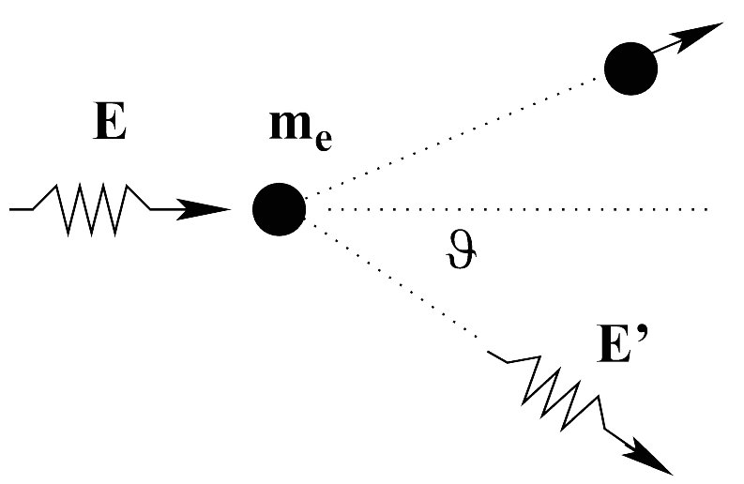
Figure 1: A schematic energy diagram showing the interaction between a photon and a free electron. The incident γ has an energy E and a momentum p=h/λ. The energy of the electron before scattering is just the rest mass energy of the electron, Ee=mec2; the momentum of the electron before scattering is zero.The scattered γ has an energy E' and a momentum p'=h/λ'. The scattered electron has an energy Ee' and momentum $p'_{e}=c^{−1}\sqrt{E'_{e}^{2}−{\left({\text{mc}}^{2}\right)}^{2}}$.

For a beam of incident photons, each of which has the same energy E=hν, there will be photons emerging at various angles θ with respect to the incident photon direction. The energy E' of a photon emerging in a given direction can be calculated using relativistic kinematics and has a value given by

$E'=\frac{E}{1+\left(E/{m_{e}}c^{2}\right)\left(1−\text{cos}θ\right)}$ (1)
where θ is the angle between the direction of the emerging (scattered) photon and the incident photon, me is the rest mass of the electrons, and c is the velocity of light.
From Eq. (1) it can be seen that in order to obtain a large Compton shift (i.e. a large value for E – E’), the incident photons should have an energy E of the same order of magnitude as the electron rest energy mec2 (mec2 = 511 keV). In this experiment 662 keV (γ - ray) photons from a Cs137 source will be Compton-scattered by a cylindrical rod made of brass.

Experimental Considerations

The primary source of photons in this experiment is a ∼5 mC cesium (Cs137) emitting 662 keV photons. The source is kept in a lead cylinder for shielding. When you are ready to take data, remove the end piece of the shielding cylinder. A narrow channel drilled through the center of the cylinder permits only photons which travel along it to scatter off the target. The direction of the channel defines θ=0, the direction of the unscattered beam.
This procedure of creating a parallel beam of particles from an otherwise isotropic source is called collimation. The emerging photons impinge on the target rod, and some small fraction will be scattered. Some of the scattered photons will enter the NaI(T) crystal attached to a photomultiplier tube (PMT) (see Fig. 2).

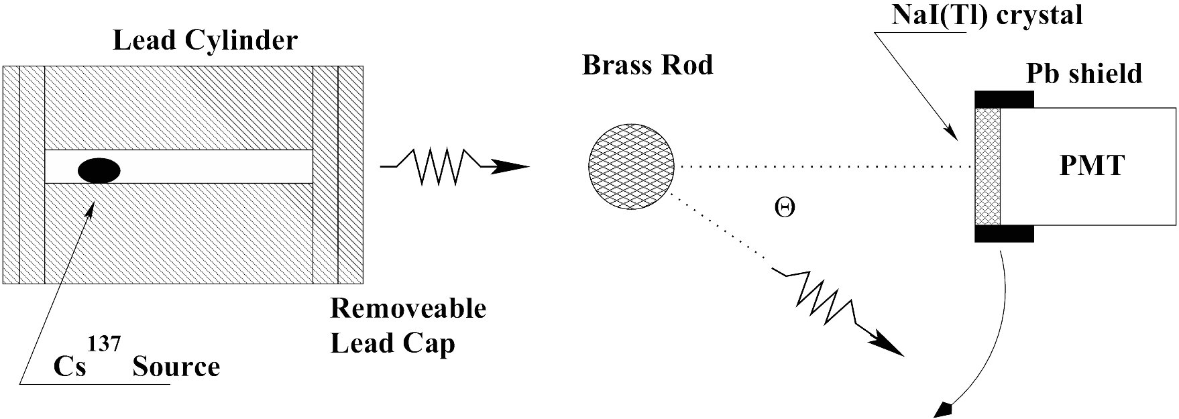
Figure 2: A schematic diagram of the experimental apparatus.

The energy lost in collisions with the I-atoms in the NaI crystal results in the emission of light photons from excited T atoms which are intentionally incorporated into the NaI crystal. These photons in turn eject electrons from the photo-cathode of the PMT. The electrons are accelerated through ∼1300 volts of electrostatic potential in such a way that they produce a cascade of electrons from electrodes (called dynodes) placed inside the tube. This electron current pulse is then transformed into a voltage pulse which is pulse-shaped so that its height is proportional to the energy of the incoming γ. The pulse height is then measured and sorted by a computer using a specially designed multi-channel analysis (MCA) board.
If the source is so intense that two of these pulses arrive at the same time within the PMT, a spurious overlapping signal is produced. This case must be avoided as there is no way to learn about the energy of each of these pulses. The time separation between two pulses must be larger than certain value (called dead time) in order for these two pulses to be resolved separately. In order to avoid this problem, you will be measuring the energy distribution of the source at a scattering angle of 5° instead of the normally chosen angle of 0°, By moving the detector slightly off-center from the source, the intensity of the γ beam greatly reduced to ensure that the probability of having two pulses within dead time interval is insignificant. In general, if average separation between single pulses in your beam is less than 10 times longer than the dead time of your detection system, the data set can be seriously skewed. Indeed, if an average time between pulses is τ_{a}, and dead time is τ_{d}, the fraction of 2-pulse events will be ~(τ_{d}/τ_{a})² for τ_{a}>>τ_{d}.
The decay scheme of Cs137 is given in Fig. 3. The long life of the isotope and the single γ decay makes this isotope a very suitable source for γ ray experiments. The β- particles can be eliminated (absorbed) by a suitable thin metal film or, as in the present case, a long enough air path.

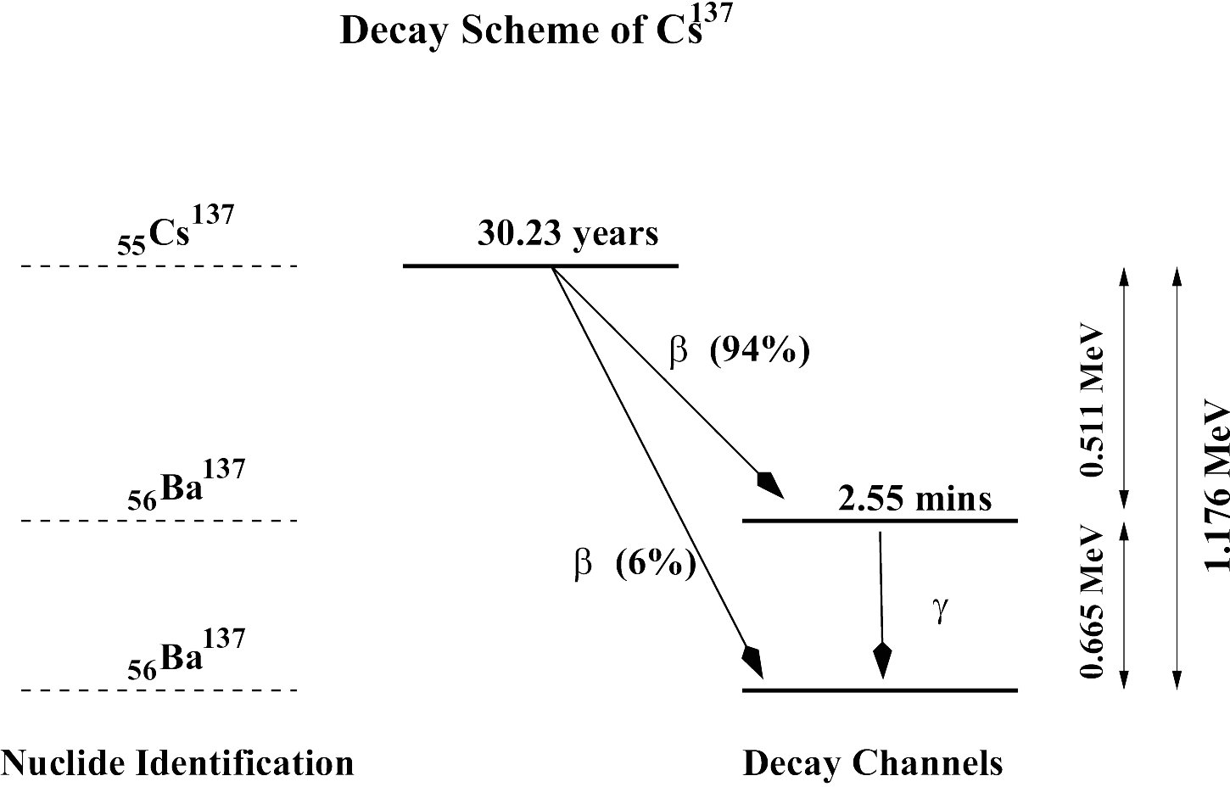
Figure 3: A schematic of the energy decay scheme of Cs137.

Set up Sequence

1. Cable Connections.
All cables should be already connected properly when you arrive. Make sure not to touch the high voltage connection when you are moving the carriage (It’s alright to touch the cable; just don’t touch the connector).

2. Computer Startup.
Login to the computer using the login and password given to you by your instructor. Follow instructions from the Appendix on starting up the program to control the MCA board.

3. Alignment of the source housing.
Check to see that the lead enclosure which holds the source is positioned directly opposite the PMT when the PMT’s rotatable mount is at the 0° position. A long brass tube is available to help check the alignment. Move the lead enclosure if necessary. Try to keep as much of your body as possible out of the path of the collimated beam.

4. Calibration of MCA channels.
A multi-channel analyzer increments the number of counts in a memory location (often called a storage bin or channel number) every time a pulse of a given height is detected. There is a linear relation between the pulse-height of the input signal and the channel number N such that

Eγ=aN+b . (2)

To determine the constants a and b you must calibrate the MCA and PMT system using two photon sources of known energy. In this way, you can determine the two unknown constants a and b appearing in Eq. 2.

(a) Calibration with Cd109
To minimize the background radiation leaking through the lead shield from the Cs137 source, rotate the carriage of the PMT to the 90° angle. Tape the Cd109 source to the front of the detector. Make sure that the end cap of the lead shield for the Cs137 source is in position. Using the instructions in the appendix, take data for two minutes of ’live time’. Using the peak locator feature, find and record the centroid of the tallest peak on the MCA. This peak should be found near channel 30. After completing the measurement, remove the Cd109 from front of the phototube. Print the scatter plot using instructions from the Appendix. See Figure 4 for an example of typical Cd109 calibration data.

(b) Calibration with Cs137
In order to expose the PMT to photons emitted by Cs137, position the PMT at θ≈5° and remove the end cap from the front of the lead cylinder. Take one minute of ’live time’ data. Using the peak locator feature, find and record the centroid of the highest energy peak. This peak should be found near channel 800 (the exact location depends on the voltage applied to your PMT). Make a printout of the γ spectrum using instructions from the Appendix. See Figure 4 for a typical example of Cs137 calibration data. Do not move the detector once you have finished taking data.

Given that the Cs137 peak is at Eγ=662 keV and the Cd109 peak is at Eγ=22 keV, determine the channel numbers that correspond to the two γ ray peaks you measured. The calibration of the γ ray spectrometer (Eq. 2) can now be determined. Write down the values for the two coefficients a and b that you find. These coefficients are required to convert channel number to photon energy.

Figure 4: Example of Cd¹⁰⁹ and Cs¹³⁷ calibration data. The peak near channel 250 in the Cs137 data results from the scattering of the 662 keV γs inside the PMT. The sharp peak near channel 100 is a characteristic X-ray signature of Ba137 in the scintillator. The large background from channel 0 to channel 500 results from Compton scattering in the NaI from Cs137 gammas. There are two characteristic γ peaks for Cd109. The peak occurring at 22 keV is considerably more intense than the one at 87.5 keV.
Smooth line on top of the 662 keV Cs¹³⁷ band: gaussian fit with center channel 545 and σ=21, the value of σ can be used as error estimate for center peak position (see Data Analysis section)

Figure 5: Typical data showing the Compton peak (after subtraction of background) for scattering through 30°.

Data Acquisition

1. Brass Target.
- Insert the cylindrical brass rod target into the target holder, and check that the PMT is still located at θ≈5°
- Clear the data plot using methods describe in the Appendix. Set the ’live time’ to two minutes, and begin data collection.
- Locate the Cs137 peak, and compare your results with the calibration run you just performed. The difference in peak location, if any, is a measure of your error in determining ΔN, the uncertainty in the peak location channel number.
- • Rotate the detector to 30° position.
• Analyze data for 5 minutes live time.
• Record the centroid of the Cs137 peak, and copy the numerical data to a file using instructions from the Appendix.
- • Remove the brass rod and record 5 minutes of live time data.
• Using Excel or another spreadsheet program, subtract this background data from the data gathered when the brass bar was in place. (See Fig. 5). Be aware that sharp negative peaks and very high counts are over-subtractions due to statistical characteristics of the signal.
• From subtracted data, identify the real scattered peak and record channel number from the subtracted dataset. Be sure to include a plot of the subtracted dataset in your writeup.
• Estimate the new peak position and discuss how you arrived at this value. Do you notice any change in the position form the unsubtracted data?
- Repeat parts (1d) and (1e), recording data at 50° for 10 minutes live time.
- Repeat parts (1d) and (1e), recording data at 70° 80° and 90° with 15 minute live times.

2. Measurement of Δθ
Measure and record the radius of the NaI(T) scintillator. This measurement is useful when estimating your error in θ. See Figure 6.

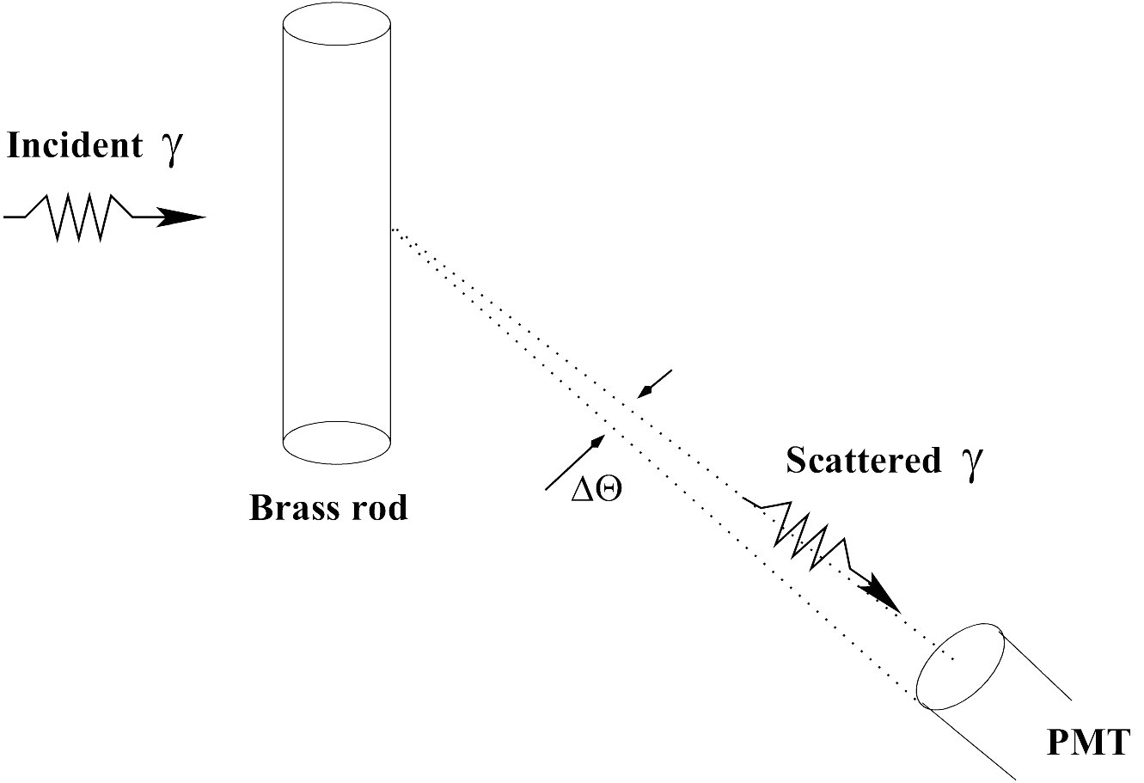
Figure 6: How to estimate the uncertainty in the scattering angle.

3. Shut Down Procedure
Put the end piece of the cylinder shield in place. Put the Cd109 disc source in its plastic container and return it to your lab instructor. Turn down power supply to standby, stop momentarily, and then turn it off. Ask your instructor if you should turn the computer off.

Data Analysis

- Find the energy calibration constants a and b fom Eq. 2. using two known (E, N) pairs from your calibration data.
- Make plots of C (counts) vs. E for the subtracted data sets at each θ.
- An indication of the MCA’s energy resolution is the measured ‘width’ of a given peak. Intrinsically, for the 662 keV γ, the transition is very well defined, so the emerging γ has a very well defined energy. However, experimentally, the γ ray spectrometer reveals a Gaussian-shaped energy distribution. You can use this distribution to estimate the uncertainty in your determination of Eγ(662 keV). Assume that the measured counts C in channel N obtained from the Eγ(662 keV) source obeys an equation of the form
$C(N)=C_{0}e^{\frac{−(\bar{N}−N)^{2}}{2σ^{2}}}$
where $\bar{N}$ is the channel number at which the peak is located (the centroid of the distribution). Using data processing program, fit the Gassian profile on top of the 662 keV band and find the σ. Convert σ into energy uncertainty ΔE. Note, that σ~0.42×fwhm, where fwhm is full width at half maximum of the Gaussian band.
- Tabulate θ, Npeak, E', and ΔE, the experimental uncertainty in your determination of E'. Include this table in your report. Make sure you include your best estimate for the uncertainty in each of these values.
- Plot 1/E' versus 1-cos θ, where E' is the energy of the Compton peak obtained at each angle θ. State what can be concluded from this plot. Be sure to include both vertical and horizontal error bars in your plot. In your report, include relevant details about how you found the error bars.
- Make a least squares fit of a straight line to the data plotted above. From the slope, determine a value of the rest energy of the electron mec2. The least squares fit can be made suing either a calculator or computer. Discuss how your value for mec2 compares with the accepted value. What is the experimental uncertainty in mec2?
Appendix: Genie 2000 Reference Sheet

• Introductory comments
The PC contains a Multi-Channel Ananlyzer (MCA) board that accepts signals from a Photomultiplier Tube (PMT) and processes them in such a way as to make histograms of the counts vs. channel number. A program called Genie 2000 serves as a link between the MCA board and the computer. Genie 2000 program splits the monitor screen in half, with the upper half displaying the MCA data and the lower half comprising the Report Window.

• To start the computer MCA controller
From the Start menu, choose Programs and then Genie 2000. Select Gamma Analysis and Something. When the program has loaded, select Open Datasource from the File menu and then click detector. In the file listing, choose Compton.

• To set data acquisition time (Live Time)
Menu Sequence:
MCA→Acquire Setup,
Select Live Time,
Input the time,
hit OK

• To use the peak locator to find the centroid of a peak
Menu sequence:
Analyze→Peak Locate→Unidentified 2nd Diff
Then, use the following settings:
Start Channel 1
Stop Channel 1024
Significance Threshold 3.00
Tolerance 1.00 keV (Energy)
Then, check Generate Report and click Execute.

• To Print the Scatterplot
Menu Sequence:
File→Data Plot

• To save numerical data
Menu Sequence:
Analyze→Reporting
Then use the following settings:
Start On New Page
Template Name 342ldump.tpl
Output to Screen
Section Name All
Activity Units μCi
Multiplier 1
Then, click the Execute button. The counts are printed to the report window in channel order, starting from channel 1. Once the data is in the report window, it must be copied to the Clipboard and pasted into a text editor, where it can be saved.

Menu Sequence:
Options→Report Window→Copy Contents to Clipboard

The Clipboard can then be pasted into Notepad to create a permanent copy. For instance, the Notepad contents can be Saved as a file on the Desktop. Using Excel, the file just created can be imported using the Text Import Wizard. When doing this, it's important to
start the import at Row 9. Once the data is in Excel, information about channel number (or γ energy) can be added, subtraction of background can be performed, and plots can be generated in the normal way.

• To clear your data
Menu Sequence:
MCA→Clear→Data,
Or Click the Clear button in the upper left part of the screen.

• To clear the report window

Menu Sequence:
Options→Report Window→Clear Contents

