Purdue Physics REU final conference

Agenda and Abstracts

Thursday, August 5, 2021

PHYS 334, Purdue University, IN

Abstracts and presentations:

9:00 Adian Keaveney. *Protochime:* *Testing a New Method for the Gravitational Direct Detection of Dark Matter.* (Prof. Lang)

Appalachian State University, NC

9:20 Samantha Rosenfeld. *XENONnT Single Electron Analysis.* (Prof. Lang)

Union College, NY

9:40 August Lee. *Optimization for A Universal Quantum Circuit Design for Periodic Functions.* (Prof. Kais)

Northern Illinois University, IL

10:00 Zane Blood. *Numeric and Analytic Calculations of Critical Current in 1D and Quasi-1D Systems.* (Prof. Vayrynen)

Cornell University, NY

**10:20 – 10:30 – break**

10:30 Michael Pacocha. *CMS Tracker Phase-2 Forward Pixel Detector Module Assembly.* (Prof. Jones)

Georgia Institute of Technology, GA.

10:50 Eliana Stoyanoff. *TBA*. (Prof. Banerjee)

Purdue University

11:10 Will Ward. *Light-induced atomic desorption for increasing coupling between thermal cesium atoms and photonic waveguides.* (Prof. Hung)

University of Central Arkansas

11:30 Andrew Rockovich. *Superconducting Microwave Circuits for Quantum Simulation*. (Prof. Ma)

Washington & Jefferson College, PA

**11:50 – 13:00 – Lunch (**Brown bag lunch provided to REU students)

13:00 Zachary Jernigan. *Optimization and Electrical Characterization of DC Reactive Sputtered NbN Films.* (Prof. Rokhinson)

University of North Texas, TX

13:20 Oliver Carey. *Raman Spectra of Water Oxidation Catalysts for Artificial Photosynthesis Usage.* (Prof. Pushkar)

University of Rhode Island, RI

13: 40 Rhea Gandy. *Growth Curves of Caaulobacter Crescentus in an environment of changing media* (Prof. Iyer-Biswas)

Claremont McKenna College, CA

14:00 Jack Stonecipher. *Stochastic homeostasis and adaptation of bacterial growth and form in dynamic environments*. (Prof. Iyer-Biswas)

Gustavus Adolphus College, MN

**Protochime: Testing a New Method for the Gravitational Direct Detection of Dark Matter**

Aidan Keaveney1,2, Rafael Lang2

Dark Matters Group

*1 Appalachian State University, Boone, NC, 28608*

*2 Purdue University, West Lafayette, IN, 46202*

There is overwhelming astrophysical and cosmological evidence for the existence of dark matter (DM). Most direct detection experiments have focused on searching for evidence of models of DM that interact weakly, an assumption not supported by astrophysical evidence. DM necessarily interacts gravitationally, but until recently, directly detecting gravitational interactions appeared unfeasible. The Windchime project is the first attempt to use the new technologies and experimental practices pioneered by LIGO and others to ultimately achieve a level of sensitivity that could observe such gravitational interactions. The Windchime detector will use a 3-dimensional array of highly sensitive optomechanical force sensors that could in principle detect a passing DM particle and provide full directional event reconstruction. This detector would also be capable of probing largely unexplored mass ranges. Here, we discuss the status of protochime, a prototype of the Windchime detector intended to develop and evaluate data acquisition and analysis techniques. We interface with a small array of 16 commercial accelerometers mounted via an FPGA that controls data sampling and manipulation. Our current analysis efforts focus on probing the ultralight DM range of 10-21 – 10-1 eV. At these small masses, DM would behave as a wave-like field due to their high occupation number. The wave-like accelerations produced by this field would be defined by $a_{s}(t)=gΔF_{0}sin(ω_{φ}t)$, where *g* is the DM coupling strength, *F*0 is the square root of the DM density, ∆ is a factor characteristic to the accelerometer and reference materials, and *ω* is the frequency of the DM field as related to DM mass. By applying a Fourier transformation to the acceleration data collected from the sensor array, we can place limits on the maximum DM coupling strength as a function of DM frequency, and by extension DM mass, from $g_{max,ω}=\frac{a_{max,ω}}{ΔF_{0}}$. Such limits, while likely uncompetitive, would prove that the technique proposed for the Windchime project could probe the ultralight DM range. In the near future, we intend to fully implement the analysis techniques described here, and develop similar analysis techniques for probing Planck-scale masses.

This work was supported by NSF REU grant PHY-1852501 and the ALPHA collaboration.

**XENONnT Single Electron Analysis**

Samantha L. Rosenfeld1,2, Amanda Depoian2, Abigail Kopec2, Rafael Lang2, Shengchao Li2

1*Union College, Schenectady, NY 12308*

2*Purdue University, West Lafayette, IN 47907*

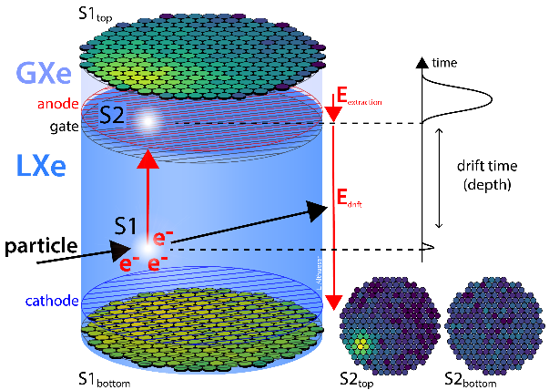Dark matter makes up almost three quarters of all matter in the Universe, yet we still do not know what it is. We know dark matter exists through indirect measurements of its interaction with gravity (e.g., galaxy rotation curves and fluctuations in the cosmic microwave background), but in order to detect it directly, the XENON Collaboration searches for Weakly Interacting Massive Particles (WIMPs) through interactions with the weak force. They have one of the most sensitive WIMP dark matter detectors in the world, XENONnT, which is located underground at the Gran Sasso National Laboratories in Italy. Their detection method involves the use of a liquid xenon time projection chamber (TPC) lined with photomultiplier tube (PMT) arrays on each end. It contains two electric fields: a drift field between the gate and the cathode and an extraction field between the anode and the gate. This entire apparatus is placed at the center of a ten-by-ten-meter water tank that acts as a muon veto, tagging stray cosmic rays that enter the detector through observing the produced Cherenkov radiation. The liquid xenon TPC for XENONnT (Figure 1) contains 8.3 tons of xenon and detects particles through two scintillations: the first occurs when a particle interacts with the liquid xenon (the S1) and the second occurs when the electrons from that first interaction drift up the electric field and interact with the gaseous xenon (the S2). In this project, we focused on studying the S2s that are produced within ten hours of data taken with the XENONnT detector in order to understand the nature of the background to ultimately increase the sensitivity in the collaboration’s search for dark matter.

In this investigation, we performed two separate analyses: one that splits the data up into five groups depending on the size of the primary S2 signal, and another that analyzes all the data together. For both sets of data, we paired all the small S2 signals with the larger S2 signals that came before them. These larger signals have energies greater than 220 photoelectrons (PE) and are called primary S2s. While pairing the primary and small S2s, we categorized the small S2 signals by their positional displacement from their respective primary S2 signals. If they fall within a displacement radius of 15 cm, they are position correlated, and if they fall outside a displacement radius of 20 cm, they are position uncorrelated. Taking each dataset (both the primary S2 dependent and independent series), we applied cuts that include removing all events with more than one electron and those that are not classified as S2s. We applied additional cuts on the primary S2s, such as removing primary windows that were overlapping and ensuring that all of the primaries we analyzed were indeed primaries. We next analyzed the events’ positions and displacements to understand the distribution of events within the detector, and found that although the events are well distributed, the wires in the detector show starkly against the single electron background. After the positions, we analyzed the rates for both the position correlated and uncorrelated events. In XENON1T, the detector before XENONnT, the single electron rates followed a clear power law. We also see such a trend with XENONnT following the maximum drift time of 2.5 ms and continuing until a delay time of about 100 ms (Figures 2 and 3). The plateau in the position uncorrelated data from 0.1 ms to the maximum drift time shows the photoionization effect that occurs from any impurities in the xenon and from all the metal surfaces inside the detector. Our analysis of the single electron rates show that they remain 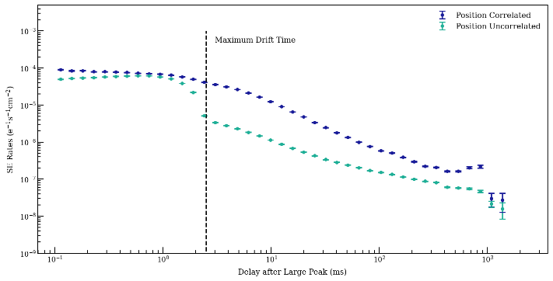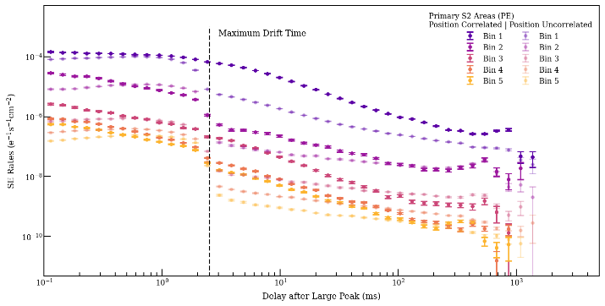consistent with what we expect. We also calculated the electron fractions for the electron trains in XENONnT, which is the number of electrons within a delay time of 5-100 ms per electrons in each primary S2 area bin (Figure 5). This resulted in a plot with a trend that is different to XENON1T (Figure 4), which means more work is needed to be done for the XENONnT electron fraction to ensure that its resulting plot is correct. Finally, other future work includes comparing all the XENON1T and XENONnT results together, performing the same analysis that was done on single electron events with events that have more than one electron (i.e., starting with just double electron events, then multi-electron events), and continuing to compare with XENON1T results.

Figure 1. XENONnT TPC [credit: The XENON Collaboration].

Figure 2. Single electron rates for position correlated and uncorrelated electron trains binned by primary S2 area size.

Figure 3. Single electron rates for position correlated and uncorrelated electron trains.

*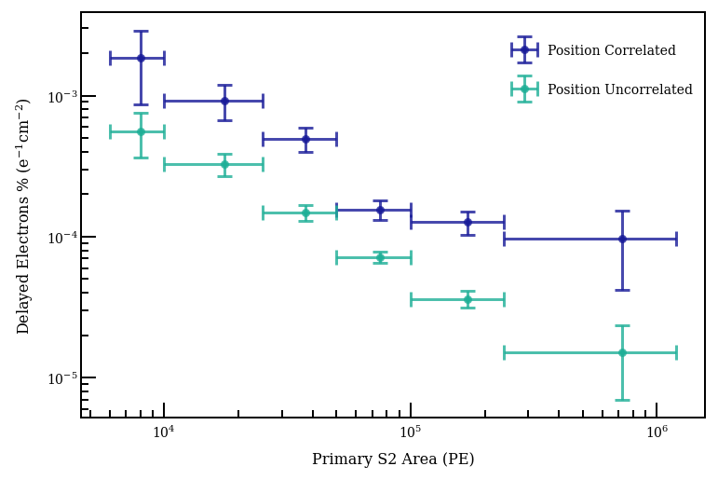This* *work* *was* *supported* *by* *NSF* *REU* *grant* *PHY-1852501* *and* *the* *ALPHA* *collaboration.*

Figure 4. XENON1T electron fraction for position correlated and uncorrelated electron trains [credit: Amanda Depoian].

Figure 5. XENONnT electron fraction for position correlated and uncorrelated electron trains.

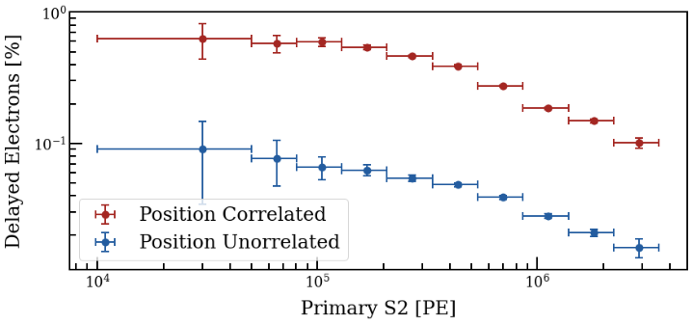

**Optimization for A Universal Quantum Circuit Design for Periodic Functions**

August Lee1,2, Junxu Li2, Sabre Kais2

1Northern Illinois University, 2 Purdue University

Quantum computers have been a huge area of research in the past decade which has resulted in the creation of a 72 qubit quantum computer [1]. The question naturally arises if we can use this new technology to speed up mathematical calculations. In a previous paper Junxu Li and Dr. Sabre Kais, outlined a Universal Quantum Circuit Design for Periodic Functions [2]. In their paper it is shown that if you had any fourier series, their circuit will be able to produce the function that the fourier series represents. This is important because this allows the use of nonlinear functions within the quantum computing framework. In their paper they simulated a square wave function within IBM-QASM, within each gate they used a universal but not optimal set of parameters.

A large portion of my research was centered around looking for an optimal set of parameters to be used within the circuit. The variable that I looked to maximize was C, which combines all the other variables into a single equation. C is limited to $\left|CF(x)\right|<\frac{1}{2}$. Where $F(x) = \sum_{n=1}^{N}{}a{}_{n}*cos(\frac{2π}{T}nx+b_{n})$ where an and bn are components in the fourier series, and T is the period of the function. To find C, I chose to use a Monte-Carlo method where I chose a random number for each variable within a reasonable range, I then found the value of C from those variables. If that value of C is within my acceptable range the parameters would be saved and then used within the circuit.

The second portion of my research was based on taking the circuit Junxu Li and Dr. Sabre Kais made and implementing them into the IBM-QASM. The circuit is made up of only 4 different gates, hadamard gates, control not gates, not gates, and RY gates. In the original paper most of the RY gates were controlled by 4 or 5 qubits. Unfortunately, the IBM-QASM can only support up to 1 controlled qubit on any one gate. To overcome this obstacle, I had to use a decomposition method on each of the multi controlled gates. Using the decomposition method, I was able to make a quantum circuit using 5 control qubits and 7 auxiliary qubits. The circuit works such that all the information is stored on the last qubit, meaning that in the circuit we only have to measure the last qubit to get all the needed information. From the last qubit the probability to get ।1〉is the estimation of F(x).

I would like to thank Junxu Li for answering my endless stream of questions, and Professor Kais for his guidance. I would also like to thank the entirety of the Purdue Physics department for putting on this great summer program. Lastly this work was supported by NSF REU grant PHY-1852501 and the ALPHA collaboration.

References:

[1] Frank Arute, Kunal Arya, Ryan Babbush, Dave Bacon, Joseph C Bardin, Rami Barends, Rupak Biswas, Sergio Boixo, Fernando GSL Brandao, David A Buell, et al. Quantum supremacy using a programmable superconducting processor. Nature, 574(7779):505–510, 2019.

[2] Junxu Li, Sabre Kais. A Universal Quantum Circuit Design for Periodic Functions.arXiv:2106.02678, 2021

**Numeric and Analytic Calculations of Critical Current in 1D and Quasi-1D Systems**

*Zane Blood1,2, Jukka Vayrynen2*

*1Cornell University, NY; 2Purdue University, IN*

Superconducting materials have zero electrical resistance, allowing for the dissipationless transport of charge. However, this superconducting behavior breaks down above a specific value of current called the "critical current", causing the material to switch to a resistive state. In this project, we studied the reciprocity of critical current versus applied magnetic field in simple models in order to pinpoint the minimal necessary ingredients that break reciprocity. We determined how including certain external fields or quantum confinement effects could cause the critical current to be larger in one direction of travel compared to the opposite direction. Such a non-reciprocal material could be used to make a superconducting diode, with possible applications in electrical circuits. The main systems studied were the 1D wire with Rashba spin-orbit coupling ("Rashba wire"), and quasi-1D systems composed of two or more Rashba wires placed next to each other. Supercurrent creates a gap in the spectrum, and at the critical current (characterized by a Cooper pair momentum *q* = *qc*), the gap closes. This fact was used to find analytic expressions and numerically-obtained values for *qc*. An example spectrum with supercurrent less than the critical current is shown in Figure (1).

In the 1D case, the main result obtained was that non-zero magnetic field Bx in the x-direction (along the wire) is necessary to induce non-reciprocity. This was supported by both numerical and analytical models. Plots of numerically-obtained *qc* values versus By were made, and these showed non-reciprocity [i.e. *qc*(By) *qc*(-By)] only when Bx was non-zero. An analytic expression for *qc* was found when Bx was zero, and then an order Bx2 correction was added. In the future, we will attempt to create an analytic expression for *qc* by linearizing the spectrum near the Fermi level, which is complicated by the fact that the gap parameter ∆ is also a function of Bx.

For the quasi-1D system, when Bx was zero and there was spin-orbit coupling (SOC) in both the x- and y-directions, the system displayed non-reciprocity. However, setting SOC in the y-direction to zero lead to reciprocity. Therefore, we determined that SOC in the y-direction is necessary for non-reciprocity. We don't have a full analytical understanding of this system, and future work is required. This specific case is important since realistic quantum wires usually have many channels, making them quasi-1D.

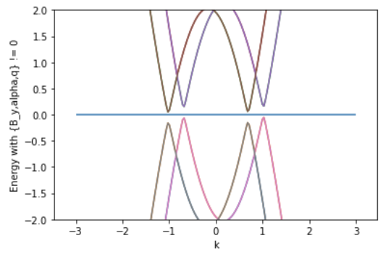

Figure (1). Quasiparticle spectrum of a superconducting 1D Rashba wire with applied supercurrent less than critical current (*q*<*qc*).

**Acknowledgements**

I would like to thank Professor Jukka Vayrynen for giving me the opportunity to collaborate with him this summer, helping me work through many of the difficult calculations, and taking time out of his schedule to meet with me throughout the project. I also want to thank the REU coordinators who helped managed the logistics of the program and the professors who shared their research with us at the weekly seminars. This work was supported by NSF REU grant PHY-1852501 and the ALPHA collaboration.

**CMS Tracker Phase-2 Forward Pixel Detector Module Assembly**

*Michael Pacocha1,2, Souvik Das², Matthew Jones²*

¹Georgia Institute of Technology, GA

²Purdue University, IN

The Large Hadron Collider (LHC) is the largest and most powerful particle accelerator in the world. It collides protons with protons, lead nuclei with lead nuclei, and protons with lead nuclei at designated collision points. The Compact Muon Solenoid (CMS) detector is positioned at one of the designated collision points and reconstructs the 3D trajectory of particles emanating from the collisions. These reconstructions allow us to infer the physics at the collision, which in turn gives us fundamental insights into the nature of matter and the forces that hold it together.

The LHC is expected to be upgraded in 2024 for higher rates of collisions, and this has necessitated the Phase-2 Upgrade of the CMS detector. The CMS detector contains an Inner Tracker (Fig 1a) built out of pixelated silicon sensors to detect charged particles. Within the Inner Tracker, a Tracker Forward Pixel detector (Figure 1b) will be upgraded with about 3,000 silicon detector modules to detect charged particles emitted at small angles to the collision axis.

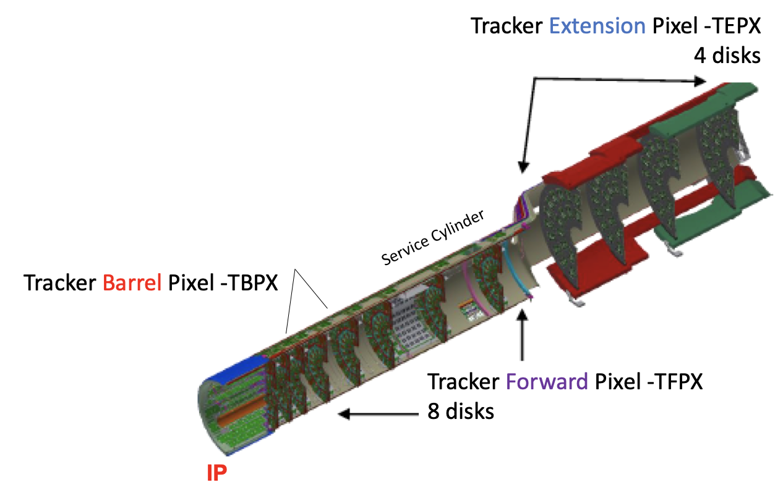 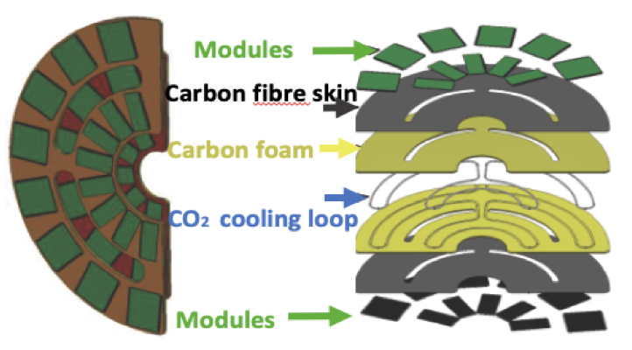

|  |  |
| --- | --- |
| **Figure 1a.** Cross section of half of the Inner Tracker detector upgrade.¹ | **Figure 1b.** Current prototype for the Tracker Forward Pixel detector.¹ |

This project focused on the development of the semi-automated assembly procedure of each of the nearly 3,000 silicon detector modules. Each module will consist of flexible high density interconnect circuits (HDI) that are glued and wire-bonded to high granularity silicon sensors that are bump-bonded to readout chips (sensorROC) (See Figure 2). Gluing the HDI to the sensorROC is a high precision and high throughput process that requires some automation.

The sensorROC has a row of bond pads on each of its two long edges; each bond pad is 86 μm × 58 μm on a 100μm pitch. The HDI has a row of bond pads that vary from ~10-40 μm × 50 μm. These length scales require that the sensorROC’s and HDI’s bond pads be aligned to a factor less than 50 μm. The alignment of these detector modules is achieved by using an Aerotech AGS10000 gantry controlled by a programmable A3200 Motion Controller, the coding of which is the focus of this project.

**Figure 2.** Schematic stack for a detector module using the prototype readout chip.²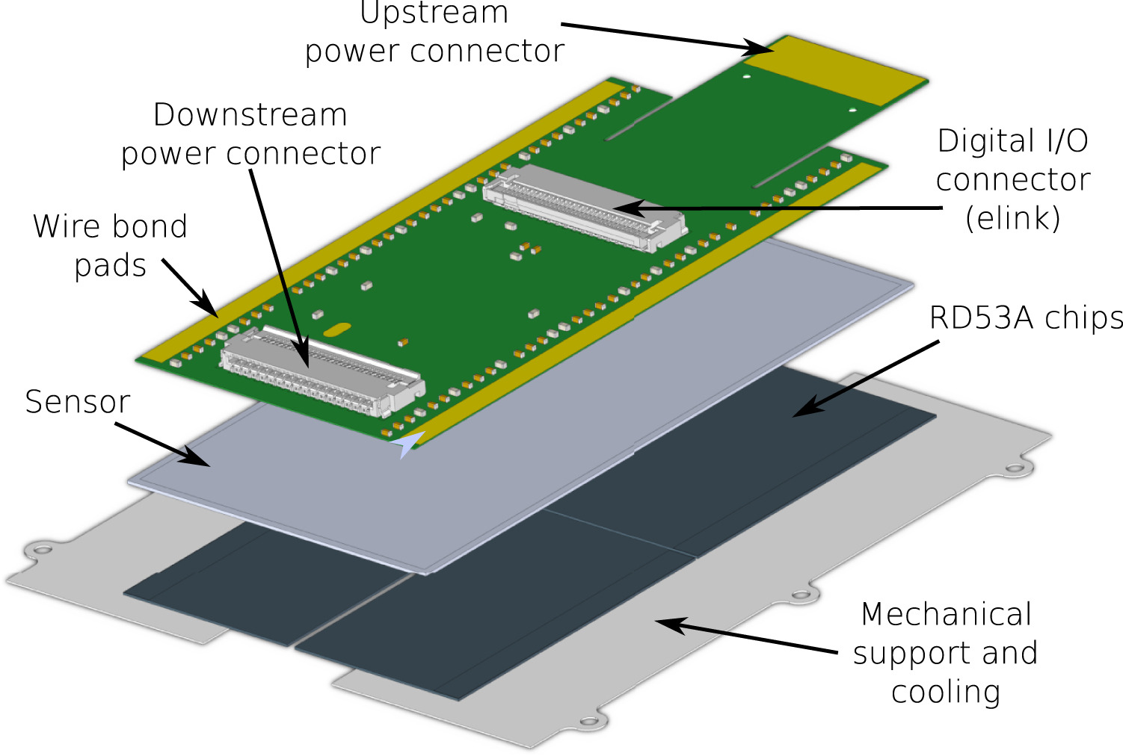

The gantry is programmed in a language named GScript, which is an interpreted language that runs on top of LabView. It was originally created by CMS group collaborator Dr. Caleb Fangmeier. The final method makes use of Horn’s closed form solution to absolute orientation³ and yields an alignment accuracy of 22 μm ± 13 μm under imperfect conditions. Alignment is predicted to be on the order of 10 μm when production of the modules begins.

I would like to thank Dr. Souvik Das and Dr. Matthew Jones for their insight and guidance in this project. This project was funded by NSF REU grant PHY-1852501 and the ALPHA collaboration.

References:

1. Orfanelli, S. (Dec. 15, 2019) *The Phase 2 upgrade of CMS Inner Tracker.* ​​12th International Hiroshima Symposium on the Development and Application of Semiconductor Tracking Detectors, Hiroshima, Japan. https://indico.cern.ch/event/803258/contributions/3582853/attachments/1962394/3262057/267-Orfanelli-CMSInnerTrackerv1.pdf

2. Perovic, Vasilije. “Serial Powering in Four-Chip Prototype RD53A Modules for Phase 2 Upgrade of the CMS Pixel Detector.” *Nuclear Instruments and Methods in Physics Research Section A: Accelerators, Spectrometers, Detectors and Associated Equipment*, North-Holland, 18 July 2020, www.sciencedirect.com/science/article/pii/S0168900220308330.

3. Horn, Berthold K. P. (1986). Closed-form solution of absolute orientation using unit quaternion. *Journal of the Optical Society of America A*, 4(4), 629-642. <https://doi.org/10.1364/JOSAA.4.000629>

Exploring magnetization plateaus using a digital annealer for the Ising Sutherland-Shastry model

in 3 dimensions

Akshat A. Jha,1 Eliana L. Stoyanoff,2 Hayato Ushijima,3, and Arnab Banerjee1

1Department of Physics and Astronomy, Purdue University, West Lafayette, Indiana 47907, USA

2Department of Computer Science, Purdue University, West Lafayette, Indiana 47907, USA

3Fujitsu Laboratories of America, 1250 E. Arques Avenue, Sunnyvale, CA 94085, USA.

(Dated: August 2021)

Frustrations is one of the key concepts behind the emergence of phases in magnetic materials since they lead to ground state degeneracy. The most common of which is the Anti-ferromagnetic phase in which equal number of spins face in opposite directions, essentially removing the magnetic strength of the material. The other phase would be the Ferromagnetic phase, which is the simplest arrangement of spins and is defined by all spins facing in the same direction giving it the highest possible magnetic strength. In order to keep track of all phases, we use a variable known as the Magnetization value (M) defined by absolute value of the difference of the spins divided by the total number of spins. With the help of this M value, we can easily give a number to the AFM and FM phase which is 0 and 1 respectively. The Shastry-Sutherland model is an amazing example of the kind of model that can help achieve more complex phases by inducing geometric frustrations which give us highly degenerate ground states. The model consists of 2 defining bonds, namely the J1 and J2 bonds, which connect all edges and alternate diagonals respectively. To simulate the results themselves, we use the Fujitsu Digital Annealer. It is a state of the art machine with real qubits performing the simulations unlike the previously tried and tested Monte-Carlo methods. This model itself gives us interesting phases such as the M=⅓ plateau and the AFM dimer.

We can also add more bonds as we have namely the J3, J4, and J5 as shown:

And by doing so we come across a variety of interesting phases some of which are the 1/2, 1/5th,1/9th, 1/10th, and the 5/9th. We also find several interesting properties about the phase diagrams themselves and plan to take it one step further. Currently we have been doing all kinds of interesting experiments on the 2D lattice and are making the lattice structure 3D. This kind of work has not been done before and we are in the process of trying to debug and fix issues that we are facing with our new bond that connects our 2D planes (J6).

I would like to thank Professor Arnab Banerjee for this wonderful opportunity to participate in this research project. This work was supported by NSF REU grant PHY-1852501 and the ALPHA collaboration.

**Light-induced atomic desorption for increasing coupling between thermal cesium atoms and photonic waveguides**

*Will Ward1,2, Tzu-Han Chang2, Chen-Lung Hung2*

1University of Central Arkansas, Department of Physics and Astronomy

2Purdue University, Department of Physics and Astronomy

Nanophotonic devices and atom-photon interactions have been of interest in physics research for many years due to their applications in chip-scale devices, such as atomic optical clocks. While strong coupling between thermal cesium atoms and nanophotonics has been demonstrated inside a vacuum chamber in the past, we attempt to enhance those interactions by introducing a process called light-induced atomic desorption (LIAD).

In our experiment, laser light will be fed into photonic circuits on a fabricated microchip inside a high vacuum chamber. The microchip hosts microring resonators with a resonant wavelength close to the D2 transition of cesium. The input laser is tuned over a small range of frequencies around the D2 transition to cause individual microrings to strongly resonate. When this occurs, cesium atoms near the chip couple with the microrings, and the transmission signal read by a photodetector is disturbed.

In previous experiments, cesium atoms have been released into the chamber close to the waveguides by a cesium dispenser. However, in this project, we will be releasing atoms into the chamber using LIAD. Atoms are first deposited onto a glass surface in the chamber by a cesium dispenser. Then, high intensity ultraviolet LED light shines on the atoms, causing them to desorb off the surface and shoot away from it at high velocities. Ideally, atoms will fly directly over the microchip within 100 nm of the resonators and interact strongly with the photons inside resonating microrings.

Using LIAD, instead of a cesium dispenser, to release atoms close to the photonic chip should give us better control over the emission of atoms. A cesium dispenser must be heated up in order for it to release atoms, and it stays hot for some time. This makes it difficult to turn the dispenser off once it turns on. The LED laser that causes atomic desorption, however, is easily turned on and off with a switch.

My role on this project was to help design a vacuum chamber setup to implement LIAD, clean and prepare vacuum components, and assist in the construction of the vacuum chamber. At this time, the experimental setup is still in the process of being built.

I would like to thank Tzu-Han Chang, Dr. Chen-Lung Hung, and all of the members of Dr. Hung’s ultracold quantum gas and quantum optics group for their help and support. This work was supported by NSF REU grant PHY-1852501 and the ALPHA collaboration.

**Superconducting Microwave Circuits for Quantum Simulation**

Andrew Rockovich1,2, Alex Ruichao Ma2

1Washington & Jefferson College, 2Purdue University

The Ma Lab group at Purdue University explores the use of superconducting qubits, controlled with microwave frequency (single-digit GHz range) pulses, for quantum simulation. Arrangement of these superconducting qubits in different ways can replicate the behavior of a more complicated physical system. Exploring the physical properties of the qubits allows researchers insight into the physical properties of the system they simulate.

The realization of superconducting qubits in the Ma lab group is done through Transmon circuits, which consist of a Josephson Junction shunted with a capacitor. The classical analogy to the Transmon circuit is the harmonic LC circuit, where the Josephson Junction behaves as the inductor. The characteristic nonlinear response of the Josephson Junction’s inductance with current means there is anharmonicity in the spacing of states in the Transmon circuit, meaning we can explicitly only use the ground and first excited states of the Transmon circuit. These two states are used as |0˃ and |1> on the Bloch sphere, and are controlled by excitation of the Transmon using microwave frequency (at qubit resonance) pulses. Accurate state rotations/manipulations are performed through precise duration pulses at qubit resonance frequency. The state of the qubit is read (yet not destroyed) by using a quantum resonator coupled to the qubit.

If the qubit were solely driven by a microwave frequency source (local oscillator (LO)) either in on or off mode, there would inevitably be leakage of that source to the qubit even in off mode. To eliminate this, the LO frequency is modulated with two 50 MHz (intermediate frequency (IF), I and Q) pulses that are 90° out of phase. Calibration of these pulses (through mixer correction matrices and DC offsets) allows for them to be fine tuned such that the LO leakage and undesirable sideband (LO ± IF) frequency are minimized to near the noise floor, and the desired sideband is relatively unaffected. These offsets and matrix terms for calibration I found through minimization techniques in Python. The result of this calibration is seen in Fig. 1. The desired sideband is then the frequency that will be used to control the qubit.

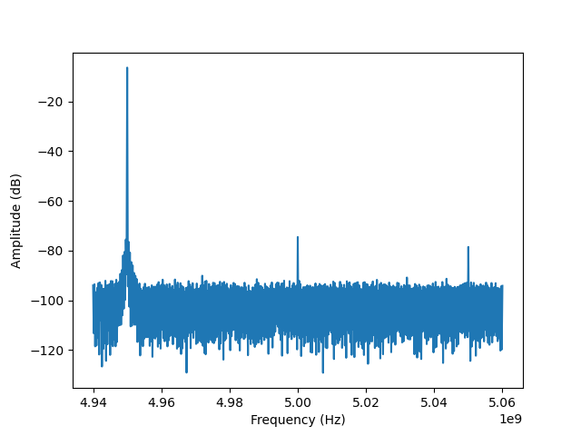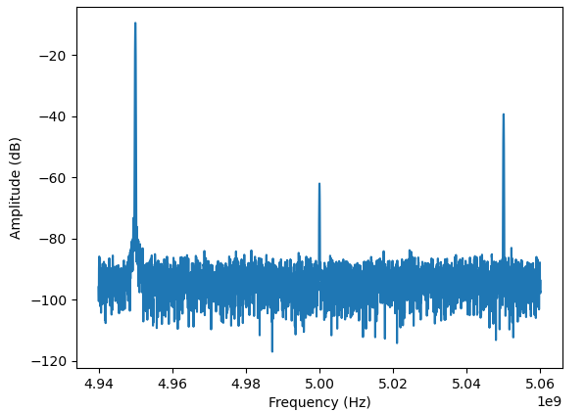

Fig. 1: With LO frequency at 5 GHz and IF frequency at 50 MHz, appropriately chosen mixer correction matrix terms and DC offsets to I and Q pulses can minimize the LO leakage and upper sideband while preserving amplitude at the lower sideband.

The platform of choice for the Ma lab group is Python for its versatility, universality, and user-friendliness. Python is used for everything software related, including interfacing dynamic circuit elements as well as the control and measurement hardware. For the circuit elements, most come with a built-in driver class using C/C++ programming language. I tested and modified existing python driver classes that encapsulate the functionality of the built-in driver class for several devices, alongside testing those devices thoroughly. These devices include phase shifters, signal generators, digital attenuators, and the lab’s new spectrum analyzer. The control and measurement of qubit states is done using the Quantum Machine, which operates on the programming language QUA, essentially a quantum programming library built into Python. It has built in functions to account for all the pulses one may need to send, as well as the ability to read in pulses sent back to the machine from the qubit setup. I built the test circuit in Fig. 2, bypassing the qubit and readout resonator and simply combining the RF outputs from the two leftmost mixers and reading it through the rightmost mixer (I and Q outputs are read by the Quantum Machine). This circuit serves to test the quantum machine, the hardware attached to it, and the calibration of the mixers. Note: mixer calibration mentioned above is done using inputs in QUA.

Quantum Machine

Analog Outputs

Analog Inputs

1 2 7 8

1 2

**I**

**Q**

**Qubit**

**Local Oscillator 1**

**Local Oscillator 2**

**RF Combiner**

**I**

**Q**

**Readout Resonator**

**I**

**Q**

Fig. 2: The test circuit used to ensure proper calibration of mixers and proper setup of the Quantum Machine and proper understanding of accompanying QUA quantum programming platform.

Noise in the pulses going into and out of the qubit chip must be kept at a minimum for the highest accuracy in control/readout of the pulses. A good deal of this noise is at a higher frequency, so it is prudent to implement special linear-frequency response low pass filters in the circuit on both sides of the qubit chip. Such a frequency response (as well as low reflection/good impedance matching) is achieved with coaxial cavity components with Eccosorb CR/CRS microwave absorber as the cavity dielectric material, seen in Fig. 3. I was responsible for continuing and refining the fabrication process of these devices, having made about a dozen over the summer. I also tested them to make sure they displayed appropriate characteristics. I also designed similar versions of the filter, with more attenuation (for use where the signal is strong).

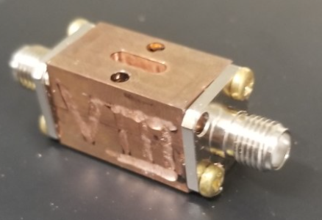

Fig. 3: A singular Eccosorb low-pass filter. In fabrication, two SMA connectors are soldered together at the inner pin, and two copper rectangular prisms with half-cylinder cavities (for dielectric material and inner coaxial pin, drilled to diameter for impedance matching) are fitted together. Eccosorb material is then prepared and injected through the top (oval shaped) opening used to access the inner cavity, and the entire device is allowed to cure on a heating schedule as recommended by Eccosorb manufacturer Laird Materials.

This work was supported by NSF REU grant PHY-1852501 and the ALPHA collaboration.

**Optimization and Electrical Characterization of DC Reactive Sputtered NbN Films**

Zachary Jernigan1,2, Leonid Rokhinson2

LR group with Professor Leonid Rokhinson

1University of North Texas, TX, 2Purdue University, IN

NbN has long been known to have a superconducting state that has a higher transition temperature than its elemental counter part Nb. The interest to implement thin films of NbN in various applications like superconducting RF cavities for particle accelerators, resonator circuits for quantum computing readout and radiation detection, and many other devices has invoked the new challenge of determining optimal deposition/growth methods to produce films with desirable properties. Bulk NbN can have a transition temperature of roughly 15 K, but this value can vary dramatically for films depending on their deposition parameters and film thickness.

Reactive DC magnetron sputtering was the method of interest to deposit thin NbN films. The AJA e-beam evaporation and sputtering system was the device of choice to deposit roughly 30 NbN films on glass substrates to study the change of critical temperature as N2 flow (reactive gas) and Ar (sputtering gas) partial pressure were varied. Film thickness and strain was also studied as Ar partial pressure was varied.

Transition temperatures were measured in 3 different cryogenic systems. Initially, a dipstick in a He dewar was utilized, where a temperature gradient existed within the dewar. Temperature decreased as the probe was lowered deeper into the dewar which hit a minimum at the surface of the liquid He (roughly 4.2 K). After the physics building’s He recycler was shut down for maintenance, the He3 system was implemented to find critical temperature. The He3 system works by condensing He3 in a pot (where the sample is in thermal contact with) and the temperature of this liquid He3 is decreased to roughly 250 mK with evaporative cooling. After the probe was damaged and required repairs, the dilution fridge was used to find relative transition temperatures. The dilution fridge cools samples to roughly 40 mK by evaporating He3 from a concentrated phase to a diluted, He4 rich phase, which is an endothermic reaction due to the difference in enthalpy in liquid and vapor phase of He3.

Strain was studied by depositing a layer of PMMA on glass substrates before NbN deposition. This polymer layer made strain propagation easier due to the greater elasticity, allowing samples to be visually analyzed with the use of ImageJ, an image processing software.

It was found that the optimal N2 flow for an Ar partial pressure of 4 mTorr was 1.7 sccm and residual resistance ratio (RRR = R(300K)/R(10K)) decreased with increasing flow. At the optimal flow of 1.7 sccm, it was found that transition temperature was optimized at 4 mTorr Ar partial pressure and as Ar partial pressure was increased, RRR decreased. As pressure increased, visual strain propagation and density was decreased.

I want to give a special thanks to Professor Leonid Rokhinson and the LR group for assisting me in this project and keeping me focused on the goal of trying to provide insight of how to optimize the AJA system for use in future projects. I also want to thank Purdue University for hosting this great Summer internship. This work was supported by NSF REU grant PHY-1852501 and the ALPHA  
collaboration

Raman Spectra of Water Oxidation Catalysts for Artificial Photosynthesis Usage

*Oliver Carey1,2, Alireza K. Ravari2, Yulia Pushkar2*

1University of Rhode Island, RI, 2Purdue University, IN

As a major phenomenon in oxygenic photosynthesis, the specialized multi-subunit protein complex, Photosystem II (PSII), catalyzes water molecules into oxygen, hydrogen (proton), and electron constituents. This is carried out by the oxygen-evolving complex (OEC) which consists of an Mn4O5Ca-cluster that circulates water molecules throughout five intermediate “S” oxidation states (S0-S4), altogether known as the Kok cycle. The chemical reaction resulting from this cycle can be summarized as follows,

2 H2O → 4 H+ + O2 + 4 e_

Unfortunately, the complete mechanism of the Kok cycle is not fully understood. The order in which the manganese within the Mn4O5Ca-cluster is reduced is unknown, as conflicting evidence holds the mechanism up for discussion. Understanding the mechanisms by which the OEC undergoes water oxidation catalysis reactions with such efficiency is precisely the motive for improving current artificial photosynthetic systems. Ruthenium-based water oxidation catalysts (WOC) are among the most promising as a solution to maximize controlled photosynthetic efficiency. Their role in artificial photosynthesis is ultimately to capture the energy provided by sunlight and use it to engage in catalytic reactions for energy storage. Furthermore, to best simulate the complex protein environment as observed in PSII, metal-organic frameworks (MOF) can be chemically coordinated for structural stability and synthetic tunability.

Resonance Raman Spectroscopy has been a key method in the analyses of these ruthenium-based WOCs. The Raman effect occurs when incident light strikes a material and the light scatters inelastically, at a different wavelength. This inelasticity is caused by interactions between the vibrational energy of the atoms in the material and the incident electromagnetic radiation. Whether the energy of the Raman scattered light is above (anti-Stokes Raman) or below (Stokes Raman) the incident light, it can be measured to analyze chemical structure, to assign reaction mechanisms, and to identify the material in question. When the energy of the incident light is particularly close to that of the electronic transition of the sample, the amount Raman scattered light is greatly increased.

My project this summer dealt with taking spectral measurements of these Ruthenium water oxidation catalysts as well as certain metal-organic frameworks. Among some was the WOC [Ru(pic)2(EtO-tpy)(H2O)]2+ (pic = 4-picoline, EtO = exothy-, tpy = 2,2′;6′,2″-terpyridine) which was created using both an oxygen-16 isotope and an oxygen-18 isotope. Both samples were measured with and without the addition of cerium ammonium nitrate (CAN), which energizes the catalyst to create low-energy pathways for water oxidation. Additionally, Figure 2 shows the spectra of MOFs FeMIL-126 (iron-based) and MOF-4 (ruthenium-based). In order to complete these tasks, two lasers (442 nm and 532 nm) were used as sources of incident light for the Resonance Raman technique allowing a spectrophotometer to detect absorbance patterns. Once these absorbance patterns were recorded, their contents could be analyzed to determine characteristics about their relative characteristics and potential capabilities for future systems.

**Figure 1.** Raman Spectra of water oxidation catalyst [Ru(pic)2(EtO-tpy)(H2O)]2+ using oxygen-16 and oxygen-18 isotopes with and without the addition of cerium ammonium nitrate. This was performed on a liquid nitrogen cryostage with a 442 nm wavelength laser. 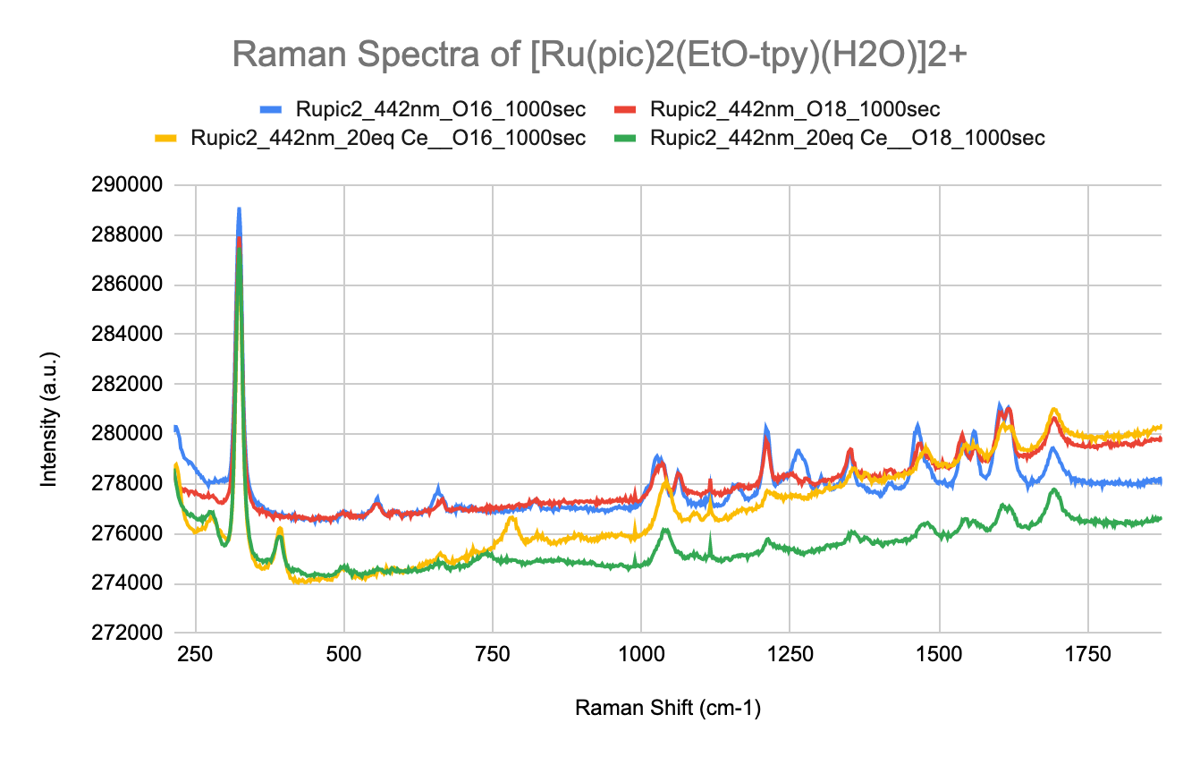

**Figure 2.** Raman Spectra of FeMIL-126 and MOF-4 metal-organic frameworks. This was performed on a liquid nitrogen cryostage with a 442 nm wavelength laser. 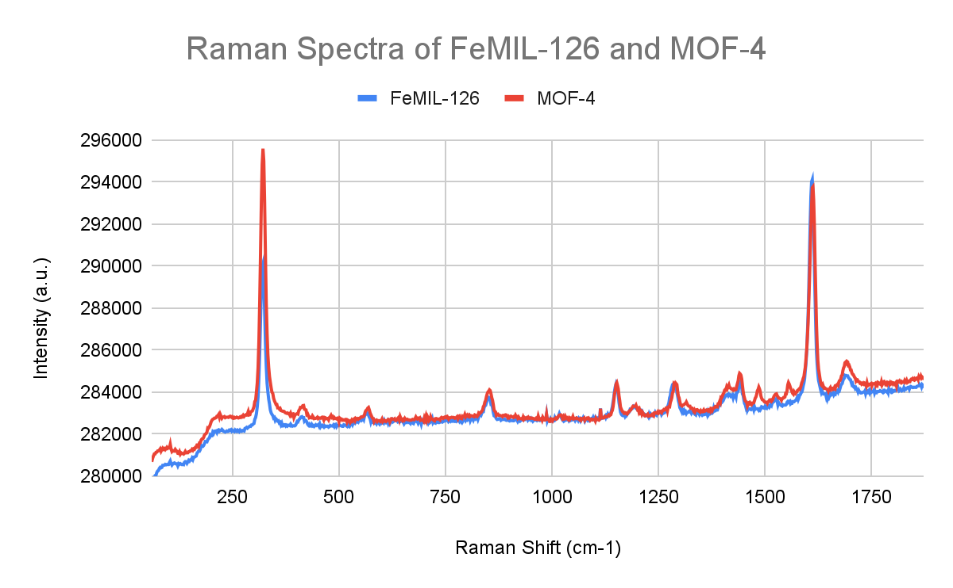

It has been a pleasure to join Purdue University’s Physics and Astronomy REU program this year. I would personally like to thank Dr. Alireza Ravari, Dr. Roman Ezhov, and Dr. Yulia Pushkar for all the guidance during this summer research experience. This work was supported by NSF REU grant PHY-1852501 and the ALPHA collaboration.

GROWTH CURVES OF *CAULOBACTER CRESCENTUS* IN AN ENVIRONMENT OF CHANGING MEDIA

*Rhea Gandhi1,3, Jack Stonecipher2,3, Srividya Iyer-Biswas3*

*1Claremont McKenna College, CA, 2Gustavus Adolphus College, MN, 3Purdue University, IN*

Over time, there have been laws found that seem to explain dynamic properties in inanimate objects and now scientists are searching for explanations of the stochastic attributes in the behavior of living matter. Looking at single cells, we’re looking to understand their behavioral responses to an ever-changing system. A problem that comes with this is that cell populations grow exponentially making it increasingly difficult to track a cell over time and measure individual changes. This issue was recently mitigated by the development of a method that allows us to study a single cell’s growth over tens to hundred of generations by tracking a single cell line from mother to daughter cell[2](Figure 1). The high precision data this method gathers allows for the construction of quantitative laws that govern processes of these single cells.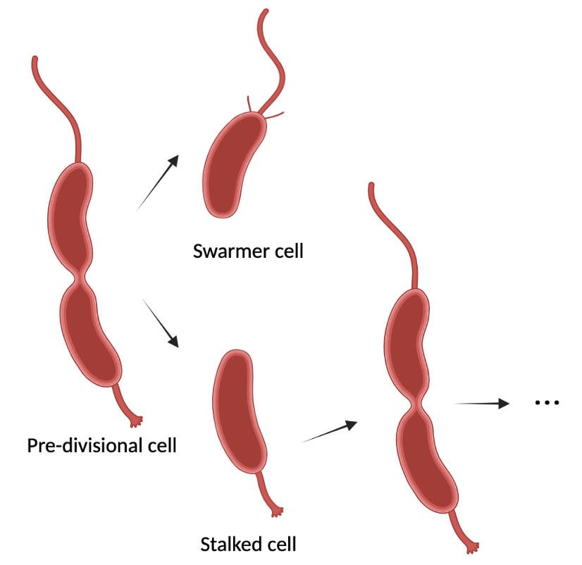

Figure 1. Growth and division cycle of *Caulobacter crescentus*. The strain used was taken and cloned with a mutation that makes the swarmer cells nonadhesive and leaves the stalked cells able to adhere to surfaces. Thus, even over long experiment times, the swarmer daughter cells would get washed out, rather than crowding the field.

A universal phenomena for organisms is the maintenance of homeostasis in many different facets. Along with this, they often have to reattain their original physiological state, or one similar to it, after some change in their environment or growth conditions. Homeostasis, adaptation and complementary processes have been analyzed for decades- many efforts have been made to look at how growth and form of organisms change over time using qualitative measures. The stochasticity of homeostasis and adaptation make them hard to precisely measure quantitatively even just by the cell size and shape of simple bacteria. Other experiments have developed laws for stochastic growth of populations under unchanging conditions over time[3]. Using the technology described above to acquire high-precision data, here we will discuss the preliminary challenges and findings with regards to understanding the physics of how homeostasis and adaptation of bacterial growth and form occur in dynamic environments.

The implications of this work are significant as the findings suggest that understanding the way by which growth curves are affected by their environmental conditions can enable us to manipulate cell populations to fit a particular timescale. Understanding the affects of nutrient availability on growth patterns enables us to be able to expect how similar environmental pressures may affect homeostasis and force the cell population to adjust, as following specific timescales, the results can be generalized to be reflective of the expected behavior of other cells.

Thank you to Jack Stonecipher for working with me, Shaswata Roy for his constant assistance, and Professor Iyer-Biswas for her continual invaluable guidance and mentoring. This work was supported by NSF REU grant PHY-1852501 and the ALPHA collaboration.

[1]Iyer-Biswas, S., Crooks, G. E., Scherer, N. F., Dinner, A. R. (2014) Universality in stochastic exponential growth. *Physical Review Letters* 113 (2) 1-7

[2]Iyer-Biswas, S., Wright, C. S., Henry, J. T., Lo, K., Burov, S., Lin, Y., Crooks, G. E., Crosson, S., Dinner, A. R, Scherer, N. F. (2014) Scaling laws governing stochastic growth and division of single bacterial cells. *Proceedings of the National Academy of Sciences* 111 (45) 15912-15917.

[3]Jafarpour, F., Wright, C. S., Gudjonson, H., Riebling, J., Dawson, E., Lo, K., Fiebig, A., Crosson, S., Dinner, A. R., Iyer-Biswas, S. (2018) Bridging the Timescales of Single-Cell and Population Dynamics. *Physical Review X* 8 (2) 021007-1-021007-14

**Stochastic homeostasis and adaptation of bacterial growth and form in dynamic environments**  
  
Jack Stonecipher1,3,Rhea Gandhi2,3, Prof. Iyer-Biswas3

Gustavus Adolphus College1, Claremont McKenna College2, Purdue University3

This lab is working to discover the physical laws that govern dynamics of living systems. The study of single cells over extended periods of time is made difficult by the exponential population growth in cell cultures. Using a unique method, individual cells can be studied over tens to hundreds of generations. This technique can also create a constant cell-density experimental system that can be observed more easily. The abundance of data provided by this method has allowed for the determination of quantitative laws governing cell dynamics.

This system also allows for the observation of cellular adaptation to environmental changes as well as maintenance of homeostasis since conditions can be changed over time in precisely programmed ways. Since these complementary processes are stochastic, collecting qualitative data on simple variables (cell size and shape) has been a challenge for a long time. This project will address the challenges and first steps to analyzing cellular growth and form in dynamic environments.

The method used to gather data involves the SChemostat technology as detailed in previous papers.[1][2] In normal cell development, a daughter cell (called a swarmer cell) will swim through the environment until it finds satisfactory conditions. At this location it will attach itself to a surface (becoming a stalked cell) and reproduce. Other groups use a different technology: The Mother Machine consists of a tube wide enough for a cell to rest inside of it. This cell can reproduce a chain of daughter cells until they reach the end of the tube where a current of media displaces new offspring at the end of the chain. In the SChemostat, rather than a one-dimensional growth, cells are in a two-dimensional culture, but do not touch each other or share nutrients. Therefore they are truly "non-interacting". A constant flow of media “whisks” away newly produced daughter cells preventing a pileup of cells. By keeping the amount of cells in a culture more or less constant, accurate growth and division data can be taken. Different “frames” of the cell culture are photographed over time. These images are analyzed by a computer which tracks each cell, measures its size, and marks divisions. Manual intervention at the final stage ensures better precision obtained using the SChemostat technology. My own contributions are to the data analysis part of the data collection pipeline.

Using an antibiotic that transiently deforms the cell, in this project we have characterized how cell shape changes from the normal crescent shape to "lemon shape" and is finally restored to crescent shape some time after the exposure to antibiotic has stopped.

I’d like to thank Prof. Iyer-Biswas, Rhea Ghandi, Shaswata Roy and everyone at the Iyer-Biswas lab for their support. This has been a super inspiring and meaningful experience for me. This work was supported by NSF REU grant PHY-1852501 and the ALPHA collaboration.

[1] Iyer-Biswas, S., Wright, C. S., Henry, J. T., Lo, K., Burov, S., Lin, Y., Crooks, G. E., Crosson,

S., Dinner, A. R, Scherer, N. F. (2014) Scaling laws governing stochastic growth and division of

single bacterial cells. Proceedings of the National Academy of Sciences 111 (45) 15912-15917.

[2] Jafarpour, F., Wright, C. S., Gudjonson, H., Riebling, J., Dawson, E., Lo, K., Fiebig, A.,Crosson, S., Dinner, A. R., Iyer-Biswas, S. (2018) Bridging the Timescales of Single-Cell and Population Dynamics. Physical Review X 8 (2) 021007-1-021007-14